

January 26, 2025 – Epiphany 3 (C)
Religious Life Sunday

Many are called to join together with others for mutual support in their spiritual journeys, for growth in their life in Christ, and for extension of mission. Religious life in The Episcopal Church takes two distinct forms under the canons:

- Members of Religious Orders live in community with each other, give up all their possessions under a vow of poverty, and are celibate. Title III, Canon 14, section 1: “A Religious Order of this Church is a society of Christians (in communion with the See of Canterbury) who voluntarily commit themselves for life, or a term of years, to holding their possessions in common or in trust; to a celibate life in community; and obedience to their Rule and Constitution.” To learn more about religious orders in The Episcopal Church, visit caroa.net.

- Members of Christian Communities live in their own homes, either alone or with their families. Those members of Christian communities who take a vow of poverty may interpret this vow as simplicity and well-discerned use of resources but do not give away all their possessions. Some take a vow of chastity, but choose whether to be celibate

January 26, 2025 – Epiphany 3 (C)
Religious Life Sunday

Many are called to join together with others for mutual support in their spiritual journeys, for growth in their life in Christ, and for extension of mission. Religious life in The Episcopal Church takes two distinct forms under the canons:

- Members of Religious Orders live in community with each other, give up all their possessions under a vow of poverty, and are celibate. Title III, Canon 14, section 1: “A Religious Order of this Church is a society of Christians (in communion with the See of Canterbury) who voluntarily commit themselves for life, or a term of years, to holding their possessions in common or in trust; to a celibate life in community; and obedience to their Rule and Constitution.” To learn more about religious orders in The Episcopal Church, visit caroa.net.

- Members of Christian Communities live in their own homes, either alone or with their families. Those members of Christian communities who take a vow of poverty may interpret this vow as simplicity and well-discerned use of resources but do not give away all their possessions. Some take a vow of chastity, but choose whether to be celibate
or live in a committed relationship with a spouse or partner. Title III, Canon 14, section 2: “A Christian Community of this Church is a society of Christians (in communion with the See of Canterbury) who voluntarily commit themselves for life, or a term of years, in obedience to their Rule and Constitution.” To learn more about Christian communities, visit naecc.net.
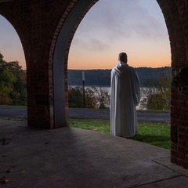
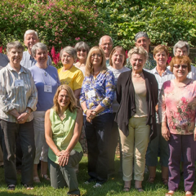
For resources and more information, visit religiouslifesunday.net. Also see our videos about CAROA and NAECC communities, visit www.youtube.com/@religiouslifesunday. Watch video discussions comparing religious orders and Christian communities on religiouslifesunday.net, and register for a live Zoom conversation on Saturday, February 8, 2025, at 4:00 pm ET on the religiouslifesunday.net website.

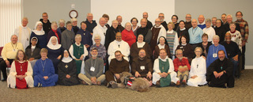
Collect For Monastic Orders and Vocations
O Lord Jesus Christ, you became poor for our sake, that we might be made rich through your poverty: Guide and sanctify, we pray, those whom you call to follow you under the vows of poverty, chastity, and obedience, that by their prayer and service they may enrich your Church, and by their life and worship may glorify your Name; for you reign with the Father and the Holy Spirit, one God, now and forever. Amen.
or live in a committed relationship with a spouse or partner. Title III, Canon 14, section 2: “A Christian Community of this Church is a society of Christians (in communion with the See of Canterbury) who voluntarily commit themselves for life, or a term of years, in obedience to their Rule and Constitution.” To learn more about Christian communities, visit naecc.net.
For resources and more information, visit religiouslifesunday.net. Also see our videos about CAROA and NAECC communities, visit www.youtube.com/@religiouslifesunday. Watch video discussions comparing religious orders and Christian communities on religiouslifesunday.net, and register for a live Zoom conversation on Saturday, February 8, 2025, at 4:00 pm ET on the religiouslifesunday.net website.

Collect For Monastic Orders and Vocations
O Lord Jesus Christ, you became poor for our sake, that we might be made rich through your poverty: Guide and sanctify, we pray, those whom you call to follow you under the vows of poverty, chastity, and obedience, that by their prayer and service they may enrich your Church, and by their life and worship may glorify your Name; for you reign with the Father and the Holy Spirit, one God, now and forever. Amen.

