

The Absalom Jones Fund

People of all backgrounds and faiths are invited to give generously to the Absalom Jones Fund in support of the work of two historically Black institutions of higher education in cultivating and preparing leaders: Voorhees University and Saint Augustine’s University.

Many Episcopal congregations take dedicated offerings around Feb. 13 in observance of the Feast Day of Absalom Jones, the first Black priest ordained by the church.

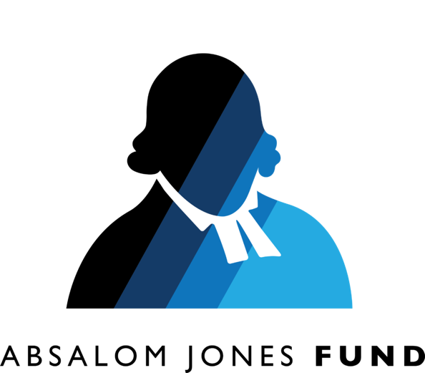
Jones’ witness to the way of Jesus included efforts to abolish slavery and to lift up all those cast down. He understood that education is the key to empowerment. “Absalom Jones recognized the transformative power of

The Absalom Jones Fund

People of all backgrounds and faiths are invited to give generously to the Absalom Jones Fund in support of the work of two historically Black institutions of higher education in cultivating and preparing leaders: Voorhees University and Saint Augustine’s University.

Many Episcopal congregations take dedicated offerings around Feb. 13 in observance of the Feast Day of Absalom Jones, the first Black priest ordained by the church.

Jones’ witness to the way of Jesus included efforts to abolish slavery and to lift up all those cast down. He understood that education is the key to empowerment. “Absalom Jones recognized the transformative power of
education,” Bishop Michael Curry writes in a churchwide letter inviting donations. “These institutions continue his mission, providing a liberal arts education and robust campus ministries that shape young adults into ethical leaders.”
Both Saint Augustine’s University in Raleigh, North Carolina, and Voorhees University in Denmark, South Carolina, were founded after the Civil War to create educational opportunities for formerly enslaved people.
“The chaplains at Voorhees and Saint Augustine’s play a crucial role in this formation, guiding students in their faith journey and helping them navigate the complexities of our world,” Curry writes.

Donations to the historically Black colleges and universities (HBCUs) help support “the vital work of these chaplains” he says. “By investing in these students, we are investing in a future where love, justice, and reconciliation prevail.”

Voorhees University and Saint Augustine’s provide an excellent liberal arts education to thousands of students, the majority of whom come from low-income households, and over 40% of whom are the first in their families to attend a four-year college. The Gospel work of education and emancipation, evangelism and formation, reconciliation and commitment to a just and humane society and world is happening at these schools!

To give: Make a donation online at iam.ec/ajf
or call (212) 716-6002.
education,” Bishop Michael Curry writes in a churchwide letter inviting donations. “These institutions continue his mission, providing a liberal arts education and robust campus ministries that shape young adults into ethical leaders.”
Both Saint Augustine’s University in Raleigh, North Carolina, and Voorhees University in Denmark, South Carolina, were founded after the Civil War to create educational opportunities for formerly enslaved people.
“The chaplains at Voorhees and Saint Augustine’s play a crucial role in this formation, guiding students in their faith journey and helping them navigate the complexities of our world,” Curry writes.

Donations to the historically Black colleges and universities (HBCUs) help support “the vital work of these chaplains” he says. “By investing in these students, we are investing in a future where love, justice, and reconciliation prevail.”

Voorhees University and Saint Augustine’s provide an excellent liberal arts education to thousands of students, the majority of whom come from low-income households, and over 40% of whom are the first in their families to attend a four-year college. The Gospel work of education and emancipation, evangelism and formation, reconciliation and commitment to a just and humane society and world is happening at these schools!

To give: Make a donation online at iam.ec/ajf
or call (212) 716-6002.

