

May 18, 2025 – Easter 5 (C)
Traveling the Way of Love: Worship

“Traveling the Way of Love” Season 2 offers video stories of the ways people across The Episcopal Church participate in the seven Way of Love practices. Produced by the Office of Communication in partnership with Evangelism colleagues, it includes study guides to help congregations or small groups engage the stories and strengthen one another’s discipleship. Each week, we’ll share information about an episode, along with study questions suitable for congregational, small group, or personal reflection. You can find each episode and its discussion guide at iam.ec/TWOL2.
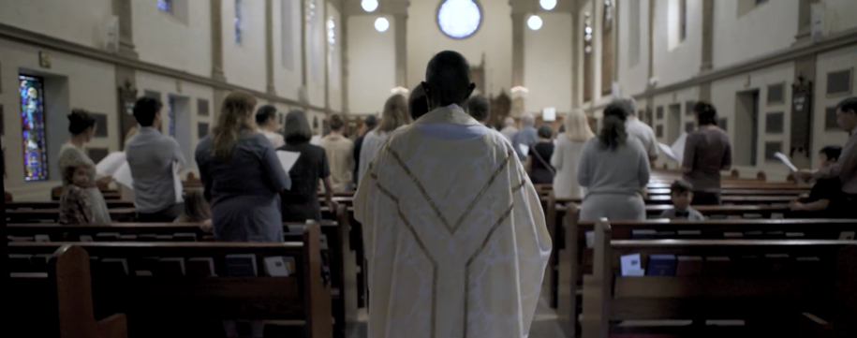
Episode 1: Worship

“When he was at the table with them, he took bread, blessed and broke it, and gave it to them. Then their eyes were opened, and they recognized him.” - Luke 24:30-31

May 18, 2025 – Easter 5 (C)
Traveling the Way of Love: Worship

“Traveling the Way of Love” Season 2 offers video stories of the ways people across The Episcopal Church participate in the seven Way of Love practices. Produced by the Office of Communication in partnership with Evangelism colleagues, it includes study guides to help congregations or small groups engage the stories and strengthen one another’s discipleship. Each week, we’ll share information about an episode, along with study questions suitable for congregational, small group, or personal reflection. You can find each episode and its discussion guide at iam.ec/TWOL2.
Episode 1: Worship

“When he was at the table with them, he took bread, blessed and broke it, and gave it to them. Then their eyes were opened, and they recognized him.” - Luke 24:30-31

When we worship, we gather with others before God. We hear the Good News of Jesus Christ, give thanks, confess, and offer the brokenness of the world to God. As we break bread, our eyes are opened to the presence of Christ. By the power of the Holy Spirit, we are made one body, the body of Christ sent forth to live the Way of Love.

1. In this episode, host Chris Sikkema visits Palmer Memorial Episcopal Church in Houston, Texas, and chats with the Rev. Ryan Hawthorne about what worship means to her. Hawthorne emphasizes that worship is not just a communal practice, but a deeply personal one. She invites individuals to find the worship practices that resonate with their soul, which might include worshipping within a church community. What worship practices deeply touch your soul?

2. The call to gather and worship within the Christian tradition, as understood through the Episcopal lens, is a call to “the collective.” It is a call to come together across generations and all sorts of messy human experiences to pray, offer praise and thanksgiving, proclaim the Gospel, and promote justice, peace, and love. What voices are missing from your worship experience? How could it be a more “collective” experience?

3. Palmer’s former senior warden, Dr. Danna Kurtin, spoke about the importance of curiosity when it comes to practicing worship on the Way of Love. Being curious about our neighbors, other traditions, and the ways God is moving in the world through changing culture are just some of the things that can influence our worship experience. Where might the Holy Spirit be asking you – as an individual or as a faith community - to be curious and to stretch in your practice of worship?

When we worship, we gather with others before God. We hear the Good News of Jesus Christ, give thanks, confess, and offer the brokenness of the world to God. As we break bread, our eyes are opened to the presence of Christ. By the power of the Holy Spirit, we are made one body, the body of Christ sent forth to live the Way of Love.

1. In this episode, host Chris Sikkema visits Palmer Memorial Episcopal Church in Houston, Texas, and chats with the Rev. Ryan Hawthorne about what worship means to her. Hawthorne emphasizes that worship is not just a communal practice, but a deeply personal one. She invites individuals to find the worship practices that resonate with their soul, which might include worshipping within a church community. What worship practices deeply touch your soul?

2. The call to gather and worship within the Christian tradition, as understood through the Episcopal lens, is a call to “the collective.” It is a call to come together across generations and all sorts of messy human experiences to pray, offer praise and thanksgiving, proclaim the Gospel, and promote justice, peace, and love. What voices are missing from your worship experience? How could it be a more “collective” experience?

3. Palmer’s former senior warden, Dr. Danna Kurtin, spoke about the importance of curiosity when it comes to practicing worship on the Way of Love. Being curious about our neighbors, other traditions, and the ways God is moving in the world through changing culture are just some of the things that can influence our worship experience. Where might the Holy Spirit be asking you – as an individual or as a faith community - to be curious and to stretch in your practice of worship?

