

June 1, 2025 – Easter 7 (C)
Traveling the Way of Love: Turn

“Traveling the Way of Love” Season 2 offers video stories of the ways people across The Episcopal Church participate in the seven Way of Love practices. Produced by the Office of Communication in partnership with Evangelism colleagues, it includes study guides to help congregations or small groups engage the stories and strengthen one another’s discipleship. Each week, we’ll share information about an episode, along with study questions suitable for congregational, small group, or personal reflection. You can find each episode and its discussion guide at iam.ec/TWOL2.

Episode 3: Turn

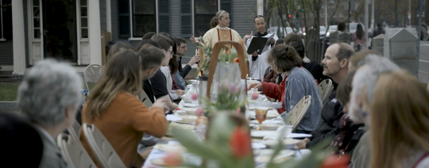
“As Jesus was walking along, he saw Levi son of Alphaeus sitting at the tax booth, and he said to him, ‘Follow me.’ And he got up and followed him.” - Mark 2:14

Like the disciples, we are called by Jesus to follow the Way of Love. With God’s help, we can turn from the powers of sin, hatred, fear, injustice, and oppression toward the way of truth, love, hope, justice, and freedom. In turning, we reorient our lives to Jesus Christ, falling in love again and again.

1. In this episode, host Chris Sikkema visits the Rev. Rita Powell and Alden Fossett at Harvard University. Together, they discuss what it means to practice “pausing” in a society that often demands exhaustion as a mark of worthiness. Where in your life could you press pause as part of a spiritual practice of “turn”?

2. When we choose to turn and pause, we have the opportunity to listen to people and places that often are overlooked or exploited. Rita and Alden shared stories of leading their communities to pause and listen to both the natural world and the stories of enslaved people. Whose stories and experiences are overlooked in your context? What would it take to practice listening deeply to those stories and experiences?

3. As the host says, when we can make something right, we are called to do so. The Episcopal Chaplaincy at Harvard hosts a series of meals out on the sidewalk as a way of making right previous church practices that excluded people from entering our doors as full members of our communities. By hosting a meal on the street, The Episcopal Chaplaincy community is turning from a tradition of oppression and gatekeeping toward a way of being that is open, just, and free for all. As you think about your community of faith and personal practice of turning, what action steps can you take to make something right? What outward and visible sign can you signal that reflects a commitment to turning toward Jesus and his way of love?

