

June 15, 2025 – Trinity Sunday (C)
Traveling the Way of Love: Rest

“Traveling the Way of Love” Season 2 offers video stories of the ways people across The Episcopal Church participate in the seven Way of Love practices. Produced by the Office of Communication in partnership with Evangelism colleagues, it includes study guides to help congregations or small groups engage the stories and strengthen one another’s discipleship. Each week, we’ll share information about an episode, along with study questions suitable for congregational, small group, or personal reflection. You can find each episode and its discussion guide at iam.ec/TWOL2.

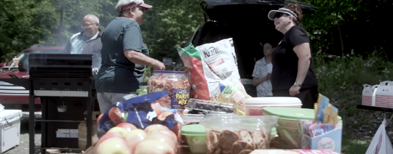
Episode 5: Rest

“Jesus, knowing that the Father had given all things into his hands and that he had come from God and was going to God, got up from supper, took off his outer robe, and tied a towel around himself. Then he poured water into a basin and began to wash the disciples’ feet and to wipe them with the towel that was tied around him. He came to Simon Peter, who said to him, ‘Lord, are you going to wash my feet?’ Jesus answered, ‘You do not know now what I am doing, but later you will understand.’ Peter said to him, ‘You will never wash my feet.’ Jesus answered, ‘Unless I wash you, you have no share with me.’ Simon Peter said to him, ‘Lord, not my feet only but also my hands and my head!’” - John 13:3-9

From the beginning of creation, God has established the sacred pattern of going and returning, labor and rest. Especially today, God invites us to dedicate time for restoration and wholeness - within our bodies, minds, and souls, and within our communities and institutions. By resting we place our trust in God, the primary actor who brings all things to their fullness.

1. In this episode, host Chris Sikkema visits with Bishop Audrey Scanlan as they hike a small portion of the Appalachian Trail. Bishop Scanlan recounts her experience of learning how to humbly receive hospitality along the trail during longer hikes. She shares how when we stop doing and start receiving, we can rest in God’s presence and love differently. Take a moment and consider—is there a place where you need to stop doing to receive instead? What steps do you need to take to lean into that practice of rest?

2. Host Sikkema comments that when we take time to stop and disconnect from our devices and to-do lists, we are more likely to see where God is present around us. He notes that “stopping is an act of faith.” What do you think of this statement? What does it bring up for you?

3. The spiritual practice of rest, in its various forms, holds a transformative power. For Bishop Scanlan, it manifests in long solo hikes, where she carries everything she needs for survival on her back, and nothing needs to be accomplished beyond putting one foot in front of the other. In this space, she can release the tyranny of the urgent, allowing her to notice the shape and symmetry of wildflowers and the presence of God all around. What rest practice could you adopt to experience this transformative power? If you don’t have one, can you imagine what one might be?

