

June 29, 2025 – Pentecost 3 (C)
Traveling the Way of Love: Pray

“Traveling the Way of Love” Season 2 offers video stories of the ways people across The Episcopal Church participate in the seven Way of Love practices. Produced by the Office of Communication in partnership with Evangelism colleagues, it includes study guides to help congregations or small groups engage the stories and strengthen one another’s discipleship. Each week, we’ll share information about an episode, along with study questions suitable for congregational, small group, or personal reflection. You can find each episode and its discussion guide at iam.ec/TWOL2.

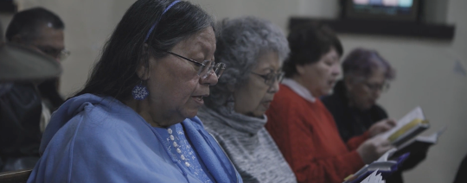
Episode 7: Pray

“He was praying in a certain place, and after he had finished, one of his disciples said to him, ‘Lord, teach us to pray, as John taught his disciples.’” - Luke 11:1

Jesus teaches us to come before God with humble hearts, boldly offering our thanksgivings and concerns to God, or simply listening for God’s voice in our lives and in the world. Whether in thought, word, or deed, individually or corporately, when we pray, we invite and dwell in God’s loving presence.

1. In this episode, host Chris Sikkema visits Holy Apostles, a congregation founded by Episcopalian Oneidas from New York, who settled in Wisconsin on Menominee and Ho-Chunk land in 1822. The first community initially first gathered beneath the trees to worship, a history reflected in Judy Cornelius’ description of prayer as “holy quiet.” Whether during high mass or under trees, prayer allows us to connect with something of God, transcendent beyond ourselves. Where do you experience “holy quiet”? How does God meet you there?

2. Consider the connection between your own prayer practices and the outward and visible signs that accompany them. For instance, like Jennifer Webster, do you find comfort in the scent of incense or the act of burning tobacco as you send your prayers to the divine? What are some of your unique prayer traditions?

3. The Oneida hymns are an important part of Holy Apostles' prayer life—both communally and individually. Are there songs or styles of music that you find helpful for your prayer life?

