

August 31, 2025 – Pentecost 12 (C)

New Episcopal Community Grants

New Episcopal Community grant applications are open for dioceses and mission developers who are envisioning, planning, or growing new worshipping communities and missional enterprises throughout the church.

The deadline to apply is Sept. 23, with grantees announced after the Executive Council meeting in late October.

The following types of grants are available:

Discernment Grants: Up to $5,000 to fund the discernment season of a New Episcopal Community. Funds may be used for sending the potential point leader to a gifts assessment retreat, coaching, training, demographic studies, micro-experiments, visits to similar types of ministries, and more.

August 31, 2025 – Pentecost 12 (C)

New Episcopal Community Grants

New Episcopal Community grant applications are open for dioceses and mission developers who are envisioning, planning, or growing new worshipping communities and missional enterprises throughout the church.

The deadline to apply is Sept. 23, with grantees announced after the Executive Council meeting in late October.

The following types of grants are available:

Discernment Grants: Up to $5,000 to fund the discernment season of a New Episcopal Community. Funds may be used for sending the potential point leader to a gifts assessment retreat, coaching, training, demographic studies, micro-experiments, visits to similar types of ministries, and more.

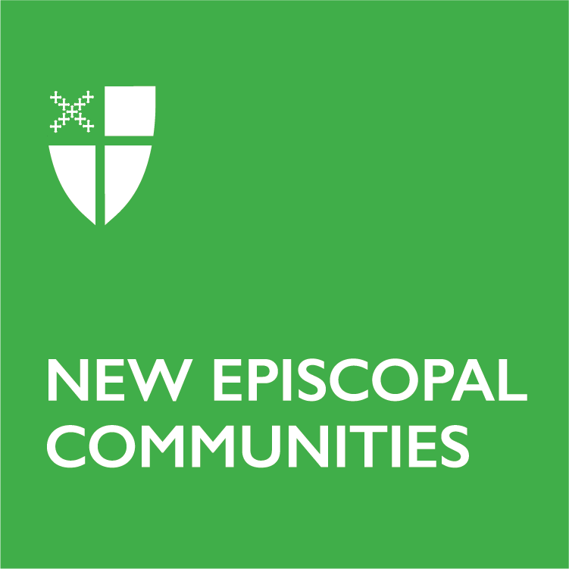
Seed Grants: Up to $30,000 to fund the initial stages of a New Episcopal Community’s launch. A seed grant recipient is typically in the first and/or second year of its life cycle. A seed grant application has a strong and realistic ministry plan, the beginnings of a core team, and support from its local diocese.

Growth Grants: Up to $30,000 to help fund approximately the second and third years of a New Episcopal Community.

Harvest Grants: Up to $40,000 to help fund the later stages of a New Episcopal Community’s launch (approximately years three to six).

Download a grant application guide and diocesan endorsement forms from the New Episcopal Community grants webpage here: https://iam.ec/necgrants.

Questions? Email the Rev. Jason Shank, interim church planting network strategist, at jshank@episcopalchurch.org.
Seed Grants: Up to $30,000 to fund the initial stages of a New Episcopal Community’s launch. A seed grant recipient is typically in the first and/or second year of its life cycle. A seed grant application has a strong and realistic ministry plan, the beginnings of a core team, and support from its local diocese.

Growth Grants: Up to $30,000 to help fund approximately the second and third years of a New Episcopal Community.

Harvest Grants: Up to $40,000 to help fund the later stages of a New Episcopal Community’s launch (approximately years three to six).

Download a grant application guide and diocesan endorsement forms from the New Episcopal Community grants webpage here: https://iam.ec/necgrants.

Questions? Email the Rev. Jason Shank, interim church planting network strategist, at jshank@episcopalchurch.org.

