

October 12, 2025 – Pentecost 18 (C)

The Nicene Creed: Week 5

To commemorate the 1700th anniversary of the Council of Nicaea, the Rt. Rev. Matthew Gunter, bishop of Wisconsin, has written a series of reflections on the Nicene Creed and its relevance for contemporary Episcopalians. Over the coming weeks, we’ll share his teachings, written mostly in a question-and-answer format.

Can’t we just worship God without getting hung up with the Creed?
Again, that presumes some knowledge (creed) about God and what it means to worship that God rightly. In fact, part of what guided the developing understanding expressed in the Nicene Creed was the language of the church’s worship.

In any event, within the Episcopal/Anglican tradition, eliminating or ignoring the Creed would not resolve things for those who don’t like it. The rest of the liturgy is saturated with the same story and the same imagery.

Further, the Creed and worship are integrally related:

October 12, 2025 – Pentecost 18 (C)

The Nicene Creed: Week 5

To commemorate the 1700th anniversary of the Council of Nicaea, the Rt. Rev. Matthew Gunter, bishop of Wisconsin, has written a series of reflections on the Nicene Creed and its relevance for contemporary Episcopalians. Over the coming weeks, we’ll share his teachings, written mostly in a question-and-answer format.

Can’t we just worship God without getting hung up with the Creed?
Again, that presumes some knowledge (creed) about God and what it means to worship that God rightly. In fact, part of what guided the developing understanding expressed in the Nicene Creed was the language of the church’s worship.

In any event, within the Episcopal/Anglican tradition, eliminating or ignoring the Creed would not resolve things for those who don’t like it. The rest of the liturgy is saturated with the same story and the same imagery.

Further, the Creed and worship are integrally related:

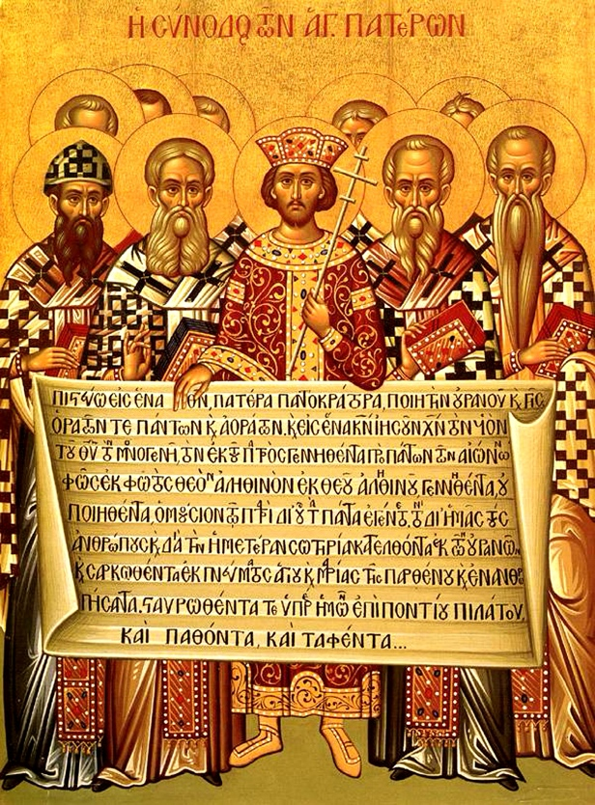
“Nicene Christianity has also understood orthodoxy in a richer and deeper sense: as right praise. To be orthodox is to strive to stand rightly with others before the mystery of the true God. To be orthodox is to join with a community of faith in adoration of God’s doxa (glory), which already casts light on the day when God will finally make everything right. Belief is never correct when it becomes nothing more than a political mechanism to ensure the unity of an institution. Belief is right only when it points us in the right direction: to glorification of the true God, who promises not to give us a secret wisdom, but to be graciously present to us, even and especially where our vision and knowledge are weak.”
— John Burgess, ‘Going Creedless; The Christian Century, June 1, 2004, pp. 24-28

“Nicene Christianity has also understood orthodoxy in a richer and deeper sense: as right praise. To be orthodox is to strive to stand rightly with others before the mystery of the true God. To be orthodox is to join with a community of faith in adoration of God’s doxa (glory), which already casts light on the day when God will finally make everything right. Belief is never correct when it becomes nothing more than a political mechanism to ensure the unity of an institution. Belief is right only when it points us in the right direction: to glorification of the true God, who promises not to give us a secret wisdom, but to be graciously present to us, even and especially where our vision and knowledge are weak.”
— John Burgess, ‘Going Creedless; The Christian Century, June 1, 2004, pp. 24-28

