

November 2, 2025 – All Saints’ Day, tr. (C)

The Nicene Creed: Week 8

To commemorate the 1700th anniversary of the Council of Nicaea, the Rt. Rev. Matthew Gunter, bishop of Wisconsin, has written a series of reflections on the Nicene Creed and its relevance for contemporary Episcopalians.

That doesn’t leave much room for doubt.

The issue is not about doubt or judging those who struggle with this or that aspect of the Creed. I have no problem with honest struggle with the Creed – historical or otherwise. I have my share, though as I've said elsewhere, there are implications of the Creed that I struggle with more than things like the virginal conception or bodily resurrection (the Sermon on the Mount for starters). Thankfully, it is not up to us to believe this or that bit of the Creed on our own. As we sometimes pray, “regard not our sins, but the faith of your Church” (1979 Book of Common Prayer, p. 395). Sometimes others believe for us. In spite of any personal doubts, the Creed is the standard of Church teaching. At the very least, it is what Christians aspire to believe and conform their lives to – however inadequately.

Doubts, whether about orthodoxy (right belief and worship) or orthopraxy (right behavior), arise when one way of

November 2, 2025 – All Saints’ Day, tr. (C)

The Nicene Creed: Week 8

To commemorate the 1700th anniversary of the Council of Nicaea, the Rt. Rev. Matthew Gunter, bishop of Wisconsin, has written a series of reflections on the Nicene Creed and its relevance for contemporary Episcopalians.

That doesn’t leave much room for doubt.

The issue is not about doubt or judging those who struggle with this or that aspect of the Creed. I have no problem with honest struggle with the Creed – historical or otherwise. I have my share, though as I've said elsewhere, there are implications of the Creed that I struggle with more than things like the virginal conception or bodily resurrection (the Sermon on the Mount for starters). Thankfully, it is not up to us to believe this or that bit of the Creed on our own. As we sometimes pray, “regard not our sins, but the faith of your Church” (1979 Book of Common Prayer, p. 395). Sometimes others believe for us. In spite of any personal doubts, the Creed is the standard of Church teaching. At the very least, it is what Christians aspire to believe and conform their lives to – however inadequately.

Doubts, whether about orthodoxy (right belief and worship) or orthopraxy (right behavior), arise when one way of

understanding how the world works and how God engages the world comes into conflict with another. But that cuts both ways. Questioning the virginal conception and the bodily resurrection, for example, is unsettling to one way of understanding things. Believing that we live in a world where such things have happened is unsettling to others.

We might also wonder why we hold doubt in such high esteem. Are we prepared to doubt everything?

Conclusion

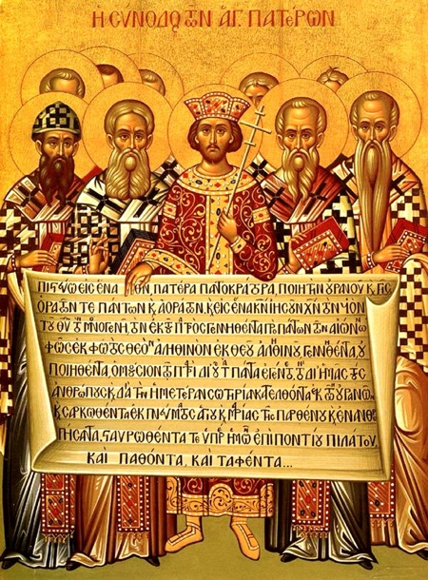
The Nicene Creed offers the foundation of a way of understanding the nature of reality and the God at the heart of it all. It presents a powerful, provocative, and evocative vision of God, humanity, and creation. The deepest truth about reality is personal and relational. The world in which we live is not an accident, but a creation delighted in by its Creator. In spite of human rebellion, sin, and brokenness; in spite of our failure to live lives of complete love and truth; that Creator, who is merciful, has entered into the mess we have made, bringing deliverance, forgiveness, healing, and transformation. It does not answer all questions and was not meant to. But those whose imaginations have been shaped by the Creed and have sought to inhabit the world it describes have found that it opens up thrilling vistas of life and hope. It is worth celebrating.

understanding how the world works and how God engages the world comes into conflict with another. But that cuts both ways. Questioning the virginal conception and the bodily resurrection, for example, is unsettling to one way of understanding things. Believing that we live in a world where such things have happened is unsettling to others.

We might also wonder why we hold doubt in such high esteem. Are we prepared to doubt everything?

Conclusion

The Nicene Creed offers the foundation of a way of understanding the nature of reality and the God at the heart of it all. It presents a powerful, provocative, and evocative vision of God, humanity, and creation. The deepest truth about reality is personal and relational. The world in which we live is not an accident, but a creation delighted in by its Creator. In spite of human rebellion, sin, and brokenness; in spite of our failure to live lives of complete love and truth; that Creator, who is merciful, has entered into the mess we have made, bringing deliverance, forgiveness, healing, and transformation. It does not answer all questions and was not meant to. But those whose imaginations have been shaped by the Creed and have sought to inhabit the world it describes have found that it opens up thrilling vistas of life and hope. It is worth celebrating.

