Christmas Day (A)

[RCL] Isaiah 9:2-7; Psalm 96; Titus 2:11-14; John 1:1-14

Emmanuel

Merry Christmas!

Emmanuel. God is with us. We wake to a new day after participating in the joyful arrival of the One we have been anticipating throughout the season of Advent. We have been waiting for the hope, peace, love and joy that comes through the birth of Jesus.

Last night our imagination was animated by images of baby Jesus in the manger, shepherds and angels. Today, baby Jesus has been born, and we are invited to reflect on this joyous event. What does it mean for us to witness and participate in a second creation, as God comes into the world in flesh? This Christmas morning invites us to celebrate and reflect not only on the text of the narrative but also to grasp the context of the Word’s participation in the world.

“In the beginning was the Word, and the Word was with God, and the Word was God. He was in the beginning with God. All things came into being through him, and without him not one thing came into being. What has come into being in him was life, and the life was the light of all people. The light shines in the darkness, and the darkness did not overcome it.”

In these words from the Gospel of John, we find the hope that comes on Christmas Day: The light that shines in the darkness. A light that is not overcome by the darkness.

We learn through the witness of John that the light that comes in the world is the true light that enlightens everyone. This light, Emmanuel, is the glory that we celebrate today. On this Christmas Day, we join John in witnessing this prophetic and hopeful event. In witnessing the glory of the Word becoming incarnate, we find the grace and truth of Jesus. It’s a grace and truth that comes to be with us in the fullness of the world we live in and experience. The meaning of this moment and development is lost if our focus is on the shiny objects that can sometime distract from the Light that has come into the world. For the Light that has come into the darkness illumines the world we are living in. It communicates to humanity as we are experiencing our lives.

What does the Word say to those whose backs are against the wall? What does this moment mean for the global majority who are vulnerable and too often living on a razor’s edge? In this time when many suffer from weeks without work, or work without sufficient pay. How will people who are living on the charity of food banks—whose pantries are limited—experience this moment? What about the suffering of those living in Ukraine? What about the brokenness and ongoing suffering in Gaza? What is the source of the grace and truth for the Palestinian Christians who live in the place where Jesus was born? What is the message we shall bring to our neighbors, people without documentation, who are living in the shadows for fear of being deported. How do we celebrate today while remembering that too many detained neighbors are being denied the sacraments from a priest? Christmas is not a moment for us to pause and turn away from recognizing the life being lived by humanity. Jesus joins us as we are and enters the world as it is.

The light shines in the darkness, and the darkness did not overcome it.

The Reverend Dr. Wil Gafney reminds us that the “light and the darkness co-exist. There is always a shadow. The world is filled with shadow.” This is important for us to remember as we celebrate the Light. We must remember the context in which the Light is shining. The Light shines in a world that includes loss, suffering and disappointment. In fact, this is not only the world in which we live now, but also the world as it has always been. This is the world that Jesus was born into. Remember there was no room in the inn for Mary and Joseph.

We are told by the prophet Isaiah that “The people who walked in darkness have seen a great light; those who lived in a land of deep darkness—on them light has shined.”

These lines call to mind “The Nativity,” a painting by Albrecht Altdorfer. This painting from the year 1513 shows baby Jesus in manger in the middle of a crumbling building. The light shines amid a chaotic background. It is a beautiful painting whose vivid colors communicate that God comes into the world in the messiness of the flesh that is the world. Christmas is not about escaping the world. Rather, Christmas is about who and what comes into the world.

The Word made flesh comes among us and, in doing so, brings hope, joy, truth, and grace. Jesus comes into the world as the light of the world. Katherine Ruch speaks cogently about this foundational aspect of Emmanuel when she writes, “Christ comes in media res, in the middle of things, right where we are. The circumstances around Jesus’ birth were chaotic—a Roman occupation, Mary away from family and all that is familiar, a sense of transience and uncertainty, finding accommodations with relatives she did not know at a vulnerable time. And right there, among the animals and strangers, in troubled times, the Light of the World, the Savior of the World, labors into the world.”

Reflecting on these words afford us an opportunity to find the joy in this hope-filled moment of Christmas, without the materialistic performance that can too easily dominate the season. Jesus comes into the world to be with all of us. He is here with and for us as we reflect on the first Christmas without a loved one who has passed to the other side, or in the void caused by a recent divorce. Jesus is here for those who are lonely, hungry, experiencing housing insecurity or living in the darkness of possible deportation. God is with us. This, we celebrate.

Ruch’s words echo the Lutheran theologian and pastor Dietrich Bonhoeffer’s reflection on Christmas during his imprisonment. In a set of letters written from prison and later entitled “God Is in the Manger: Reflections on Advent and Christmas,” Bonhoeffer asks us not to think of Christmas as a “holiday from living.” He wrote, “The world has always been full of thousands of demands, plans, summonses, exhortations with which people seek to overcome the distress of the world, which sooner or later, sadly enough, becomes evident to everyone.” Consider his cogent and compelling Christmas message, a message that recognizes that the Word became flesh in a concrete world, a message that celebrates that Jesus was born into the world as it is, to be with humanity as we live.

Listen closely to Bonhoeffer: “‘Behold, I bring you’— who are in darkness and in the shadow of death— ‘tidings of great joy! For to you today is born the Savior, Jesus the Lord.’ In the feast of Christmas we are directed in a new way to the very thing that stands in the center of the Bible, to the simple reality of the gracious and merciful action which comes from God …We are no longer concerned with quaint and happy pictures and fancies. Rather, from the reality, which is so plain and from our distress, we thirst for the realty of the great divine help. Our question is whether God really has sent the One who has the right and authority for complete, all-embracing, final redemption.”

Has he? Has he?! “And the Christmas message is the complete, glorious ‘Yes!’”

Katherine Ruchs invites us to embrace that “Whether your Christmas will be celebrated this year in the ruins of loss and disappointment or in a glorious festive cozy home, all of us have reasons to be surprised by joy. Christ came for such a time as this, and he is quite comfortable among the ruins.”

In remembering this, we are all brought closer to baby Jesus in the stable. Amen.

The Reverend Charles Wynder, Jr. serves as the Dean of Chapel & Spiritual Life at St. Paul’s School in Concord, New Hampshire. He previously served as Priest-in-Charge at Holy Comforter in the Diocese of Washington. He also served on the Presiding Bishop’s Staff of The Episcopal Church, where he worked to enhance the denomination’s capacity for advocacy, witness, and engagement to advance social and racial justice.

Reverend Wynder earned his B.A. in political science at Syracuse University, where he at-tended on a four-year Army ROTC scholarship. A Truman Scholar, he earned a Juris Doctor degree at the University of Michigan Law School. He then served six years as an attorney in the U.S. Army Judge Advocate General’s Corps. Rev. Wynder continued his public service as a Deputy Commonwealth’s Attorney, executive director of a federally funded legal services program, and vice president of programs for the National Legal Aid & Defender Association. He served several years as an adjunct professor at Hampton University teaching Constitutional Law: Civil Rights & Civil Liberties. Reverend Wynder earned his Master of Divinity Degree from the Episcopal Divinity School.

He lives on campus with his wife, Bethany Dickerson Wynder, and their son.

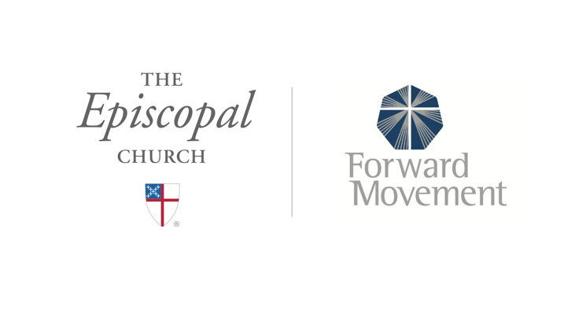
Sermons that Work and Bible Studies that Work are a joint offering of Forward Movement and The Office of Communication at The Episcopal Church.

https://www.episcopalchurch.org/bible-study/
https://www.episcopalchurch.org/sermons-that-work

