The First Sunday After Epiphany (A)
The Baptism of Our Lord

[RCL] Isaiah 42:1-9; Psalm 29; Acts 10:34-43; Matthew 3:13-17

Adopted as God’s Children

If you were to read the section of the Gospel of Mark that comes before today’s gospel reading, you might be really surprised by what is happening here. John the Baptist has just told a crowd of people, “I baptize you with water for repentance, but the one who is coming after me is more powerful than I, and I am not worthy to carry his sandals. He will baptize you with the Holy Spirit and fire.” And, suddenly, it seems, the very person that John has been speaking about arrives, asking John to baptize him! It’s no wonder that John is shocked and initially resists baptizing Jesus.

At the conclusion of this reading, God’s spirit descends on Jesus, and we hear the voice of God: “This is my Son, the Beloved, with whom I am well pleased.” We can assume, then, that God approves of Jesus’s baptism.

But all of this still leaves us with a big question: Why did Jesus, the Son of God, need to be baptized? What is going on here?

There are several references to being baptized into Christ’s death in the service of Holy Baptism. Was Jesus baptized into his own death, which hadn’t happened yet, when he was baptized? In a way, it seems he might have been. When Jesus was baptized, we are told, the heavens were opened to him, and the Father names Jesus as his son.

Later in this Gospel, a similar mysterious event will occur on a mountain with Jesus and his disciples Peter, John, and James. Jesus was transfigured, his clothes appeared bright as light, and his face shone like the sun. And the disciples heard a voice say, “This is my Son, the Beloved; with him I am well pleased; listen to him!” However, in this earlier passage of Jesus’ baptism, the heavens didn’t open.

But when Jesus dies, this Gospel tells us, “At that moment the curtain of the temple was torn in two, from top to bottom. The earth shook, and the rocks were split.” The curtain the Gospel writer spoke about was a heavy cloth barrier that separated the innermost part of the temple in Jerusalem, where God’s presence was believed to dwell, from the rest of the temple (and world).

And, after seeing the earthquake that happened after Jesus died, the centurion who had participated in Jesus’s crucifixion declares, “Truly this man was God’s Son!”

In these details, we see a noticeable parallel between Jesus’s baptism and his death. Both involve the barrier between heaven and earth being torn open. Both involve Jesus being named as God’s son. The text wants to make clear that these events are linked. It could be said that they serve as bookends for Jesus’s earthly ministry, one marking its beginning, and one marking its end. It could also be said that Jesus’s baptism sets in motion the events that will lead to his death, Resurrection, and Ascension. (In fact, there will be another earthquake in the following chapter, when an angel arrives to roll back the stone cover of Jesus’s tomb after Jesus’s Resurrection.)

So, to return to our earlier question, perhaps Jesus needed to be baptized as a sign—showing that his earthly ministry, which would culminate in the events of Good Friday and Easter, had begun.

Maybe we can also look to the text of today’s reading for some clues about why Jesus needed to be baptized. If you were to read this passage in the original Greek in which it was written, you would notice something very interesting about the grammar its writer used. Throughout this gospel, the writer often uses the present tense to describe something that happened in the past. This is one such passage. So, the text doesn’t actually say, “Then Jesus came from Galilee.” It says, “Then Jesus comes from Galilee.” It doesn’t say, “Then John consented”; it says, “Then John consents.” Scholars have discussed why these passages might have been written this way. Many people think that it is so we, the readers, feel that the action is happening right in front of us, and that we are a part of it.

Even when we read the English translation of this passage, we get a sense of urgency and action. Jesus tells John that it is proper to baptize him, and to “let it be so now.” And then, just as Jesus gets out of the water, suddenly the heavens open, and God’s spirit descends. The writer is telling us that something very special is happening with time.

What the writer of the story does not tell us is what happened during Jesus’s baptism. The text does not describe what John and Jesus said or did. John consents, and then, we are told simply that Jesus has been baptized. We are left to imagine for ourselves whatever liturgy John used. Given the importance of Jesus’s baptism in the passage, this might seem like a confusing omission.

Maybe it’s not surprising, though, considering how much else the gospels don’t tell us about Jesus. The writer of the gospel of Matthew tells us the story of Jesus’s birth, the Magi coming to adore him, Jesus’s family’s flight to Egypt to escape the slaughter of infants in Bethlehem by King Herod, and the return of Jesus’s family to their home in Nazareth. But we aren’t told much else about Jesus’s life before his baptism, even though he was well into his adulthood at that time.

It seems, then, that the author of this text wanted us to be able to imagine ourselves as part of Jesus’s story. We can imagine ourselves standing outside of time, participating in the action. When we read this Gospel and the narrative of Jesus’s baptism, we can think about the things we have experienced in life and fill in the gaps with things that are familiar to us.

And this makes sense, because Jesus’s baptism is part of his human life. At this point in the year, both in our culture and liturgy, we have left Christmas behind. The decorations in stores came down weeks ago, and, at church, we are in the season after Epiphany. Jesus isn’t a baby anymore. But, the power of Jesus’s human birth, the world-shattering effect of his Incarnation, remains still with us. Jesus took on our humanity in his birth and continued to share in what it meant to be human throughout his lif—and even in his death.

The question of why Jesus needed to be baptized also raises the question, why do we get baptized? In our Book of Common Prayer, Holy Baptism is defined as “the sacrament by which God adopts us as his children, and makes us members of Christ’s Body, the Church, and inheritors of the kingdom of God.” It also tells us that the inward and spiritual grace we receive in Baptism is “union with Christ in his death and resurrection, birth into God’s family the Church, forgiveness of sins, and new life in the Holy Spirit.”

Just as Jesus’s baptism signified the beginning of his participation in a new mission in the world, so too does ours. When we are baptized, we are told that we now share in Christ’s priesthood—even if we are a helpless infant. At our baptism, we are told to “confess the faith of Christ crucified” and “proclaim his resurrection,” even before we are able to speak!

If we are anxious about the daunting prospect of sharing in Christ’s priesthood, this Gospel can remind us that baptism is a sacrament of joyful connection. In the Incarnation, Jesus shares in our humanity. And in Baptism, we share in Christ’s Body. We are connected not only to God, but to one another, as members of the household of God.

And not only are we connected through Baptism, even more, we are adopted as God’s children. And we know —because this Gospel tells us—that God is a loving Father who takes pride in his Son. How lucky we are that we get to share in that love!

The Rev’d Erin Morey has served as Assistant Rector at St. Paul's Episcopal Church in Mt. Lebanon, Pennsylvania, since July 2022. She is currently enrolled in a D.Min. program at Pittsburgh Theological Seminary. In addition to sharing in the pastoral and sacramental leadership of St. Paul's, she supports the ministry of the Pastoral Care, Social Justice and Anti-Racism, and Outreach Commissions. Erin graduated from the University of Pittsburgh School of Law in 2002. She previously served as an Assistant Public Defender in Allegheny County, Pennsylvania, and an Advocate at Women’s Center & Shelter of Greater Pittsburgh. In addition to her full-time work in ordained ministry, Erin serves as a volunteer attorney with Neighborhood Legal Services.

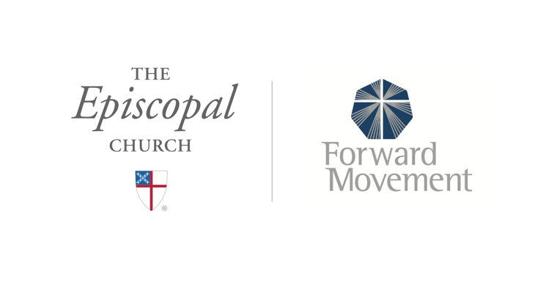
Sermons that Work and Bible Studies that Work are a joint offering of Forward Movement and The Office of Communication at The Episcopal Church.

https://www.episcopalchurch.org/bible-study/
https://www.episcopalchurch.org/sermons-that-work

