Ash Wednesday

[RCL] Joel 2:1-2,12-17 or Isaiah 58:1-12; Psalm 103 or 103:8-14; 2 Corinthians 5:20b-6:10;
Matthew 6:1-6,16-21

Ash/Dust

It might be that we have Ash Wednesday all wrong.

Or, at the very least, we have it a bit muddled and mixed up. In song and Scripture and tone, this day is an odd combination of impulses. It is penitence and hopefulness striving for some sort of cohesion but never quite finding it. We aren’t sure exactly how to feel today.

And no wonder, because to prostrate oneself and to reach for the stars are postures quite at odds with each other. This arguably makes Ash Wednesday the most honest and human of our holy observances—for who among us knows whether to wail or to shout most days—but that means it’s also the most ambiguous.

We might ask, why have we paused, on this day, amidst all our usual strivings? Have we come here in order to regret our flesh or to bless it? The liturgy and the prayers don’t quite help us make up our minds. And nowhere is this more evident than in the central ritual action of this day: the tracing of ash upon our brows with that familiar phrase, “remember that you are dust, and to dust you shall return.”

If you’ve been doing this for many years, you might take this moment and these words in stride. But there is, even here, a tension worth noting. Because ashes and dust are not the same thing at all; they come from different places and point to different truths. They are, in fact, two symbols attempting to operate as one.

First, there is ash. Ash is the stuff, quite literally, of endings. It tells us of things consumed, things completed, things that have already filled their purpose. The substance itself is, of course, the product of materiality and fire. However it has come into our possession on this day—through the burning of last year’s palm fronds or by some other means—it whispers of transience and change. Ash suggests that the fire—of time, or of circumstance, or of Spirit—comes for us all, eventually, laying bare our hillsides, and there is a stark, February sort of beauty in accepting this. Ash is our acquiescence. We receive it, we surrender to your flames, O God. We are scorched by your unimaginable power and freedom. Bring us to our knees, bathed in ashes.

But then, there is dust. Remember, remember, we say, that long before the fires came, first you were dust. First, you were particle. You were participant. You were part of the whole, lifted up from the living potentiality of the earth. Remember. Remember how God breathed upon the rain-soaked soil and shaped it into your face. Remember how God placed divine light behind your eyes, so that you might truly begin to see as no other creature can. You are dust, and, unlike ash, dust is not an ending, it is an always-beginning. It is an eternal circularity that only knows itself as life. Remember, remember that you are that. And on a February night, O God, help us to remember. Help us reach up with our dusty fingers toward the dusty stars, and recall that everything is in us, and we are in everything.

So yes, we have gotten Ash Wednesday all wrong, if only because we haven’t reflected fully enough on how, if we would know Truth, then both of these things must be true at once: the ash and the dust of ourselves; the transience and the transcendence of life; the fury and the fecundity of God. We tend to land in one camp or another as our formation and our circumstances dictate, but this is a mistake, as if we could choose between only tears or only smiles in this life.

No, if we are to be faithful on this day, we must hold them both together, the ash and the dust, not in a muddle but as a mission: a mission to bless what leaves and to bless what remains. A mission to love what dies and to love what begins again. A mission, of course, that is embodied and enabled in us through Jesus, who is himself a collision of opposites in so many ways, this man of sorrows and stars. He is not the God of either/or, much as we might sometimes like him to be.

Which makes it fitting, perhaps, that the appointed Gospel for today is also a source of Jesus-shaped paradox. We hear him condemn ostentatious pieties even as we gather publicly for this liturgy to receive the mark of ash on our brows. Oh, life, we are trapped, again! What are we to do, Lord? Wipe the ashes off in the car so as not to make a spectacle? But then we hide our light. Leave them on and do an extra kind deed for our neighbors? Pride goeth before a fall. Ashes or dust? If I am too quiet about my faith, the world starves for good news. If I am too brazen, I get tripped up by my ego.

Ash Wednesday gives no solution to any of this; it simply invites us to notice the ongoing challenge. How can we find the right balance between humility and boldness in this life? How can we at once fall to our knees and reach for the stars? How can we contend with both the ash and the dust of ourselves and make it all work together?

God will not leave us to wonder forever, thankfully. There will be a definitive response to this challenge, and it will come directly from Jesus himself. Somehow, be assured, all the pain and the promise, all the dead ends and possibilities of life will ultimately cohere together. But the solution has to do with last suppers and crosses and empty tombs, and today is not that day. No, today is simply the day to take note of the tension, so that we might begin to live creatively and lovingly within it.

Which means that we should go into Ash Wednesday and the season it initiates with eyes and hearts wide open. We must begin the process of accepting, again or for the first time, that, yes, there is both ash and dust, and that they are not the same thing, and that they are both part of this story. For Jesus brings both death and life to us; both endings and eternities. We will be consumed in his holy fire and we will be renewed in his holy flesh. And we have all forty days of Lent to ponder how this will be wrought in us.

His Gospel admonition to us tonight—and all the other odd tensions in this liturgy—are just a starting point. They simply invite us to see, if we dare, that the stakes of all our pondering and searching—muddled though they might be—are not about winning a pious parlor game, but about the discovery of existential truth. The ambiguity and the strangeness of this day is the point.

It is Jesus meeting us where we are, we who are unsure of whether to crumple into a heap or learn to fly. You will do both, he tells us. You will wear the ashes on your brow and you will bear the dust in your flesh, and you will realize that salvation begins with the refusal to choose between earth and heaven. It will bring us to our knees, this realization. It will bring the stars close enough to touch.

And even if we have gotten Ash Wednesday all wrong, for all this time, it will be ok. Because we have been formed and sustained—and we will soon be saved—by the One who makes all things right.

The Rev. Phil Hooper serves as rector of St. Anne Episcopal Church, West Chester, in the Diocese of Southern Ohio. He is a regular contributor to several Episcopal projects including Sermons that Work and the Prophetic Voices preaching podcast. You can find his sermons and other writings at byanotherroad.com.

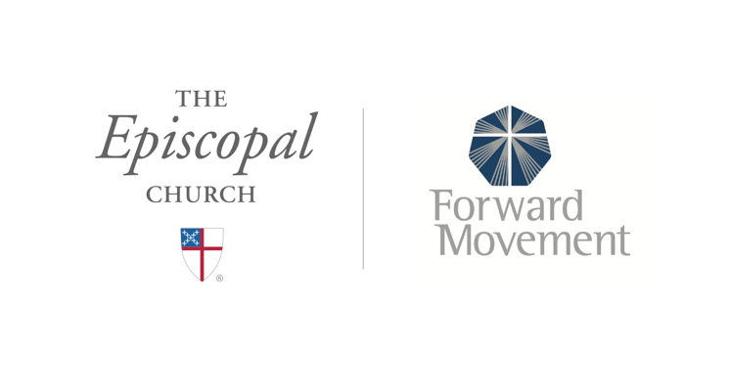
Sermons that Work and Bible Studies that Work are a joint offering of Forward Movement and The Office of Communication at The Episcopal Church.

https://www.episcopalchurch.org/bible-study/
https://www.episcopalchurch.org/sermons-that-work

