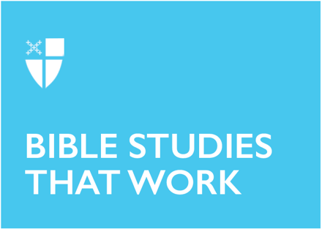

Epiphany 2 (A)
January 18, 2026

RCL: Isaiah 49:1-7; Psalm 40:1-12; 1 Corinthians 1:1-9; John 1:29-42

Opening Prayer |

Almighty God, whose Son our Savior Jesus Christ is the light of the world: Grant that your people, illumined by your Word and Sacraments, may shine with the radiance of Christ’s glory, that he may be known, worshipped, and obeyed to the ends of the earth; through Jesus Christ our Lord, who with you and
the Holy Spirit lives and reigns, one God, now and for ever. Amen.

Context |

The Book of Acts details Paul’s missionary work in the bustling and diverse port city of Corinth, located about forty miles west of Athens. It was here that God spoke to Paul in a vision, imploring him to “speak and do not be silent,” explaining that there were many in the city who were God’s people. Paul remained in the city for a year and six months (Acts 18:9-10).

This direct experience and familiarity framed Paul’s First Letter to the Corinthians with a deep, personal understanding and appreciation for the Corinthians’ nuanced cultural and religious paradigm. Paul was not simply dishing out advice and admonishment to a group with whom he had no connection. He was offering careful encouragement and constructive critique based on known information regarding the issues that were plaguing the Corinthian church at the time. These issues ranged from simple arguments to disagreements about major moral and theological viewpoints. Over the course of the letter, Paul writes about spiritual gifts, sexual morality, resurrection, observance of the Lord’s Supper, and numerous other pertinent matters in the life of the church. In keeping with literary conventions, Paul begins his letter to the Christians in Corinth by introducing himself and identifying the recipient of his letter. However, even the pleasantries contained in this letter serve as a vehicle for a uniquely personalized exhortation.

Theological Reflection |

Paul’s greeting to the church in Corinth is undergirded by the recurring language of calling, a theme that returns throughout the entirety of Paul’s letter. Paul’s self-identification as “called to be an apostle of Christ Jesus by the will of God” is a statement of great theological and personal weight (v.1). However, Paul is not using this descriptor as a means of self-aggrandizement but rather as a means of distancing himself from his personal achievements or accolades; he links himself instead to the grace God has bestowed upon him. Paul is simply carrying out the work God has called him to do.

Paul then is able to redirect this language of calling towards the Christians in Corinth themselves. He identifies the Corinthians immediately as those “called to be saints” (v.2), a descriptor that seemingly contradicts the messiness and conflictual behavior described throughout the letter. However, Paul’s language serves as an intentional reminder of their unique and purposeful calling to life in Christ before addressing any specifics of their current predicaments. Their identity as members of Christ’s Body is a calling larger than any of the shortcomings or disagreements that might currently occupy their minds.

Paul’s central emphasis on “calling” acts as an equalizer both between himself and the Corinthians and within their own power structures. Before he offers any corrective feedback to the problems they are facing, he reminds them that they all have access to the same spiritual gifts as a byproduct of their calling in Christ. Paul’s reminder that they are “not lacking in any spiritual gift” (v.7) is not a way to give them a pass on their behaviors, but rather to assure them of their full status and identity in God. A familiar analogue arises in our daily life: when a child misbehaves, an adult might strive to get their attention by addressing them with their full name, rather than a nickname. Being reminded of their fulsome identity often awakens something deep within the child that catches their attention and may redirect their behavior. Similarly, when children of God are reminded of the full extent of their identity, it helps remind them of their responsibility and calling in Christ. Paul is not trying to overload them with empty compliments or to give them a false sense of superiority. He is instead reminding them of the grace and generosity God has already bestowed upon them as he implores them to treat one another as fellow children of God, all of whom are called to special purposes.

Paul’s reminders to the Corinthians—reminders of God’s faithfulness and generosity—issue a call to all Christians to cast aside the need for power and recognition still often found in church communities of all sizes and contexts. The challenges and complexities the Corinthians faced in their journey as a community were no match for the spiritual gifts and freedom God had already given them. Similarly, Paul’s letter serves as a reminder to us: that church communities today are uniquely called to serve as Christs’ vessels and to utilize our spiritual gifts in the context and locale to which we are entrusted.

Divisions within the wider culture—and pressures within the community—are not a hindrance to the work of the church, but rather an opportunity to discern further the spiritual gifts that God calls each community to use in their given time and place. It is through these callings that God’s people can shine—as we hear in the Collect of the Day, with the “radiance of Christs’ glory.” As each community and every individual grows into the calling God has for them, God promises that he will “strengthen you to the end” (v.8).

Reflection Questions |

- How have you experienced calling in your own walk with Christ? How does this Epistle reading from 1 Corinthians shed light on this experience?
- Has a calling from God ever created challenges for you? How did God help you to overcome these challenges?
- What spiritual gifts do you recognize in yourself?
- What spiritual gifts do you see at work in your community? What new areas may God be calling you into as a community?

Faith in Practice |

Paul assures the Christians in Corinth that despite their challenges, they are “not lacking in any spiritual gift.” Take a moment this week to contemplate the spiritual gifts that God has given you. Write them down—at least five— then add to your list as more occur to you. Prayerfully reflect on the list and circle the gift that most speaks to you at this given moment. What is something concrete you can do this week (outside of your regular routine) to share this particular gift with your local community?

Ethan White is a Candidate for Holy Orders in the Episcopal Diocese of Georgia and is working towards a Master of Divinity at Virginia Theological Seminary in Alexandria, VA. Previously he worked in youth and family ministry at St. Stephen's Episcopal Church in Richmond, VA and earned a B.A. in Music and History from Sewanee: The University of the South. Ethan is a native of Savannah, GA and enjoys playing and writing music in his free time as a vehicle for building community.

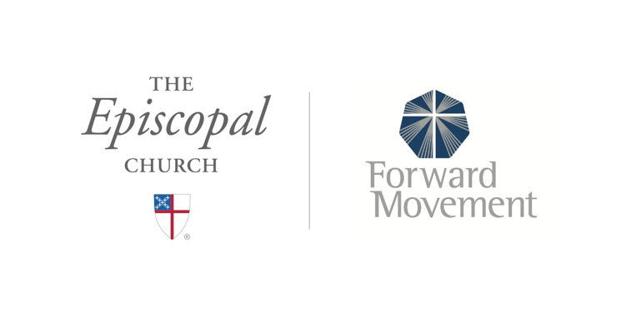
Sermons that Work and Bible Studies that Work are a joint offering of Forward Movement and The Office of Communication at The Episcopal Church.

https://www.episcopalchurch.org/bible-study/
https://www.episcopalchurch.org/sermons-that-work

