The Second Sunday After Epiphany (A)

[RCL] Isaiah 49:1-7; Psalm 40:1-12; 1 Corinthians 1:1-9; John 1:29-42

Come and See

How long will we sing this song?
I will sing, sing a new song. I will sing, sing a new song.
— U2, 40

Today’s Gospel gives us Jesus’ first spoken words in the Gospel of John. And they are perplexing words, words that beg an answer: “What are you looking for?”

What are you looking for? Another, better translation: “What are you seeking?” Both an invitation and an examination. Jesus’ first words in the Gospel of John are a question—an important question—“what are you seeking?” It’s an invitation to actively examine our own hearts and to see, to bear witness to, what we find there.

The two disciples he asks don’t actually answer Jesus’ question, do they? In fine rabbinic tradition, they respond with still another question. “Where are you staying?” Which is actually another poor translation, because it reads a little as if these two disciples of John are asking where Jesus’ hotel room is. What they’re actually asking is a bit more significant; it’s the same verb that Jesus himself will use later, when he says “I abide in you, as you abide in me.” The disciples are asking, “Where do you abide? Where do you make your home? Where do you rest? Where may we come and be present with you?” And Jesus does not give them the easy answer. He doesn’t say, “Nazareth” or “next door to Bob.” He merely says, “Come and see.”

It is an invitation, this “Come and see.” It is also a choice, and a challenge. If we are to come and see something, we have to be open to the possibility that it is going to be something new. It is something which we’re going to have to be willing to see, to open our eyes to, and be willing to look at, even if what we see is something we have never seen before. If we’re going to see with new eyes, then we have to be willing to admit to the possibility that we ourselves don’t have all the answers already—that there is still more for God to show us. Even if it turns out to be something that surprises us or shocks us, that breaks into our lives and reorders it.

This is the Epiphany, after all, the time when we celebrate the light breaking into our lives, when we celebrate the unfolding of the Incarnation, when God does a new thing and breaks into history here on earth. It’s that time when we bring our gifts, and ourselves and we offer them to God—even when we don’t quite understand the mystery of how this has all happened, or why. We only know that we are not the people we used to be.

In order to find what they seek, these two followers of John will turn and follow Jesus; they will spend time with him, abide with him for a while, and then one of them, Andrew, will then go and tell others. He goes to his brother, Simon Peter, and says to him, “We have found the Messiah!” Andrew accepts the invitation to “Come and see” and then goes out to issue the same invitation to his brother and others. “Come and see” this new thing that God is doing. Come and see the Messiah, the one who baptizes not with water, but with the Holy Spirit. Come and see.

And then we have the beginning verses of Corinthians, with the apostle Paul writing a letter to the young congregation in Corinth. It’s hard to remember, sometimes, that when we’re reading the epistles, what we’re doing is reading someone else’s mail—and only getting one side of the conversation, at that. From what Paul has to tell us, we understand that the people at the church in Corinth are in the middle of a serious argument over several things, one of which is whose spiritual gift is more important than the others.

“In every way you have been enriched in him, in speech and knowledge of every kind...You are not lacking in any spiritual gift.” Paul is speaking to the plural “you,” remember. As we would say in the South: “All ya’ll have been enriched in him.” Together, collectively, the Corinthians have all the gifts they need, and one person is not more important than another. As a community, they need one another if they are to be able to see what God has to reveal to them.

This is something hard for us to remember these days, when what divides us may seem much more powerful than it ought to be. “Whose gift is more valuable?” we and the people of Corinth ask one another. Paul’s answer is unmistakeable: In every way, we are a gift to one another. Each one of us has gifts with which God has endowed us, gifts that the rest of us need. And when we are not in community with our neighbors, with one another, then there are gifts that we miss.

When you came to church today, bringing those gifts with you, what did you hope to see? You got up, you got dressed, you traveled some distance, and you came here. Why? What were you seeking?

What do we come to our faith community hoping to see? What are we looking for? We come here because we have found goodness here, we’ve found something life-sustaining—we’ve found something very much like hope. Or else we wouldn’t return.

Have you found hope here—in the Eucharist, in the prayers, in the presence of the Spirit, in friendship, in one another, in service? How have you borne witness to that hope? Have you ever, in your own way, invited someone else to “Come and see” what there is to see for themselves? Have you shared whatever it is you have found—hope or friendship or forgiveness or service?

If we sing our own song, the one that God has placed in our hearts, if we bear witness to what we have seen...if we speak of God’s love and God’s faithfulness, then we too are drawn closer to God and to one another in the telling of it. The Psalmist says, “I waited and waited for the Lord.” There is an element of hope, of expectation. “I hoped and hoped for the Lord.” The Psalmist is one who has found God or been found by God. “You have done great things, God. You have lifted me out of the lonely and desolate pit. You have set me on a high cliff and made my footing sure.” It is a witness and a testimony. It is telling the story of what God has done so that others might hear it and find hope themselves.

Wil Willimon sums up our seeking and our waiting and our hope, and he prays it to God this way: “We have come here this day searching for you, because we believe that you are searching for us. In countless ways you have reached out to us. We confess that sometimes we have searched for you in all the wrong places. We admit that sometimes we have thought that we found you when we only found cheap substitutes for your love. (Today), find us new so that we might find you, and in finding (you), love you, and in loving you, serve you in all that we do.”

What is it that Jesus asks of you today? If he were to turn to you right this moment, just as he did to the disciples, and ask, “What do you seek?”—what would be your answer?

When we have found the Jesus we seek—or we have been found by him—then it is our turn to use the gifts God has given us to tell the story of God’s hope-filled and redeeming grace. We are to invite others, in turn, to “Come and see.”

In this new year, we will sing God’s song together, that same never-ending song of hope and grace and peace, so that all God’s people might hear it.

Gracious and loving God, help us to see Jesus Christ in this place, to hear his words of invitation and love. Teach us to go forth and sing your song of hope and grace each and every day, in the name of Jesus Christ. Your song is new every morning, O Lord. Now IS the time to sing it for all to hear. Amen.

The Rev. Amy Hodges Morehous is an Episcopal priest, spiritual director, mental health advocate, fiber artist, and native east Tennessean.

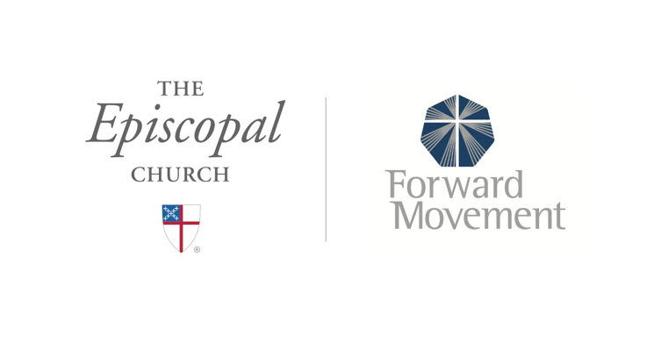
Sermons that Work and Bible Studies that Work are a joint offering of Forward Movement and The Office of Communication at The Episcopal Church.

https://www.episcopalchurch.org/bible-study/
https://www.episcopalchurch.org/sermons-that-work

