The Third Sunday After Epiphany (A)

[RCL] Isaiah 9:1-4; Psalm 27:1, 5-13; 1 Corinthians 4:12-23; Matthew 4:12-23

A Poor Church for the Poor

The calling of the first disciples in the Gospel of Matthew can seem unrealistic or even fantastical. Jesus walks along the Sea of Galilee and calls two sets of brothers, Peter and Andrew, James and John, as they go about their daily routine as fishermen. In both instances, the response to Jesus’ call is immediate. All four men “immediately” drop what they are doing, leave their previous lives behind, and follow after Jesus. James and John make such a quick and hasty departure that they leave behind their no doubt dumbstruck father Zebedee without even saying goodbye. The whole scene can feel intimidating to most who have come to their faith in Christ in a far more gradual and halting way.

It does not take a reader long, however, to come to understand that the immediacy with which these four fishermen answer the call does not mean that life as a disciple of Jesus is any easier for them. James and John—sometimes dubbed “the sons of thunder”—are frequently quarrelsome and routinely vie for prominence amongst the disciples. Jesus, tired of their ambitions, chastises them for their request to sit at his side in glory. And Peter denies Jesus three times when he needs him the most. The gospels repeatedly testify to the fact that, however readily the disciples initially respond to the call of Jesus, they are just as flawed, fallible, and full of fear as anyone else. They struggle to follow Jesus and struggle to live in community with one another. There are frequent moments of division and discord.

This dynamic is also lifted up in St. Paul’s first letter to the church in Corinth, as he writes to an early Christian community rife with division. Paul writes to these Corinthians with deep concern at reports he has heard of the community quarreling with one another and separating themselves into factions. In Paul’s absence, the faith in Christ has devolved into a battle for control, as one group seeks supremacy over the others or tries to elevate one leader over another. Petty squabbles increasingly dominate the landscape. This, for St. Paul, diminishes not only the unity of the body of Christ but also the proclamation of the gospel of Christ crucified. “For the message of the cross is foolishness to those who are perishing, but to us who are being saved it is the power of God.”

It is an understatement to say that the present times challenge the whole church with deep divisions. Political polarization, social media echo chambers, and constant distrust out in the world not only challenge the church to respond beyond its walls, but also continue to challenge the church from within. The church is always called to unity if not uniformity so that, as St. Paul puts it, the church may remain of the same mind and purpose. And yet, divisions and disagreements of all sorts persist.

The witness and work of the church are all too often diminished by such divisions that can reflect the same kinds of quarrels the early church experienced in Corinth. Even with shrinking numbers, decaying properties, and threats to viability, the witness to the Gospel is continually hindered by posturing for power; by the temptation to act out of a loss of control; and by internal tensions of every shape and flavor.

Amid these divisions within the church and the world, the answer must lie in the persistent call of the seemingly “foolish” message of the cross of Christ. What might it look like to embrace this cruciform faith amid the divisive landscape of today? How might a reassertion of the centrality of the cross help guide the way to resurrection and new life? And where is the good news to be found in the challenges of this present moment?

Pope Francis seems to have responded to such queries when he made a “poor church for the poor” a central theme at the outset of his papacy. Inspired by the life and witness of his namesake, the 13th-century saint, Francis of Assisi, Pope Francis’ thematic focus was grounded upon a call for a humble and austere church that focuses itself on ministry to those on the margins, following in the footsteps of Jesus. As Pope, Francis quickly ruffled feathers with this focal point, because embodying this call for a church that is poor offers an invitation to a way of life radically different from the ways of this world.

A “poor church” is a church that does not exist to assert itself—not the grandeur of its sacred spaces, not the pomp and circumstance of its cherished ways of worship, not the authority it believes it should have in society—but rather exists “to proclaim the gospel, and not with eloquent wisdom, so that the cross of Christ might be emptied of its power.” For Pope Francis, this meant laying down some of the trappings of papal ceremonial authority. It meant repurposing church property or financial resources for ministry to the poor, and it meant a willingness to sometimes even transgress long-held assumptions of who was welcome into the household of God. To some, such actions seemed foolish, but they bear witness to the power of God made perfect in weakness.

An embodied example of a “poor church for the poor” within the Episcopal tradition, is the transformation that occurred decades ago at the Church of the Holy Apostles in lower Manhattan. This parish, by the late 1970s, had fallen into hard times and was struggling to keep the doors open. A young priest arrived at just that time to be a chaplain of sorts to what was then a dying congregation. In relatively short order, however, the priest and people of Holy Apostles chose to empty themselves out in service of the large homeless population that surrounded them. They chose to lean into a sense of mission to the poor, as opposed to clinging to the vestiges of what they had been up to that point. And slowly but surely, what began as a small group handing out sandwiches just beyond the church doors soon turned into a large feeding program. When a fire damaged the church property, the congregation repurposed their nave to allow the place where the congregants were fed at God’s table be the very same place where the homeless and hungry of New York could be fed during the week. Today, the Holy Apostles Soup Kitchen is one of the largest continuous feeding programs in the country, sustained by a parish community who continues to worship and praise God each and every week.

Jesus begins his ministry in the Galilee during a dark and difficult time. His cousin, John the Baptist, had been arrested. Many of the impoverished and oppressed people around him occupied a land that seemed shrouded in darkness and despair.

In that context, Jesus begins his ministry by promising a great light through the inbreaking kingdom of God. The church exists to carry forward that ministry by, as Matthew’s Gospel puts it, being “salt” and “light” for the world. The church exists to illuminate the darkest of places by proclaiming the good news of the gospel and following in the footsteps of Jesus. In other words, the church exists for just such a time of this; a time full of division, doubt, and despair.

The invitation is to repeatedly embody the good news of the gospels by claiming this calling not for our own sakes, but for the welfare and well-being of the world that God has made and loves so very much. This requires a way of life that may look and feel foolish, given the ways of this world. This great and wondrous calling demands the church remain united in prayer and worship, grounded in love, and ever committed to the cruciform way of Jesus.

A “poor church for the poor” offers a way when it may seem like there is no way. The way of humility, austerity, and simplicity of life—embodied by that poor man from Assisi—may just be the key for the church of the 21st century, amid all the darkness and divisions of our world. The cruciform way may not only offer a path to transcend our divisions, but also to guide all God’s people—and indeed the whole human family—towards resurrection and new life.

The Rev. Dr. Adam Shoemaker serves as Rector of St. Stephen's Episcopal Church in downtown Charleston, South Carolina. Prior to coming to St. Stephen’s, he has served churches in North Carolina and Massachusetts and was a missionary to Rio de Janeiro, Brazil. Adam is an Egyptian American with Christian, Jewish, and Muslim roots in his family of origin. He is originally from New York and is married to the Rev. Courtney Davis-Shoemaker. Together they have three children. A rabid sports fan, he enjoys cheering on his beloved New York Mets in the summer and the Liverpool Football Club, of the British Premier League, in the winter.

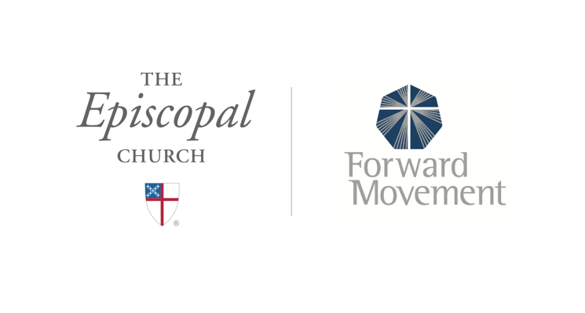
Sermons that Work and Bible Studies that Work are a joint offering of Forward Movement and The Office of Communication at The Episcopal Church.

https://www.episcopalchurch.org/bible-study/
https://www.episcopalchurch.org/sermons-that-work

