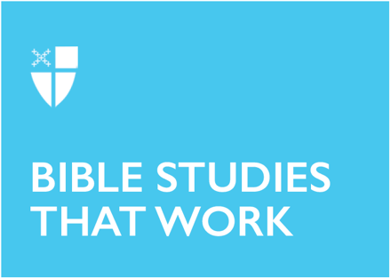

Epiphany IV (A)
February 1, 2026

RCL: Micah 6:1-8, Psalm 15, 1 Corinthians 1:18-31, Matthew 5:1-12

Opening Prayer |

Almighty and everlasting God, you govern all things both in heaven and on earth: Mercifully hear the supplications of your people, and in our time grant us your peace; through Jesus Christ our Lord, who lives and reigns with you and the Holy Spirit, one God, for ever and ever. Amen.

Context |

In 1 Corinthians 1:18-31, St. Paul addresses the church in Corinth, a faith community he establishes around 50 or 51 CE, during his second missionary journey. Located in a cosmopolitan Greek city, the church is socially and economically diverse, with a membership consisting of Gentile converts, Jewish Christians, slaves, freed people, and a few wealthy families. Paul spends about eighteen months founding and nurturing this community before he leaves to continue his missionary endeavors in Ephesus.

A couple of years later, he learns, much to his dismay, that factions have broken out within the congregation. Instead of prioritizing a common commitment to the life and teachings of Jesus, and striving to love each other across their differences, members are pledging loyalty to rival leaders, based on their own standards of eloquence, education, and social status. The followers of “Apollos” look down on the followers of “Cephas.” The factions committed to “Paul” consider themselves more sophisticated than the factions enamored of other leaders. The members who value rhetoric and philosophy have very different notions of divine impressiveness than the members who value signs and miracles.

The result is a church plagued by pride, competitiveness, and self-promotion. 1 Corinthians is the pastoral letter Paul writes to the church, to address these and other pressing spiritual problems within the community.

Theological Reflection |

Paul responds to the divisiveness within the church at Corinth by emphasizing that God’s wisdom—the wisdom through which God saves us—is radically different from human wisdom. So different, in fact, that human beings, left to themselves, will inevitably find God’s ways foolish and weak. And yet, it is precisely because God’s wisdom testifies so powerfully to the saving virtues of humility, sacrifice, and apparent weakness, that it challenges human notions of pride and power.

Specifically, Paul highlights the divine wisdom of the cross, which is “foolishness” to the Greeks and “a stumbling block” to the Jews. In Paul’s cultural, political, and religious context, crucifixion is a scandal; there is nothing redemptive about it. It is no more sacred or salvific a symbol in the public imagination than electric chairs or lethal injection chambers are for 21st century Americans. So why does God allow Jesus’s humiliating crucifixion to become the means of humanity’s salvation? Why is a cross—an instrument to crush criminality or rebellion through public disgrace—chosen to become the instrument of liberation?

Paul suggests that this astonishing and scandalous “foolishness” on God’s part is specifically intended to teach human beings that God’s ways are not our ways. In the inbreaking realm of God, business as usual will not work; human assumptions around power, popularity, and might-makes-right have to give way. God’s ways are specifically intended to “make foolish the wisdom of the world.” Where human beings prize power, money, celebrity, and self-achievement, God prizes humility, simplicity, service, and self-sacrifice. Where human beings flock to the strongest, wealthiest, and most eloquent, God intentionally chooses the lowly, the weak, the poor, and the socially despised. Where human beings often exacerbate divisions based on social status, privilege, and hierarchy, God always cherishes unity, humility, and mutual care.

Having described the ways in which God reverses human priorities and preferences through the paradoxical wisdom of the cross, Paul suggests that followers of Jesus must likewise embrace the same countercultural wisdom. The church should “boast” in nothing but the cross and Christ crucified. The scandal of Jesus’s humble death should be the foundation of a radical humility among Jesus’s followers. God’s decision to choose, not the wise and powerful of the world, but the simple and lowly, should inspire a unity that supersedes all differences of intelligence, eloquence, education, or socioeconomic privilege. And because the ultimate source of Christian life is Christ, “who became for us wisdom from God, and righteousness and sanctification and redemption,” Christian identity should be rooted deeply in the life, death, and resurrection of Jesus, not in leaders who encourage cults of personality, with all their attendant cliques, divisions, and factions.

Reflection Questions |

- St. Paul’s letter is addressed to a community struggling with division, competition, and partisanship. Where in our culture do you see similar problems leading to fracture and pain?
- In what ways does our society and our institutions define and wisdom and power differently than God does?
- What does it mean in your own life of faith that Christ has become your “wisdom?”

Faith in Practice |

Paul’s teaching in this scripture passage encourages his readers to honor the people whom the world tends to overlook. This week, commit to noticing, honoring, and (if possible) including at least one person in your community whom you’ve previously ignored or underestimated. Perhaps someone who is shy or otherwise quiet. Perhaps someone whose education level, socioeconomic status, or profession fall beneath your typical notice, or make you uncomfortable. What might this person teach you about the countercultural wisdom, power, and saving love of God?

Debie Thomas is a transitional deacon at St. Mark's Episcopal Church in Palo Alto, CA, and a seminarian at The Church Divinity School of the Pacific. She is a columnist and contributing editor for The Christian Century, and the author of Into the Mess and Other Jesus Stories, and A Faith of Many Rooms: Inhabiting a More Spacious Christianity. She and her husband have two grown children and live in northern California.

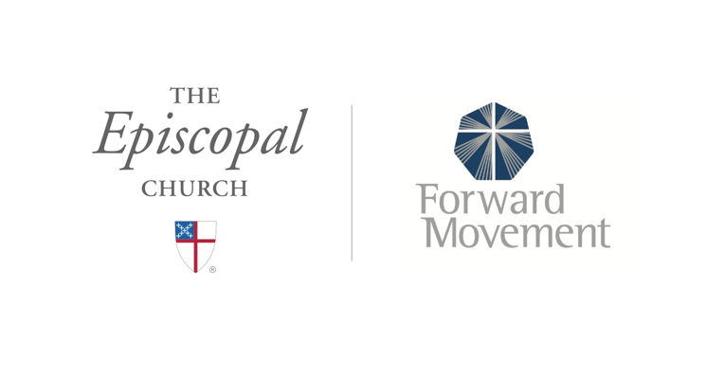
Sermons that Work and Bible Studies that Work are a joint offering of Forward Movement and The Office of Communication at The Episcopal Church.

https://www.episcopalchurch.org/bible-study/
https://www.episcopalchurch.org/sermons-that-work

