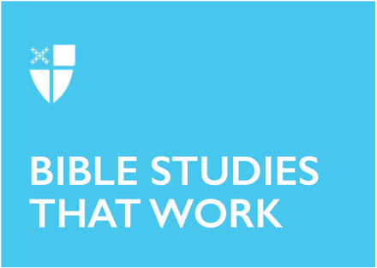

Epiphany V (A)
February 8, 2026

RCL: Isaiah 58:1-9a [9b-12]; Psalm 112:1-9, (10); 1 Corinthians 2:1-12 (13-16); Matthew 5:13-20

Opening Prayer |

Set us free, O God, from the bondage of our sins, and give us the liberty of that abundant life which you have made known to us in your Son our Savior Jesus Christ; who lives and reigns with you, in the unity of the Holy Spirit, one God, now and for ever. Amen.

Context |

Paul is writing to the church he established in Corinth, a wealthy and growing city that was once destroyed and then rebuilt by Rome. Judy Fentress-Williams documents that this letter is being written around the time when the city is closing in on one-hundred years after its rebuilding (Fentress-Williams, 2021). The formation of this community was deeply influenced by the fact that many of the members of newly formed Roman colony were formerly enslaved.

Though this is the first canonical letter to the Corinthians, it is likely Paul’s second letter to them. Emissaries from Corinth—Stephanus, Fortunatus, and Achaicus (1 Cor 16:17-18)—have carried back a letter responding to an earlier letter from Paul, and this reply contains several additional questions.

We see across the letter the series of their concerns, which he addresses: “Now in regard to matters about which you wrote (1 Cor 7:1); “Now in regard to virgins” (7:25); “Now in regard to meat sacrificed to idols” (8:1); “Now in regard to spiritual gifts” (12:1); “Now in regard to the collection for the holy ones” (16:1).

Paul further is aware of the state of division within the church in Corinth. Paul has received oral reports (1 Cor 1:10-11) that confirm divisions, rivalries (1 Cor 11:18), and immorality (1 Cor 5:1).

This fresh correspondence back from Paul is written to the congregation based on new information Paul has received through oral reports from Chloe’s people (1 Cor 1:11), which takes up Chapters 1-6, whereas Chapters 7-16 focuses on questions that the emissaries carried with them to Paul.

Paul’s systematic response to both oral and written reports about the church in Corinth reveals that overall, this communication is pastoral in nature, counseling them to grow in the right direction. The content reveals a practical theology focused on themes of unity in Christ, as well as an exhortation to be held together in love. Because Paul is responding to divisions and rivalries caused by allegiance to different leaders, he is using a format that almost seem to mirror case law. He first narrates a situation, which he then connects to a broader theological or legal principal. For example, he starts with a specific issue, then offers a prescribed remedy, rooted in deep theology, painted in poetic words.

Overall, the letter’s theme about remaining in unity amidst diversity offers a timeless message, not just for the Church in Corinth, but for larger ecclesial bodies across the world, as well as local churches—like each of our Episcopal missions and parishes.

Theological Reflection |

While rhetoricians held privileged positions in cultures like Corinth at that time, Paul minimizes his own impressive skills to instead reveal the glory of God working through him in the Spirit. To a community that is already vying for attention, power, and privilege, Paul—the messenger of the Word—rests on the power of God at the foot of the cross, rather than his own strength and skill. In lieu of his own rhetorical skill, he wants them to focus on the content, which is “Jesus Christ and crucified” (v. 2).

Through this humble stance, Paul aims at quelling the internal divisions by demonstrating Christ-like behavior and submission to the centering message of Christ crucified. The rootedness he wants to emphasize reminds the community that, in Christ, there is no division, and the crucifixion must be the center of the Christian church moving forward.

He urges the Corinthian church to decenter the wisdom of the world and to understand that the wisdom he speaks of is something they are still being trained on. He has not yet taught them such wisdom in full detail. In pointing to the tragic mistake made by the Roman Empire in crucifying Christ (v. 9), he paints a picture of the supposed wisdom of rulers of this realm, as compared to God’s rule. Through this comparison, Paul begins to draw a distinction between the Spirit of God and the mind of humans. His choice of words contrasts human and divine spirit in a way that “underscores not only the otherness of God but also the action of God and the divine initiative” (Collins, 123).

God’s Spirit—the primary agent making revelations, preparing untold things, offering gifts for the chosen—is also a Spirit of revelation that communicates to human beings. Paul and his community of fellow preachers are among those who have received this revelation. He is clear, however, that there are those who received the Spirit and those who have not, and therefore some are spiritual and others are unspiritual.

The Spirit that Paul and his fellow preachers have is from God, knows God, and is of God (v. 11, 12, 14). Staying rooted in this Spirit helps one discern things of the Spirit, and to be unfazed by scrutiny. Paul culminates this point by saying that having a discerning spirit mean having the mind of Christ himself in us.

The implications of the larger context for the letter to the Corinthians are woven through these verses. The human spirit, unlike the Spirit of God, is rooted in conflict, rhetoric, comparisons, and tends to focus on earthly things. As Paul deals with oral reports from Chloe’s companions, and the content of the letter brought to him by the emissaries, he begins to draw these distinctions between human and divine wisdom to eventually demonstrate how following God’s wisdom will help the floundering community to grow.

His counsel to the church in Corinth resonates today because we struggle still with many of the same questions that beset them.

Reflection Questions |

- How do we embody Christ’s spirit in our vestry meetings, stewardship conversations, and as we face the difficult, thorny issues in our midst?
- How do we stay focused on Christ crucified? How can we avoid getting swayed into the reasoning of the world for every day practical issues of running a church?
- Paul is full of love and eagerness for this church and is not afraid to be honest about the real issues amongst them. How do you engage in difficult and real conversations with folks in your congregation regarding difficult subjects?
- What aspects of Paul’s writing in this chapter might inform our practice of conflict resolution in churches?

Faith in Practice |

Set an intention to embody God’s Spirit this week in your work, in your interactions, even in how you read or listen to the news and interact with social media. As you find yourself responding and reacting to things, ask yourself: Does this response align with the mind of Christ? Where are the points of challenge for you? Use them to consider how Christ is inviting you to grow into his likeness in this season.

References |

Collins, R. F. First Corinthians (Sacra Pagina 7). Collegeville, MN: The Liturgical Press, 1999.

Fentress-Williams, J. Holy Imagination: A Literary and Theological Introduction to the Whole Bible. Nashville, TN: Abingdon Press, 2021.

The Reverend Deepu Varughese George is a transitional deacon and candidate for the priesthood in the Diocese of West Texas, currently serving as Deacon-in-Charge at Grace Episcopal Church, Weslaco, TX. He completed his theological education at Nashotah House Theological Seminary in Masters in Pastoral Ministry in a Hybrid-Distance Program. He holds a Ph.D. in Human Development and Family Science and is currently an Associate Professor in Family Medicine at the University of Texas Rio Grande Valley School of Medicine. His work focuses on integrating behavioral health into primary care to increase access to mental health in the Rio Grande Valley, a region located along the U.S.-Mexico border.

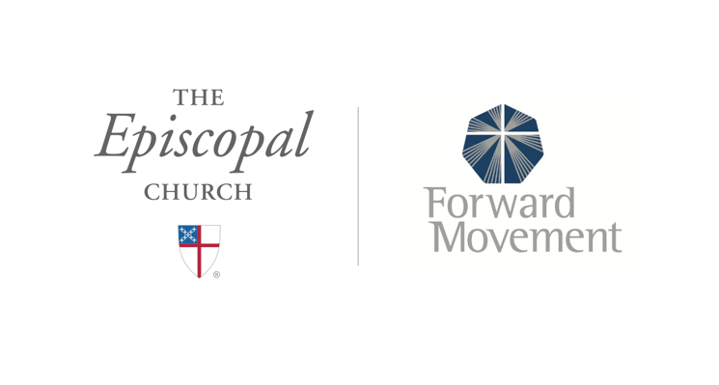
Sermons that Work and Bible Studies that Work are a joint offering of Forward Movement and The Office of Communication at The Episcopal Church.

https://www.episcopalchurch.org/bible-study/
https://www.episcopalchurch.org/sermons-that-work

