Lent 5

RCL: Ezekiel 37:1-14; Psalm 130; Romans 8:6-11; John 11:1-45

Our Common Humanity

A social activist by the name of Jo Cox was a member of the House of Commons in the Parliament of the United Kingdom in the early 2000s. According to her sister, she was a devoted sibling, mother, wife, and friend. By many accounts, Jo Cox was also a voice for the voiceless in communities around the world. She didn’t just stand for the marginalized in the United Kingdom; she also spoke out on those she considered marginalized people in the Middle East. Sadly, she was assassinated for her beliefs at the age of 42. Her vocation was driven by one simple belief: “we are far more united and have more in common than that which divides us.” Her passion was for protecting our common humanity.

In this third week of Lent, the gospel lesson provides a beautiful illustration of what it means to discover our common humanity. Jesus is camped out by a well in a Samaritan city called Sychar. The disciples have gone into town to find food for the rabbi and his followers. A Samaritan woman approaches the well and immediately Jesus asks for a drink of water.

It is fair to assume that the Samaritan woman might have been unnerved by the request, because Jews and Samaritans typically did not speak to one another, as Samaritans were marginalized people in that region. While we might look at this encounter as one between an outsider and the incarnate God, in this context, they are just two human beings who share an interesting conversation. The Samaritan woman has no idea who this Jesus is. Imagine her confusion when he offers her “living water” instead of the water that she was prepared to draw out of the well. She challenges more than just his imagery; she challenges Jesus’s ability to get water from the well, inasmuch as he does not have a bucket! She appears to be teasing him further when she says, “if you’ve got some of this living water why don’t you just give me some of that so that I may never be thirsty or have to keep coming here to draw water.”

As we encounter people along our journey, our initial reaction may often be that we have nothing in common. Our lifestyles may be completely different. One person is married with children, while the other is single. In our communities, in our workplaces, we share space with humans who love sports, while other are foodies. Encounters arise between people who are profound readers and others who prefer to travel. An extreme introvert connects with a self-avowed extrovert who makes friends easily and keeps the room in good humor.

If we are able to embrace the notion that we have more in common than what separates us, then as we converse with our neighbors, we are called to find common ground. Remain engaged; discover some common bonds. Suddenly our empathy meter expands tremendously, and we are able to give voice to and appreciate not only our common attributes, but our differences as well.

In Jesus’s interaction with the Samaritan woman, God models for humans what it looks like to be able to sit and share a moment with someone who appears vastly different from us. Jesus asks for a sip of water from someone he should not have addressed at all. And in that, Jesus shows the world what it looks like when we cast aside the labels imposed by societal norms and look into the heart of another human being, to connect on a personal level.

The Samaritan woman did not know Jesus and was understandably hesitant about sharing too much of herself. He tells her to go and get her husband, and she quietly says, “I have no husband.” Jesus knows the rest of her story, so in this case he tells her her own story, readily pointing out that she has had five husbands. Suddenly the Samaritan woman has a revelation: “Sir, I see that you are a prophet.” This story is a sign of what can happen when we truly see each other.

During the season of Lent—this time of renewal—we have an opportunity to seek the image of God in one another. In the midst of the hustle and bustle of life, it becomes too easy to rush past other people and not see each other at all. But in Lent, we are encouraged to slow down and to become present.

One of the greatest gifts that Jesus offered the Samaritan woman was presence. He saw her—not her community or her reputation. She was not used to Jewish people connecting with Samaritans. From her response, we can see clearly that it was unusual for her to interact with those outside of her community. Yet Jesus reminds us that we have so much more in common than that which separates us. Empowered with that knowledge, move forward, sharing your love of God with others and showing what it is to be God’s disciple.

You may recall another biblical story about a Samaritan in the tenth chapter of Luke: We read in a parable that Jesus told that the Samaritan was the one person willing to stop and assist an injured man. Through these encounters with and stories about Samaritans, Jesus offers examples of how we recognize the love and light present in the other. Your own light shines brightest when you are able to see your neighbor clearly. God tells us that we are light and love when we offer each other a drink of water, both from the well and from the living water given to us at baptism. God asks us not to run away from such moments, not to pass by these opportunities, but rather to embrace them. As one of God’s chosen people, you are called to share the light of love with all on your path.

The woman Jesus met and spoke with at the well overflowed—not with water, but with newness of life. She ran back to her neighbors and friends, to tell them what she had seen, and to beg them to come and see this man who knew so much about her.

It’s remarkable that with one simple conversation, this woman discovered the truth of who Jesus was. She could see him, while the disciples he was traveling with were still uncertain about Jesus and the fullness of his identity. By now, the disciples have seen Jesus’ work and witnessed miracles that the Samaritan woman has never seen. In spite of that, they are struggling with Jesus’ full identity. They don’t yet understand what Jesus means when he says to the disciples “my food is to do the will of Him who sent me and to complete His work.”

To do the will of God is our challenge, beloved. We are called to love our neighbors as ourselves. Your joy will come from your benevolence, compassion, and the ability to show God’s mercy to one another.

Throughout this season of Lent, may you claim the time and space to spend with God, and to experience how the living water touches and changes your life.

As you remember the Samaritan woman and meet Jesus at the well, remember the beautiful words of Jo Cox: “We are far more united and have more in common than that which divides us.” Amen.

The Rev. Kathleen Walker joined the staff of the Episcopal Diocese of North Carolina in February 2020 to focus on the continuity and vitality of the dozen Black congregations. The history of the African American tradition in North Carolina is rich and profound. It is important to weave their diversity into a closer bond of inclusion with other parishes and the diocese. The goal is to ensure all predominantly Black congregations have the best opportunity to make the fullest use of the resources of their parishes, partnerships, and the diocese. Currently there are 11 active African American congregations in the diocese and one historical church that is in process of redevelopment. Canon Walker is passionate about sustaining and supporting Black communities in the context of the Episcopal church. Canon Walker graduated from Virginia Theological Seminary in 2018. She is currently president of the Alumni Association Executive Committee. She has dedicated many years to the cause of social and racial justice. Rev. Walker is committed to fulfilling the diocese’s priority of becoming beloved community as we work through racial reckoning, justice and healing. She is also president of the Rt. Rev. Michael B. Curry chapter of the Union of Black Episcopalians.

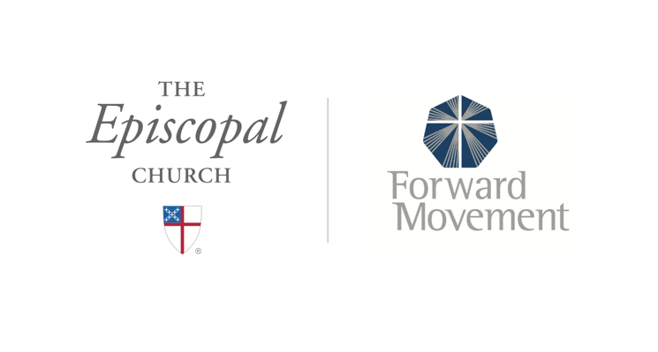
Sermons that Work and Bible Studies that Work are a joint offering of Forward Movement and The Office of Communication at The Episcopal Church.

https://www.episcopalchurch.org/bible-study/
https://www.episcopalchurch.org/sermons-that-work

