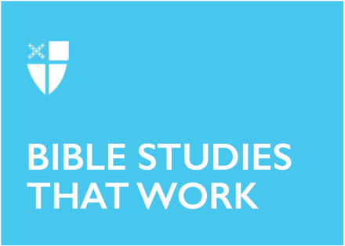

Lent IV

March 15, 2026

RCL: 1 Samuel 16:1-13, Ephesians 5:8-14, John 9:1-4, Psalm 23

Opening Prayer |
Gracious Father, whose blessed Son Jesus Christ came down from heaven to be the true bread which gives life to the world: Evermore give us this bread, that he may live in us, and we in him; who lives and reigns with you and the Holy Spirit, one God, now and for ever. Amen.

Context |

The book of Psalms, often attributed to David but more likely the result of several centuries’ compilation, may be divided into three main categories: complaints, thanksgivings, and hymns. Psalm 23 is difficult to rigidly categorize and has been referred to as both a song of lament and a song of trust. This dual emphasis makes it particularly appropriate as the one commonly recited at the bedside of someone who has died or in the company of those grieving. While the psalms focus on the whole of the human condition, as well as on individual difficulties, they demonstrate a common thread of dependence upon a trustworthy God. Psalm 23’s every line, in fact, comes back to trust in God, in the face of one’s ever-present enemies.

The psalms which bookend this one (22 and 24) both picture God as King, and in ancient imagery, kings were often depicted as shepherding their people. There are also parallels in this imagery to the story of the Exodus. The good shepherd motif reflects the historical tale of God’s leading the people of Israel through the wilderness. The Lord is said to lead and guide the people here in language that is similar to both Exodus 15:13, “In your steadfast love you led the people whom you redeemed; you guided them by your strength to your holy abode,” as well as to Isaiah 40:11, “He will feed his flock like a shepherd … and gently lead the mother sheep.”

Theological Reflection |

This psalm may be so familiar to us as to lead us to regard it with the contempt or neglect common to over-familiarity. Yet such a response ignores the dynamic, living nature of scripture. As readers, we are encouraged to invite the presence of the Spirit to accompany our reading, that these words may land on fresh ears and bring new insight.

The task of a shepherd may have been humble, but it was also imperative. Notoriously vulnerable, sheep in Palestine faced multiple threats; fires, wolves, snakes, cliffs, and hard-to-find food being only a few. One of the biggest threats to a sheep, though, then as now, is simply: itself. Sheep tend to become “cast down,” a term that basically means they have fallen … and they can’t get up. Stuck on their fluffy backs, feet in the air, the sheep will die if someone does not come and rescue them, setting them back on their feet. They also wander off—not known for their intelligence—have no natural defense against predators, and are prone to parasites. No wonder they need a shepherd’s constant presence!

While we may resist being identified through this psalm with such needy beings, here we are. What can it show us? Surely there are times for each of us when such a description feels apt. The author immediately assures us that God is our faithful shepherd. Thus, regardless of how things appear, we are never truly lacking. God will feed us in a green pasture—a picture of plenty and peace. God leads us beside “waters of comfort,” as Coverdale translates it; these “still waters” reinforce the sense of abundance as well as quiet. In a world of constant distraction, with fearful news all around, is this not an appealing idea?

It is God who converts us, God who draws us close, and God who enables us to grow in righteousness. We may notice echoes here of Philippians 2:13: “for it is God who is at work in you, enabling you both to will and to work for his good pleasure.” While we may battle with protecting and perfecting our own lives, this psalm reminds us that such is not our own work; God is the one who shepherds us. God’s faithfulness to that task is “for his name’s sake;” thus surely not something that we can accomplish on our own, or that will be left undone.

The image of the “shadow of death” is perhaps the one most readily associated with this psalm, and it has many possible implications. Whether we think of this in terms seasons of relational, financial, physical, or mental difficulty—or perhaps in those times when we grieve the death of a loved one, in all these shadows—we are assured that we need not fear. God’s “rod” of guidance and protection is with us, even in such times.

Next, the psalmist insists God will prepare a table before us in the sight of our enemies. We don’t like to think of ourselves as having those, of course. But at some point in each of our lives, enemies there will be. They may have us cornered, and we may feel overwhelmed. The promise of the psalm is that in that very place, God will provide for us. We may even be provided for in such a way that it will be clear to those who stand against us that it is God who sets our table.

Shepherds often poured oil on the heads of their charges to protect them from pests and promote the healing of injuries. While we may see ourselves as needing similar protection and healing, this verse also suggests the promise of anointing with more elevated connotations, as anointing during the time of the author was common to the consecration of royalty and priests. Episcopal services of baptism and confirmation harken back to this, with the anointing with oil signifying our being marked by the Holy Spirit, as a reminder that we, too, have been anointed by the Shepherd.

Our cup is full to overflowing. While the last line begins with mentioning a set table—surely unusual in a discussion about sheep—the mention of the cup broadens its application to include all those willing to be led. The psalm’s closing promise that lovingkindness and mercy relentlessly follow us evokes a powerful hope: God will not leave us alone. In the psalm, we are both led and followed, and when, at some point, we come to the end of our journey, we will dwell in the house of God.

Discussion Questions |

- In today’s world, we can have a tendency to idealize individuality and self-sufficiency. How might you consider yourself like a sheep in need of a shepherd?

- How has God worked in your life as a shepherd: leading, providing, and guiding?

- When have you walked in the “valley of the shadow of death”? How are you there now? How might God be offering you protection and guidance through the “rod and staff”?

Faith in Practice |

This week, indulge your creative side. Find some paper and pencils, watercolors, crayons, or whatever supplies you like, and imagine how you might depict this psalm. You are a sheep in the care of our great shepherd: What does that look like?

Misty Krasawski is a nominee for holy orders in the Episcopal Diocese of Tennessee. Previously, she earned a Master of Letters in Bible and the Contemporary World from the University of St. Andrews, Scotland. She has eight children ages 16-33, three daughters- and one son-in-law, as well as four grandchildren, and has spent decades in ministry to children, youth, and mothers with Whole Heart Ministries and in her local church. She would love to spend more time exploring the intersections of maternity, theology, and feminism, and believes that better theology helps us all move toward a better world.

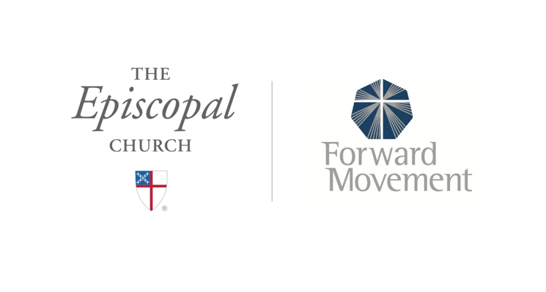
Sermons that Work and Bible Studies that Work are a joint offering of Forward Movement and The Office of Communication at The Episcopal Church.

https://www.episcopalchurch.org/bible-study/
https://www.episcopalchurch.org/sermons-that-work

