Lent 4

RCL: 1 Samuel 16:1-13, Ephesians 5:8-14, John 9:1-4, Psalm 23

“Do you believe in the Son of Man?”

Today’s gospel text is a lot: a lot of words and a lot of concepts. Within John’s narrative, today’s gospel comes from what scholars call “the Book of Signs,” John 1-12. In this section of the gospel, Jesus—God’s word made flesh, the light which the darkness could not overcome—is traveling around, performing miracles. These miracles are “signs” because they cause some people to come to have faith in him.

Later on, Jesus will say that those who believe without having seen are even more blessed.

As Jesus walks, he encounters a blind man. The disciples, operating under the assumption expressed in Exodus that “The sins of the father are visited upon the children,” ask Jesus whether this man’s blindness is the result of his sins or the sins of his parents. Jesus tells the disciples, “Neither. This man is blind so that God’s glory can be revealed.” Then Jesus reveals God’s glory by healing the man with mud. Jesus re-forms the earth from which the man is made, and through no work or merit of the man’s own, the man is remade.

A word about language here: It’s always important to remember that, in this gospel, John writes “the Jews” as a shorthand to mean either “the Judeans”—because of where the story is taking place—or “the Jewish leaders.” None of John’s writing is meant as an indictment of the children of Abraham, Isaac, and Jacob, with whom God has made eternal covenants. As Christians, we have a duty to know and name how John’s writing has been misused to persecute Jewish people. We have a duty to reject that practice with no equivocation.

This duty brings us back to today’s healing story. In all the gospel, healing means restoration to community as part of God’s salvation. Healing is full when it means healing in mind, body, and spirit. To be restored to community—and to show God’s power!—this unnamed blind man is taken to the religious leaders. He’s interrogated and pushed away. Rather than defending him, his parents tell him to stick up for himself. We see in this that he is, in a way, rejected by both communities that previously defined him. Thus today’s chapter from John shows the creation of a new community—a community of those who put their faith and trust in Jesus. And so the man born blind becomes part of a new community of those who believe.

After the Pharisees question the man (and doubt him), then question his parents—to be sure he was actually born blind—and then question him again, they’re at their wits’ end. Where do you see yourself in this part of the story? The characters in John’s gospel can act like screens onto which we can project ourselves, and it’s pretty easy in this chapter to see ourselves as either the Pharisees—who preserved Judaism in the midst of imperial occupation and kept their religious traditions alive—or as the blind man.

On the one hand, we have the Pharisees, who are just shocked: A man born blind sees again because a carpenter from the backwaters put mud in his eyes and had him wash in a special pool? And he did it on the Sabbath? It’s easy to understand their incredulity. In today’s passage we hear, “Some of the Pharisees said, ‘This man is not from God, for he does not observe the sabbath.’ But others said, ‘How can a man who is a sinner perform such signs?’ And they were divided.”

On the other hand, here is a man who’s never seen before. Someone he’s never actually seen makes mud, puts it on his eyes, and tells him to wash in the pool of Siloam. He does and suddenly he has vision, such as he’s never had before. We know that this man is “of age,” but don’t know if that means 13 or 33. We don’t know how long he’s been blind. We don’t know how long he’s been navigating adult life without vision, or how supportive his parents have otherwise been. He hasn’t done anything except be in Jesus’s path as Jesus walks by, and now he’s given sight.

As easy as it is to understand the Pharisees’ incredulity, it’s also easy to understand this man’s exasperation with their persistent questions. He can see! That’s really all he knows. Whoever made it possible, however they did it, isn’t really his concern. He just wants to enjoy this gift that’s new to him, a gift that everyone around him takes for granted. “What did he do to you? How did he open your eyes?” Imagine him exploding in his answer, “I have told you ALREADY, and you would NOT listen. Why do you want to hear it again?”

Here are the words the gospel records: “You do not know where he comes from, and yet he opened my eyes. We know that God does not listen to sinners, but he does listen to one who worships him and obeys his will. Never since the world began has it been heard that anyone opened the eyes of a person born blind. If this man were not from God, he could do nothing.”

Then the man shoots across their bow, “Do you also want to become his disciples?” As the Pharisees continue to needle him, this man’s belief only deepens. His faith and trust in Jesus grow.

After the newly-sighted man is driven out, Jesus finds him. Jesus does not abandon him as his parents and the religious leaders have done. Jesus asks, “‘Do you believe in the Son of Man?’ He answered, ‘And who is he, sir? Tell me, so that I may believe in him.’ Jesus said to him, ‘You have seen him, and the one speaking with you is he.’ He said, ‘Lord, I believe.’”

These last few verses of today’s Gospel hint at why we hear this passage on the Fourth Sunday in Lent. During Lent, the church invites us to reevaluate our lives (again) and see how well we are—or aren’t— following Jesus.

When Jesus asks this man if he believes, it might be a difficult question for us to hear, impacted as we are by the Enlightenment and the culture wars of the 20th century; at a moment when so much is being reframed in terms of belief: belief in evolution; belief in marriage equality; belief in abortion; belief in sin; belief in salvation; belief in immigration policies; belief in the climate crisis; belief in vaccines. We use “belief” as a shorthand for “supporting policies around” or “accepting scientific findings.”

When John writes about belief in the Son of Man, he’s writing about putting our faith and trust in Jesus and his life-giving work of redemption. This is not intellectual assent or generic support. This “belief” means putting one’s whole life into Jesus’s hands, relying on Jesus for everything, and—like this healed man—worshiping Jesus, through whom all things have been made. This “belief” means accepting God’s gift of grace and living a life changed through that grace to be more like Jesus. The man born blind is a model for the church throughout the ages, in part, because he doesn’t do anything to earn God’s favor. His life exists to show God’s glory—he is healed only because of God’s grace.

At the Easter Vigil in a few weeks, the candidates for baptism will be asked throughout the church, “Do you put your whole trust in his grace and love?” And what about you. Do you?

During Lent, we’re invited to discern how well we are following Jesus, to amend our failures, and to consider where Jesus is calling us next. That may mean upsetting our families or communities. For some of us, it may mean putting our bodies in harm’s way to protect the vulnerable whom Jesus welcomes.

Pray that when we are asked “Do you believe in the Son of Man?” as we reaffirm our baptisms at Easter, we can answer, “Lord, I believe.”

The Rev. Joseph Peters-Mathews is a priest in the Diocese of Olympia. Joseph was ordained priest in 2012 and has served on the staffs of the presiding bishop and bishop of California. He is married to Brandon and they have two children, Topher and Finny. Joseph has written for Sermons that Work, Earth & Altar, and Modern Metanoia. Joseph is an alumnus of General Theological Seminary and Troy University.
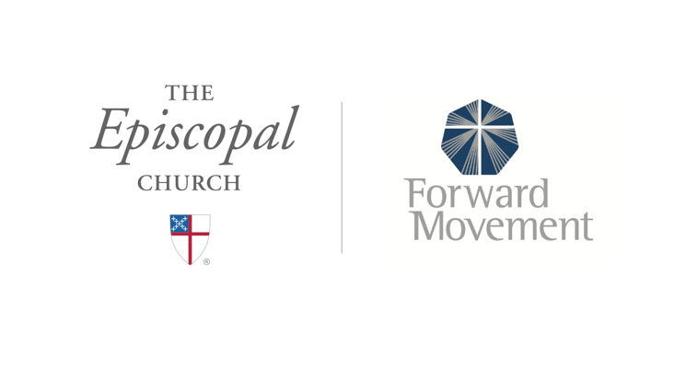
Sermons that Work and Bible Studies that Work are a joint offering of Forward Movement and The Office of Communication at The Episcopal Church.

https://www.episcopalchurch.org/bible-study/
https://www.episcopalchurch.org/sermons-that-work

