

Lent V
March 22, 2026

RCL: Ezekiel 37:1-14; Psalm 130; Romans 8:6-11; John 11:1-45

Opening Prayer |

Almighty God, you alone can bring into order the unruly wills and affections of sinners: Grant your people grace to love what you command and desire what you promise; that, among the swift and varied changes of the world, our hearts may surely there be fixed where true joys are to be found; through Jesus Christ our Lord, who lives and reigns with you and the Holy Spirit, one God, now and for ever. Amen.

Context |

The psalms as a whole reveal that God created humanity for community, to give thanks and to praise together, as well as to lament and suffer together. Psalm 130 is one of the “songs of ascents,” perhaps originally sung by communities of worshippers on their way to the temple in Jerusalem. Today it can be read or sung as a prayer of faithful trust.

In the opening lines, the author petitions God to hear their voice “from the depths,” naming the possibility that they are too far away from God for God to hear their plea. But the author knows God through God’s word and finds hope there. Through God’s word, the psalmist has come to know God to be forgiving and redemptive, and takes care to remind God and God’s people of these characteristics in their prayer. The psalm closes on words of expectant waiting: calling on Israel to wait for God and calling on God to redeem Israel.

Reading this psalm in the fifth week of Lent offers a reminder of the season’s trajectory from acknowledging disobedience and the need for repentance in the first three weeks to a focus on divine redemption in the last three weeks. We can think of this redemption we await as being “already and not yet”—both accomplished and ongoing. In Jesus’s life, death, and resurrection, eternal redemption is complete; and yet we expectantly wait on the final redemption that is still to come. And we participate in the daily unfolding of God’s purposes of transformation in ourselves and in the world around us.

Theological Reflection |

In this digital age, when deliveries and news updates happen almost instantly, waiting—at least when it comes to information or material goods—has become rare. Sometimes this speed is a good thing, helpful even. Forgot glue needed for a project? Just run down to the big box store (that’s open until midnight) to grab it. Wondering who won the game that didn’t end until past bedtime? A news app will have the results first thing the next morning.

Technology satisfies our curiosity and rescues the forgetful more readily and easily than ever before, making waiting into something of a lost art. However, instant gratification does not equal joy. Instant gratification is often momentary, fleeting; joy endures.

Waiting can either be a time of excited expectation or excruciating anticipation, depending on what one is waiting for. Some things that bring the most fulfillment—a flowering plant, a work of art, the birth of a child—take time and require patience. Other things, like healing from an illness, receiving a job offer, or mending a broken relationship, may seem to take longer than they should to reach fulfillment, making waiting feel lonely. In such moments, we may wait more impatiently than “watchman for the morning.” We wait in the hopes of being freed from the waiting.

Yet Psalm 130 is a prayer of trustful waiting. It begins by calling out in desperation, even with a plea of uncertainty that God can hear, but it quickly pivots to recalling divine forgiveness and the mercy that make God worthy to be worshipped. Staying rooted in the promises found in the word brings the hope of mercy and redemption – not only for an individual but for the entire community. Being rooted is connection, and connection to God is found in community. Expectant waiting is best not done in solitude. Prayerful waiting brought Israel “out of the depths” and into the joy of “plenteous redemption.”

Like today’s Psalm, the season of Lent is a journey from hopelessness, from the defeat of sin and death, toward renewed hope in redemption.

The Lenten disciplines we take on are meant to transform the Body of Christ, not just test individual willpower. They are practices of prayerful waiting that demonstrate trust; they remind us to stake our trust in the promises that make God worthy of worship.

When individuals live out their Lenten practices in communities of faith, the whole body is strengthened, encouraged, and supported. Step by step, year by year, the community—the Body of Christ—is brought out of the depths and closer to God, where—despite a world that sometimes changes too quickly or too slowly—true joy is to be found.

Discussion Questions |

- If you have chosen a Lenten practice, how is it leading to transformation—of yourself and of your community?
- Consider times in your life when you had to wait. How did being part of a faith community help you during those periods?
- What line from Psalm 130 most resonates with your experience of waiting? How might it inspire you to help others during their times of waiting?
- Where in your life right now is there movement from despair to hope? In what areas could the expectant waiting, rooted in God’s promises, bring hope from despair?
Faith in Practice |

Find a way to reach out this week to someone whose life is marked by waiting. How might you turning waiting into community and connection? Check on a neighbor; send a card to a fellow church member on the prayer list; volunteer at a food pantry or homeless resource center; take a friend with you. Let your own hope fill someone else’s waiting time with an expectant sense of God’s promises.

Ellen Huckabay, from the Diocese of the Central Gulf Coast, is a senior Master of Divinity student at the Episcopal Theological Seminary of the Southwest in Austin, Texas, where she is pursuing the ordination track. She is married to George, and together they have a son, Will. Ellen is currently discerning a call to parish ministry and brings a deep commitment to pastoral care and outreach work.

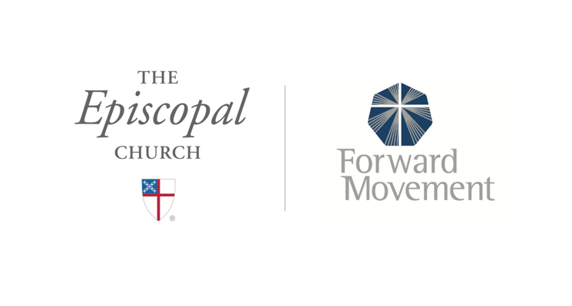
Sermons that Work and Bible Studies that Work are a joint offering of Forward Movement and The Office of Communication at The Episcopal Church.

https://www.episcopalchurch.org/bible-study/
https://www.episcopalchurch.org/sermons-that-work

