World Mission Sunday 2026

[RCL] Exodus 24:12-18; Psalm 2 or Psalm 99; 2 Peter 1:16-21; Matthew 17:1-9

Good morning. I’m Bishop Jennifer Reddall of the Episcopal Diocese of Arizona. We are a diocese of 63 worshipping communities spread around most of the state of Arizona, which is in the southwestern United States on the border with Mexico.

In the Transfiguration story, the change of Jesus is obvious. They are glowing, wearing white clothes, and if that wasn’t enough, the voice from heaven calls out, “This is my Son, the Beloved. With him I am well pleased. Listen to him.”

Peter, James, and John don’t seem to be as substantially changed at first. Peter is still asking un-insightful questions, and all three of them are so terrified that they fall to the ground.

But it’s the consistent encounter with the holy that does, eventually, transform Peter and James and John into faithful disciples, leaders in the faith, who go out after the resurrection and preach the Gospel to all nations. Transformation in faith takes time, and it takes relationships—relationships with Jesus and relationships with our neighbor—and a willingness to be surprised by where you find the holy. I’m pretty sure Peter and James and John did not expect anything like the Transfiguration when they accompanied Jesus on a hike up a mountain. But they went on a journey and they were changed.

Which is much of what world mission and global partnerships are about. It’s about being changed by our relationships with Jesus and our neighbors—both the neighbors who are near to us and those who are far away. And it often involves going on a journey of some kind.

At the 2022 Lambeth Conference, one of the discussion topics at the tables of bishops were about the four “instruments of communion”: the Archbishop of Canterbury, the Lambeth Conference, the Primates Meeting, and the Anglican Consultative Council. I remarked at the time—and will do so again—that while those four obviously are instruments of communion, for me the primary instrument where I have encountered the Anglican Communion is through diocesan global partnerships.

If you’re watching this sermon, chances are you have been involved in some way in global partnerships or world mission. Chances are you know what it’s like to be changed by a faith relationship.

My first trip to Africa was to Tanzania on a pilgrimage with the Diocese of New York to the Diocese of Central Tanganyika. We were working together on a ministry called the Carpenter’s Kids that connected parishes in New York with villages surrounding Dodoma to support 50 kids per village so that they could get an education. Bishop Mdimi Mohogolo was the bishop, and I remember so specifically one of the things he said to us: “If you have the choice between giving us $1000 and spending $1000 to come visit us, I would prefer that you spend the $1000 to come visit, because that visit will transform both you and us.”

He was right. I was transfigured, changed by that trip. My faith had grown. Right after I got home, I was celebrating the Eucharist at the convent where I’m an associate, and the assigned gospel of the day was “Blessed are the poor,” and I just broke down in tears because that verse hit me differently. I had seen people who were utterly poor, and knew they were completely blessed and loved by God. That transformation goes both ways. I know the difference we made for many children who are now grown who got an education because of that partnership.

The Diocese of Arizona is now in partnership with a diocese in the Iglesia Anglicana de Mexico and with the Diocese of Upper Southern Nyanza—Kisii in Kenya. One is our nearest neighbor, with whom many of our church members share a language and a culture and so a partnership is really more like acknowledging that the national border between us is human-made, not divine, and that we are conscious that we are one people.

The other is much further away in terms of distance and culture and travel time. Upper Southern Nyzna–Kisii is a very new diocese that is growing by leaps and bounds through the Spirit. The relationship started because Bishop John Orina Omangi and I met at Lambeth and were curious about the other’s context. In 2023, I visited with a couple leaders from Arizona; in 2024 he visited us, and in 2025 a larger group visited Kisii from Arizona. We’ve helped out financially as they get on their feet as a diocese, and have helped them get a diocesan school off the ground that just opened in January of 2026.

I’ve learned about what it means to be an Anglican in Kisii. The issues they face are at once radically different and extremely similar. Arizona doesn’t spend a lot of time worrying about FGM in our context, like they do in Kisii–but we do have issues around bodily autonomy and medical practice. Our diocese is growing–but nothing like they are in Kisii. Their passion for the gospel and for planting churches helps encourage us. And in a world where political and social and ecclesiastical divisions constantly tell us that we ought not be in relationship with one another… we keep on doing it. And I think Jesus wants us to. The first thing he says to Peter and James and John when they are so terrified by the voice from heaven that tells them to listen to Jesus is: “Do not be afraid.”

Do not be afraid.

I’m not sure what the future of travel is for many of our global partnerships. Visas to visit the US are hard to come by these days. But we are not a people without hope, and we are people who know we can be changed by relationship… thank God for the internet, and WhatsApp, and the many ways we have of building those relationships even when we do not see one another face to face. So do not be afraid. The Gospel’s call is to change you through relationships with Jesus and your neighbor, and you will be changed. We will be changed. Amen.

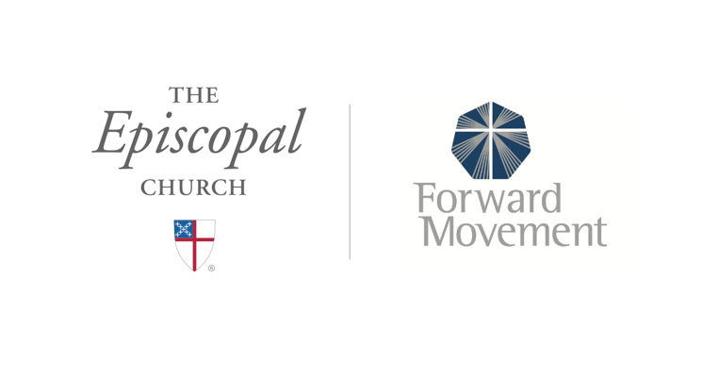
Sermons that Work and Bible Studies that Work are a joint offering of Forward Movement and The Office of Communication at The Episcopal Church.

https://www.episcopalchurch.org/bible-study/
https://www.episcopalchurch.org/sermons-that-work

