Easter 2 (A)

April 12, 2026

[RCL] Acts 2:14a, 22-32; Psalm 16; 1 Peter 1:3-9; John 20:19-31

Come and Touch

There’s something wonderfully honest and fascinating about the story we hear today from Thomas. While the other disciples hid behind closed doors on that first Easter evening, Thomas was absent. When they found him, they told him everything they had seen, but he refused to take their word for it. “Unless I see the mark of the nails in his hands, and put my finger in the mark of the nails and my hand in his side, I will not believe.” We call him “doubting Thomas,” as if the center of this story was his inquiry, as if the moral of the story was that we should not doubt like Thomas. But if we look more carefully, we will notice that Thomas’s question is a great gift to a skeptical world. His doubt is not a failure of faith, but rather—in the hands of a loving and teaching God—a path that leads to faith.

It is worth looking more carefully at that word: “believe.” In the original Greek of John’s gospel, the word is pisteuō (pist-yoo'-o), and it appears about 90 times. But pisteuō does not only mean “believe,” as an intellectual act, as approval or adherence to a concept. Instead, it also means to have faith on, to lean one’s weight on someone, to entrust oneself. It is relational before it is cerebral or conceptual.

When Jesus said to Thomas at the end of the passage, “Do not doubt but believe,” he is not simply asking Thomas to change his opinion. He is inviting Thomas to enter into a full relationship of trust. And crucially, he does not ask Thomas to believe without evidence or chastise him for asking for proof. He offers his hands and his side to assuage Thomas’s thirst for evidence. Come, touch, and trust. Faith in this story is not a leap in the dark; it is walking towards the light that is already present.

Gregory the Great, writing in the sixth century, remarked that Thomas’s doubt did more for the faith of the church than the ready belief of the other disciples. Because Thomas demanded proof, he received it, and what he received was not a vision, not a feeling, not a spiritual impression. He was instead invited to touch—to stick his fingers in a real wound, to put his hand in Jesus’s real side. Gregory sees that as providential. God was not only not angry at Thomas’s stubbornness; he did not only tolerate it: he used it! The next Sunday, Jesus came back to visit the disciples again, and this time he offers his body to Thomas to examine. The message for future generations is clear: Our doubt is not an obstacle to encountering Christ; it can become the path that leads us to finding the risen Lord.

What Thomas found when he approached his friend—when he put his fingers in his wounds, when he felt his side—was undoubtedly physical. This is very important. The resurrection of Jesus is not a metaphor for new beginnings. It not a conceptual idea or the survival of a message in the community of believers.

The resurrection of Jesus means a physical body, walking out of the tomb, still bearing its scars from the trauma Jesus had experienced. The gospels narrate intrinsically physical experiences. In them we see Jesus eating, drinking, walking, even crying. This is particularly true after the resurrection, when Jesus demonstrates his presence—not spiritual or ghostly, but physical—by eating, cooking, and walking with the disciples. It is in this story of stubborn Thomas—who would not settle for a secondhand experience of his master and friend—that Jesus’s physicality is even more overtly proved. Thomas’s pisteuō, his entrusting of himself, was grounded on what his own hands had touched. Jesus fulfilled his need for proof, allowing him to believe. What’s more, Jesus blessed all those—you and me—who, through Thomas’s experience, will believe in him and his resurrection.

But there’s another layer to this story, which you may have already been seeing. The side where Thomas sticks his fingers, at Jesus’s invitation, is the same side that the spear of the Roman soldier pierced earlier in the gospel. Remember? At the request of the religious authorities, the soldiers came to end those that had been crucified and remove their bodies, since Sabbath was approaching. They broke the legs of the other men, but since Jesus was dead already, they pierced his side, and from it flowed blood and water. The early church saw in this event a sign and symbol. Water and blood: Baptism and Eucharist, the streams from which the entire sacramental life of the Church flows. The side of Christ is not only a wound; it is also a place a birth. From here comes the origin of the Church; here is the source from whence her life pours out. In today’s story, Thomas reaches into it—into that sacred opening—and is completely transformed. His initial doubt is now a statement of faith, one of the most beautiful in all the gospels: “My Lord and my God.”

Notice also, that all of this is happening on the first day of the week, on a Sunday, the same day of the week on which the first appearance of Jesus to the disciples occurred, when Thomas was missing. This timing is not an accident. John is writing to a community who gathers around the table of the Lord on a Sunday, and he is drawing a deliberate line between what happened that one Sunday and what happens every week. The risen Christ comes to his gathered people. He shows his wounds; he offers himself. These appearances of Jesus to the gathered community in John 20 are the first Eucharists, and what we celebrate today is the continuation of that event. This is why Thomas missing the first Sunday appearance is so important. Thomas was isolated from the community, and that isolation led him into doubt. Jesus could have appeared to him any other day of the week, but it is only when Thomas rejoins the community the next Sunday that the encounter becomes possible. In this, there’s a gentle but present reminder for us about why we gather on Sunday as a community. The table requires our presence. And when we gather together at the table, we encounter Jesus.

As a Church, we continue to gather on Sundays, just as Thomas and the disciples did. Every time we are able to come together to celebrate the Eucharist, the table set before us is the side of Christ, and that same water and blood are given to us in the body and blood of the risen Lord. What Jesus said to Thomas that night, he says to us now, whether we can receive him physically or spiritually: Come forward, reach out your hand, and put it on my side.

May that encounter do to us what it did to Thomas. May our eyes be opened, our hearts consoled, and may our mouths utter his same confession: “My Lord and my God.” May we practice true pisteuō, entrusting ourselves fully to the one that showed and shared his wounds not as signs of defeat but as sources of transformation.

You may come this morning with doubts as Thomas did. Curious? Wondering. You may come with questions that have no easy answers, with grief, with a faith that feels thin and fragile; you may come after being absent for a while.

Come anyway, get closer, reach out your hands in prayer. And perhaps, like Thomas, you will find that the risen Christ has been waiting for you with wounds still visible, and the only thing left to say is: “My Lord and my God.”

Br. Luis Enrique Hernandez Rivas, CFC serves in the Diocese of New York as Priest in Charge of Saint John’s Getty Square and Iglesia San Andrés, both in Yonkers, NY. A member of the local Franciscan Solidarity Table in NYC, Br. Luis is also part of the team of facilitators of Academia Ecuménica de Liderazgo and other churchwide initiatives.

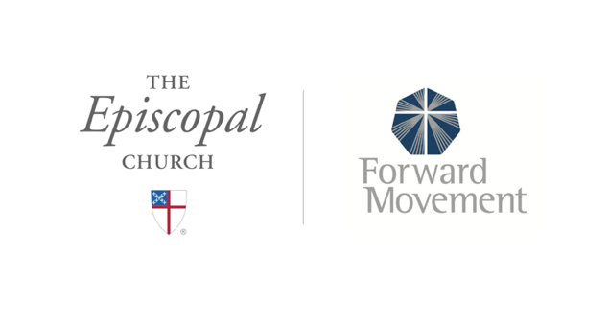
Sermons that Work and Bible Studies that Work are a joint offering of Forward Movement and The Office of Communication at The Episcopal Church.

https://www.episcopalchurch.org/bible-study/
https://www.episcopalchurch.org/sermons-that-work

