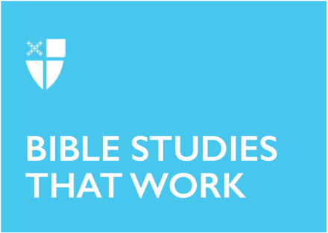

Easter 4 (A)
April 26, 2026
RCL: Acts 2:42-47; Psalm 23; 1 Peter 2:19-25; John 10:1-10

Opening Prayer |
O God, whose Son Jesus is the good shepherd of your people: Grant that when we hear his voice we may know him who calls us each by name, and follow where he leads; who, with you and the Holy Spirit, lives and reigns, one God, for ever and ever. Amen.
Context |
Today’s passage from Chapter 2 of Acts brings the reader into the narrative immediately following the great day of Pentecost. Earlier in the chapter, Jesus’s first apostles—eleven of the twelve original disciples, with Matthias having been appointed to replace Judas—were touched by the Holy Spirit and received the gift to communicate the good news of Jesus in many languages. Following this incredible demonstration of God’s power, the apostles have just baptized three thousand new followers of Jesus’s teachings. They are finally putting into motion the work their teacher commissioned them to do before his death. The wonders and signs performed by the apostles, as described in this passage, contain echoes of the prophet Joel’s invocation that the Lord’s Spirit would one day come and touch every person on earth (Joel 2:28-32). This prophetic call-back reveals a clear thread running through the ancient prophecies of Israel, Jesus’s salvific ministry, and into the continuing work of the apostles.
In the final two verses of this passage, we read that they “spent much time together in the temple” (2:46). The setting of the temple is contextually significant. For that is where Jesus spent much of his time teaching near the end of his life on earth. The author is perhaps driving home the point that the apostles are meticulously following the path Jesus laid for them to nurture and grow the spiritual body of believers. Both the charge to distribute wealth among the community and the imagery of breaking bread around a table also serve to affirm that the actions of Jesus the Messiah should and will be repeated by his followers.

Theological Reflection |

The newly baptized in this story likely did not understand the full scope of what they had just signed up for. They willingly chose to follow the ways and words of Jesus Christ, but did they know they would be setting up the foundation of a community of faith that would spread across the entire earth and the next two thousand years (and counting)? Surely not. The text states they became more and more astounded by the “wonders and signs” accomplished by the apostles the longer they spent time together, growing in their belief that God had walked among them and would come again. Their eagerness to know God more intimately, and to experience the fullness of salvation in Christ, became a lifelong journey.

What is particularly striking about this passage is the emphasis on the fellowship these newly baptized believers experienced in every aspect of their everyday lives. Koinonia (koy·now·nee·uh) is the Greek word used in verse 42 translated as “fellowship.” This word implies a gathering that is far more than just an assembly of people. It is a gathering during which physical possessions are distributed, and whereby folks actively participate in one another’s lives. The newly baptized embraced the selling of possessions and sharing of proceeds as a spiritual practice of love, knowing that all present would receive all that they needed. This historic understanding of “fellowship” offers an interesting challenge to what we associate with fellowship in churches today: Sunday activities like “fellowship” hour and spaces like “fellowship” halls. How might they develop a whole new meaning with this ancient definition of fellowship in mind?

The fellowship that took place in the temple—and in the homes of early followers of Jesus—involved the sharing of meals and the proliferation of joy and gratitude. The church’s celebration of the Eucharist is reminiscent of the devotion the apostles—and the three thousand newly baptized—had to the breaking of bread among the wider community.

This form of fellowship, of praising the Lord by sharing food and other resources, served the early apostles as a strategy for authentic evangelism. We read that they “ate their food with glad and generous hearts, praising God and having the goodwill of all the people” (2:46-47). As they lived this authentic expression of the faith Jesus had handed onto them, people caught on. The Lord rewarded their faithfulness with more believers to invite into the faith, so that Christ’s salvific love could reach and transform generations to come.

Each time we gather with others today for prayer and Eucharist, we not only re-member the body of Christ, we also knit ourselves back together with this particular, earliest iteration of fellowship among the church. Congregations today have an eternal connection to the first congregation of the apostles described in this section of Acts.

Luke offered this narrative as an idealized vision of koinonia for his second-century audience to take to heart. Perhaps we can make it a practice during the season of Easter—while Christ’s great resurrection is fresh in our minds—to regularly reflect back on the earliest expressions of Christian fellowship. May this model help us to renew our own sense of awe and wonder, in Christ and one another.

Reflection Questions |
- What do you think the ideal Christian community looks like today? Has it changed from the model Luke upholds? Are there practices we should reclaim?
- What resources, skills, or passions do you have today that you are ready to share with others, with a glad and generous heart?
- Think about a community whose love has astounded you? What did you learn from that experience? What can the Church learn from that experience?

Faith in Practice |
This week, share a meal with another person or group of people. During the meal, reflect on the various gifts you are receiving from and giving to one another through your fellowship. How is God in your midst?

Paige Trivett (she/her) is a Senior Seminarian at Seminary of the Southwest in Austin, TX and a Candidate for Holy Orders with the Episcopal Diocese of Virginia. She has past experience working in leadership for her diocese’s summer camp ministry and has served as a mentor in the Education for Ministry program. Paige’s current ministry interests include multicultural parish ministry and hospital chaplaincy.

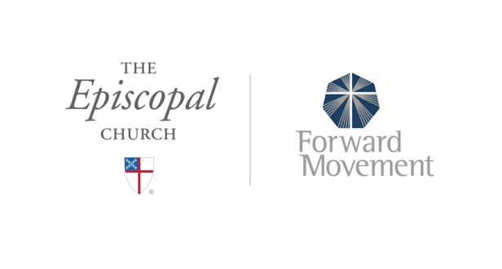
Sermons that Work and Bible Studies that Work are a joint offering of Forward Movement and The Office of Communication at The Episcopal Church.
https://www.episcopalchurch.org/bible-study/
https://www.episcopalchurch.org/sermons-that-work

