Good Friday (A)

[RCL] Isaiah 52:13-53:12; Psalm 22; Hebrews 10:16-25 or 4:14-16; 5:7-9; John 18:1-19:42

When the Crowd Yells Something Awful

The passion narratives in the gospels contain many voices. In today’s gospel, we primarily hear the voices of Jesus, Peter, and Pilate. Since the gospel references passages of scripture written earlier, we also hear the voice of the prophet Zechariah, who wrote, “when they look on me, on him whom they have pierced, they shall mourn for him, as one mourns for an only child, and weep bitterly over him, as one weeps over a firstborn.” We hear the voice of the Psalmist who wrote, “he keeps all his bones; not one of them is broken.” We even hear the crow of a rooster, announcing a new morning.

But we also hear the voices of crowds. These crowds are made up of unnamed, everyday people who assembled to watch—and engage with—the story of Jesus’s passion as it unfolded. And, just as this gospel reaches across time and space to weave in the voices of Zechariah and the Psalmist, so too when we gather to worship on Good Friday, in our own particular time and context, we are also woven into the story of Jesus’s passion. As we gather to watch and engage, our voices become part of the crowd.

Given that, it is important to notice what these crowds say during the story of Jesus’s passion. Their words can help us consider what we ourselves say to and about Jesus. In our daily lives, we may do our best to speak words of love, justice, and mercy. The Passion Gospels remind us that we don’t always succeed in doing so.

The first line spoken by a crowd in today’s gospel is a response to Jesus’s question, “Whom are you looking for?” The crowd responds, “Jesus of Nazareth.” This statement is probably true for us, too. If we are at a Good Friday service, we are very likely looking for Jesus of Nazareth. And this might be a comforting thought. Except, notice who is speaking this line: It is a detachment of soldiers who have come with weapons. They have come prepared to arrest Jesus violently, even to put him to death. This is probably not a crowd we would like to see ourselves as part of.

The same is true of the next time this particular crowd speaks. The soldiers yell, “Hail, King!” And we probably do intend to live our lives in a way that proclaims to God, “Hail, King!” But, how complicated this statement in our Gospel today is! On the one hand, it is a sign that a glimpse of God’s goodness and glory shine through, no matter the circumstances. Jesus is being mocked, tortured with a crown of thorns, and slapped across the face. Yet God can never be humiliated, and the truth of God does not change in the face of human hatred. But, once again, these words, “Hail, King,” are spoken by the soldiers degrading and torturing a man in their custody, a person they might soon be executing. This crowd is getting it all wrong. And often, so do we. How many times have we looked for Jesus of Nazareth and cried out, “Hail, King!” while getting things—in our relationships with God, and our neighbors—disastrously wrong?

The next words from the crowd are chilling. When asked if they wish to have released Jesus, or a bandit named Barabbas, the crowd cries out, “Not this man, but Barabbas!” It’s worth noting that the name “Barabbas,” directly translated, means “son of the father.” The crowd is ostensibly rejecting Jesus, calling out to save a bandit, but with a buried irony, they are actually admitting that the one they really want is the very one they are condemning: Jesus, the Son of God the Father.

Things do not become more promising for the crowd as the passage continues. As this passion narrative draws to its end, Jesus—who is still wearing clothes intended to torture and humiliate him—is taken before the crowd. Their immediate, unprompted response is to scream, “Crucify him! Crucify him!” When Jesus is presented to the crowd a second time, their response is the same: “Get him away from us! Make him go away! Crucify him!”

It is awful to imagine that we, the crowd, would ever shout, “Crucify him” at Jesus, without those words catching in our throats and tears coming to our eyes. And yet, we know that, over and over, we have failed to love as God calls us to love. We have made choices that hurt others. We have made choices that now interfere with our experience of God’s love for us. The guilt and shame of sin weighs horribly.

And yet, we also know that Jesus endures this dehumanizing, terrorizing torture and death precisely to free us all that is disastrously wrong. He suffers to free us from the overwhelming guilt and shame of sin.

Maybe that truth is the great irony of this passion narrative. Each time the crowd screams the most violent, humiliating words they can invent, the true meaning ends up being redemptive. Nothing we can do ever diminishes God. We can demand that God go away, but God will never leave us. When the crowd demands, “Crucify him!” they are calling for the very thing that will deliver the world from the sin and death they are perpetrating.

We know that Jesus’s death is not the end of the story. We know that Jesus rose from the dead and overcame death forever in his resurrection. We know that we are here today because the glory of Easter is only a few days away.

But right now, it is Good Friday, and we are confronted still by the cross. We are confronted by the enormous burden of the choices we have made that are death-dealing. It is uncomfortable to acknowledge how many times we have shouted, “Crucify him!” through our words and actions.

But, today, we have the opportunity to repair the damage of our past choices, and to reflect on how we can make better choices moving ahead. We are given a chance to be honest with ourselves and with God, to finally confront the wreckage of our pasts. God will never go away. Knowing that Jesus has already conquered sin and death, we can begin the process of healing, following him to the cross and toward the life that waits on the other side.

The Rev’d Erin Morey serves as Rector of the Episcopal Church of the Holy Innocents in Beach Haven, NJ. She is currently enrolled in a D.Min. program at Pittsburgh Theological Seminary. Erin graduated from the University of Pittsburgh School of Law in 2002. She previously served as an Assistant Public Defender in Allegheny County, Pennsylvania, an Advocate at Women’s Center & Shelter of Greater Pittsburgh, and as a volunteer attorney with Neighborhood Legal Services. This March, Erin served on the Episcopal Church's delegation to the United Nations Commission on the Status of Women.

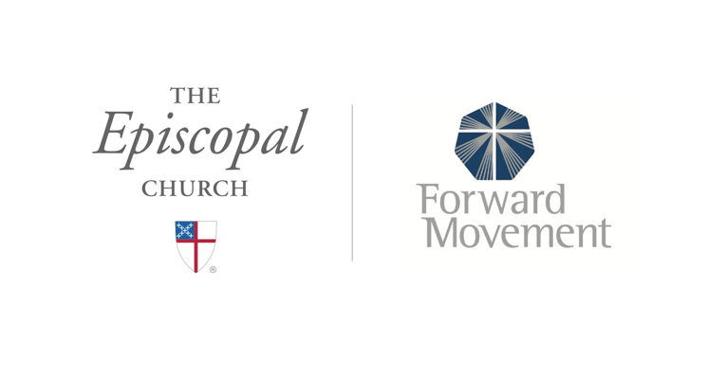
Sermons that Work and Bible Studies that Work are a joint offering of Forward Movement and The Office of Communication at The Episcopal Church.

https://www.episcopalchurch.org/bible-study/
https://www.episcopalchurch.org/sermons-that-work

