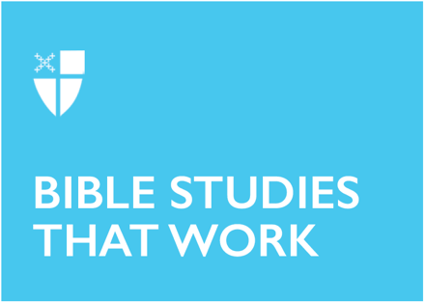

Palm Sunday – Sunday of the Passion

RCL: Isaiah 50:4-9a; Psalm 31:9-16; Philippians 2:5-11; Matthew 27: 11-54

Collect |

Almighty and everliving God, in your tender love for the human race you sent your Son our Savior Jesus Christ to take upon him our nature, and to suffer death upon the cross, giving us the example of his great humility: Mercifully grant that we may walk in the way of his suffering, and also share in his resurrection; through Jesus Christ our Lord, who lives and reigns with you and the Holy Spirit, one God, for ever and ever. Amen.

Content |

Just days before the Passover, Jesus rode into Jerusalem and was greeted with shouts of praise and messianic hope by the people, who hailed him as their king and gave him the most meaningful expressions of welcome. Significantly, the crowds laid their cloaks on the road and waved palm branches, shouting, “Hosanna in the highest!” Jesus’s entrance into Jerusalem caused a tremendous commotion. Matthew describes the event: “When Jesus entered Jerusalem, the whole city was stirred and asked, “Who is this?” (Matthew 21:10). In fact, scholars note that the word translated as “stirred” in verse 10 is far too mild and would be better rendered as “shaken,” evoking the force of an earthquake.

It was intentional and purposeful that the people waved palm branches, since carrying palms and other branches represented victory and success. This connection recalls the line of the psalm, “The righteous will flourish like a palm tree” (Psalm 92:12–15). The act of spreading out one’s garment was a gesture of recognition, loyalty, and a promise of support, echoing the scene in 2 Kings 9:13 when garments were spread before Jehu as he declares his kingship over Israel.

As the garments are spread on the road into Jerusalem, the message is clear: Jesus is the king Israel has been awaiting.

Theological Reflection |

The question of Jesus’ true identify comes up again today’s gospel account as Jesus stands before Pilate, who asks, “Are you king of the Jews?” Jesus simply replies, “You say so.”

It is clear from his line of questioning that Pilate recognizes that the Jewish leadership was motivated to bring charges against Jesus because they were fearful of his expanding authority, especially how it threatened their own standing within the established order. Yet Pilate clearly recognizes Jesus’ innocence and tries to give him a way out of the accusations, especially by offering the notorious criminal Barabas in exchange for Jesus. And yet the Jewish leadership choose to release Barabas, a criminal, instead of Jesus. Jesus is subject only to God his Father—and not to the Jewish Law or the Roman imperial power—a truth he has embodied throughout his earthly ministry.

Pilate having washed his hands of Jesus’s fate, Jesus is now left to endure suffering and death at the hands of his accusers. As the events of Jesus’s crucifixion unfold, we see the soldiers dress him in a purple robe with a crown of thorns and a reed in his hands, mockingly proclaiming him as a king. His purported kingship is not contested, but it is mocked and jeered at. The crowds, and even the bandits, join in taunting this so-called king.

In Jesus’s calm responses to the mockery and torment inflicted on him, we see his humility and unwavering commitment to his Father’s will. Jesus stood alone and abandoned but remained steadfastly obedient and faithful, even when facing such grave injustice. He remains faithful even unto death.

The moment of Jesus’ death would change the world forever. A significant detail in the gospel narrative marks this change: the massive thick curtain in the temple in Jerusalem—which was the most holy place, accessible only to the high priest—was ripped in two. In this sign, we see that humanity now has immediate and unfettered access to God—not through the high priest once per year, but through the grace ushered in when Jesus gave his life in sacrifice, the lamb of God.

Even though the chief Priests and Pharisees, the jeering crowd and Roman soldiers, did their best to discredit and mock Jesus as “King of the Jews,” one Centurion who commanded the Roman soldiers was overcome by faith and compelled to acknowledge that Jesus was indeed the Son of God. We see in his conversion the biblical promise that

at the name of Jesus
every knee should bend,
in heaven and on earth and under the earth,
and every tongue should confess
that Jesus Christ is Lord,
to the glory of God the Father. (Philippians 2:11-12)

Discussion Questions |
- What do the actions of the crowds who welcome Jesus reveal about human expectations of authority and God’s redemptive actions? Where do you see yourself in this story?
- How does Jesus’ humility and obedience in trial, crucifixion and death expand and redefine our understanding of authority in God’s kingdom?
- What questions do you have for Jesus about how the last days of his life unfolded?

Faith in Action |

This week, reflect on how you receive Jesus into your life. Do you wave palm branches and lay your garments down? Do you ask questions, as Pilate did? Do you turn away when the scene becomes too dark to bear? Consider how the events of Holy Week and Christ’s Passion invite you to follow along in the footsteps of the Lord. Notice what arises in you: of guilt, of grief, of hope.

Jerrick Rutherford was born and raised in Guyana, South America, and is currently a Postulant for the Priesthood in the Diocese of Newark. He earned an Associate’s degree in Education from the Cyril Potter College of Education and a Bachelor’s degree in Education from the University of Guyana. He also holds a Master of Science in General and Special Education as well as a master’s degree in School Leadership from Columbia University and is presently completing a Master of Divinity at Bexley Seabury Theological Seminary.

A lifelong educator, Jerrick has taught in Guyana, Botswana, and New York City. He currently serves as Vice Principal of Bronx Bridges High School, a public high school dedicated to serving English Language Learners. His professional work reflects a strong commitment to equity, leadership, and the transformative power of education.

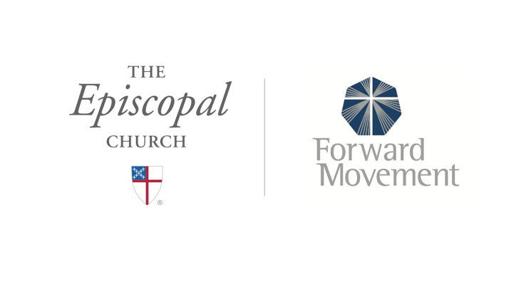
Sermons that Work and Bible Studies that Work are a joint offering of Forward Movement and The Office of Communication at The Episcopal Church.

https://www.episcopalchurch.org/bible-study/
https://www.episcopalchurch.org/sermons-that-work

