Tuesday in Holy Week

[RCL] Isaiah 49:1-7; Psalm 71:1-14; 1 Corinthians 1:18-31; John 12:20-36

Children of Light

Today, we speed forward in the story of Jesus’s life, and toward his death.

On this Tuesday of Holy Week, Jesus offers the crowds in Jerusalem his final public words before his arrest. He will have more words for his disciples when they gather afterward in private, but this is Jesus at his most public. He has processed through the city to the songs and the acclamation of the crowds, waving branches and shouting Hosannas. They have seen and rejoiced with him—perhaps this is the king who will save them from all that oppresses them? Now, he speaks directly to them for the final time.

How poignant this detail: that some Greeks come to Philip and ask him directly, “Sir, we wish to see Jesus.” Six words full of yearning—a request that seems so simple—words we ourselves might echo, at certain points in our lives. The story wants us to know that those who are asking are definitely not Hebrews. These are not people of Jesus’s inner circle, but are from outside. Perhaps, even, they are people just like us.

Jesus’s response to them—and to the whole crowd that is assembled—is perplexing. He says that to see and follow him will come at a cost. Those who come to him—not only to see him, but to follow him—must also be prepared to follow in his steps after he is gone. Following the way of Jesus may be hard, may be sacrificial. It may not be a path full of glory and “Hosanna!”

Jesus lifts up his paradoxical message, one as puzzling to the disciples as to the crowds surrounding him: To truly live, one must be prepared to die. The grain of wheat must fall into the earth; only then will it sprout and bear fruit.

With these words, Jesus speaks not only of himself, but directly to those who will be challenged with spreading his light in the world after he leaves and returns to God.

All the readings today want to point toward the light, even in this hard week. Jesus tells the puzzled crowds who want to hang on to him that “the light will be with you for a little longer.” If you walk in the darkness, you do not know where you are going, says Jesus. He means that literally: when we blunder around in the darkness, we cannot see the path before us, and we are likely to run into obstacles.

Presbyterian minister, author, and tv personality Fred Rogers (of “Mr. Roger’s Neighborhood”) reminded people that everyone had childhood fears. We might grow out of them, even forget all about them, but they’re still back there, somewhere, in our mind. He once said that when we become adults, we forget what it was like not to be able to reach the light switch for ourselves. When we were small, we had to rely on others to light the room for us.

We forget that once we needed someone else to turn on the light for us.

This holds true for the teachings of Jesus: Someone had to show us the way to the light, to teach us about Jesus’s birth, life, death, and resurrection. Someone had to tell us about Jesus’s great love and call on us to do the same for others. Even those of us who have heard the story of Jesus can forget, when things are very good or very bad, that there is Gospel good news. We can forget that Jesus is the light who has gone before us.

Even after we’ve become adults—able to easily flip that switch ourselves now—there is still that child somewhere inside us who lives in fear of being stuck in the dark. Worldly forces around us play on those fears; they hope to offer us substitutes for the true light that is Jesus Christ. They offer us riches or false worship, security or hope in earthly riches. Such things can seem like a sure light in times of darkness—but they will lead us astray, away from the true Light of the world.

This Holy Week, as we walk with Jesus toward the cross, we walk towards what seems like absolute darkness. Even if we know in advance that death will not have the final word, there are still hard things before us: grief and suffering and loneliness and pain.

Yet Jesus himself reminds us that we are not hopeless; nor are we powerless. We may not be wise, or powerful, or of noble birth, but God chooses people just such as us to not only keep company with Jesus, but to shine his light for others to see. Others have turned on the light for us when we couldn’t quite reach it ourselves. They shared faith, or hope, or kindness, or love, in the name of Jesus. We must do the same, in turn, for others.

When Jesus speaks his last words to the crowd, God affirms those words, offering assurance to his son that God will be present with him through the days ahead. The crowd seeking to understand does not hear the same words, only something vague and rumbling—like thunder, like the voice of an angel.

Then Jesus speaks his last public words: “The light is with you for a little longer. Walk while you have the light, so that the darkness may not overtake you. If you walk in the darkness, you do not know where you are going. While you have the light, believe in the light, so that you may become children of light.”

As we walk through this week together, continue to look to the light, that we may become children of light.

God’s glory cannot be diminished by any evil that continues to lurk in the corners of our world. Remember that the Gospel of John begins by teaching that “the light shines in the darkness, and the darkness cannot overcome it” (1:5). In Jesus’s last words to the crowd, we are called to be children of light. We are called to shine with the light of Christ, to the glory of God, no matter what darkness might still be lurking under the bed.

When you are most afraid, know that that light is still within you, and it cannot be put out—not by powers, or principalities, not by those in authority, or those yet to come.

Shine, children of the light, knowing that darkness has no power over you—not now, and not ever. Shine, and give glory to your Father, who is in heaven.

Amen.

The Rev. Amy Morehous is the Sr. Associate Rector at Church of the Ascension in Knoxville, TN. She is also a Spiritual Director, a fiber artist, an asker of questions, and a lover of laughter in all forms. She shares her life with her spouse, one grown-up kid, a whole host of family and friends, one dog and far too many cats.

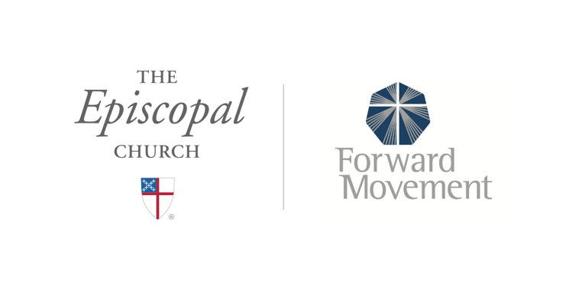
Sermons that Work and Bible Studies that Work are a joint offering of Forward Movement and The Office of Communication at The Episcopal Church.

https://www.episcopalchurch.org/bible-study/
https://www.episcopalchurch.org/sermons-that-work

