Wednesday in Holy Week

[RCL] Isaiah 50:4-9a; Psalm 70; Hebrews 12:1-3; John 13:21-32

The Cross Defeats Shame

As we continue our journey through Holy Week, we attempt to be faithful to Jesus in his hour of need. We show up. We listen. We pray. And we ask ourselves some hard questions: What prevents us from following him? What drives us away from his presence? What keeps us from living up to our aspirations to love God and our neighbor with freedom and joy?

Shame. Shame shows up across all our texts today, and it turns out that shame is one of the deadliest barriers between us and Jesus.

Our Hebrew scripture lesson is the third of the four “Servant Songs” in Isaiah. Although this text can stand on its own with its own rich meaning, as Christians we can also hear these verses in the voice of Jesus. The song points to the pain and indignity of what Jesus will suffer on Good Friday—and his willingness to endure it: “I gave my back to those who struck me, and my cheeks to those who pulled out the beard; I did not hide my face from insult and spitting.” Pulling out someone’s beard and spitting on their face are painful ways of imparting shame to someone. They demean and devalue the victim.

Much of what happens to Jesus on the final day of his life was designed to inflict shame along with pain, all the way up to and including his death on the Cross. Crucifixion was never intended to kill someone efficiently. Death could be accomplished much faster and more efficiently by beheading them, as happened to John the Baptist. Crucifixion is a slow, painful death in full view of the world. It is meant to be a spectacle of shame: showing everyone that the crucified person is a criminal, the dregs of society.

And in the process of death by crucifixion, the victim is robbed of all dignity. As they slowly lose strength, they are subjected to animal pain, losing control over their body and their mind in full public view. As with all shaming methods, this death robs the victim of their identity, crushing them completely until they die.

It is unlikely that any of us will ever have to go through something as terrible as death by crucifixion—though we must always remember our siblings around the world, of all faiths, who are persecuted for their beliefs. But what the world did to Jesus on the cross—killing him not just with violence, but with shame—the world also tries to do to us.

It happens in a thousand, small ways. You are not smart enough, fit enough, young enough, rich enough, religious enough, or whatever other standard people might apply. You are not enough. That is what the world tells you.

And if you listen, you will die.

You will die, just like Judas. Think about Judas and Peter for a moment. They both abandoned Jesus. They both betrayed him. They both sold him out, gave him up, denied him, and left him to die alone. All of their best intentions and dearest hopes were destroyed by their own self-interest and the triumph of their baser selves, when the critical moment came.

But Peter survived, and Judas did not. Peter came back, and Judas did not. Peter was redeemed, and Judas was not, at least not on earth.

And that’s because Judas gave in to shame.

The world imparts shame to us all. Regardless of merit, we will be shamed. But in scripture we see that the determining factor of whether or not an individual allows their shame to penetrate, to dominate, and to destroy them is whether or not they turn to God in the midst of it.

When we feel shame—when we know that we’ve done wrong or when we feel like we’re not enough—is when it’s hardest to turn to God. We want to hide away, cover our wounded vulnerability, avoid the truth, and numb our pain. But this is when we need God the most. This is when God welcomes us with utmost tenderness.

Peter took the risk to turn to Jesus in his shame and was restored. Judas did not. Judas did not, and it killed him.

Isaiah’s Servant Song sets the example: “I did not hide my face from insult and spitting. The Lord God helps me; therefore I have not been disgraced; therefore I have set my face like flint, and I know that I shall not be put to shame; he who vindicates me is near … It is the Lord God who helps me; who will declare me guilty?”

Jesus was not destroyed by shame—not even by the shame of the cross—because his heart was safe in the keeping of God the Father, even in the midst of his suffering.

The author of the Letter to the Hebrews drives the point home in today’s lesson: “Since we are surrounded by so great a cloud of witnesses, let us also lay aside every weight and the sin that clings so closely, and let us run with perseverance the race that is set before us, looking to Jesus the pioneer and perfecter of our faith, who for the sake of the joy that was set before him endured the cross, disregarding its shame, and has taken his seat at the right hand of the throne of God. Consider him who endured such hostility against himself from sinners, so that you may not grow weary or lose heart.”

Jesus disregarded the shame of the cross. In fact, he turned it inside out. As the collect from yesterday summed it up: “O God, by the passion of your blessed Son you made an instrument of shameful death to be for us the means of life.” The ultimate tool of destroying a person’s self-worth and identity—a punishment inflicted on Jesus for being who he was—becomes the very means by which Jesus saved the world, by pouring himself out in love.

Our task is not to avoid shame, but to take our broken, ashamed hearts to God, trusting that God is our vindicator, our defender, and our redeemer. Whether our shame is learned from the world or earned by our sins, God receives it with healing grace.

At the Last Supper, Jesus does not reveal Judas as his betrayer by name. The disciples sit together and ponder: “Could I be the one who betrays him?”

We ask, “Could I be the one who betrays him?” The answer is yes, and the answer hurts.

But there is also another question we are invited to ask ourselves today: “Could I be the one who loves him?” The one who stays? The one who returns? The answer is yes, and that answer heals.

And so our call, this Holy Week, is to turn to God with our shame and to let ourselves be healed. We are called to “lay aside every weight and the sin that clings so closely” as Hebrews put it.

But our call does not stop there.

On the cross, Jesus is a beacon of light to a whole world of people who are aching for someone to know them, to remember them, to love them.

We are called to join the faithful few who gathered on Calvary. We are called to draw others into the circle. We are called to spread the light of Christ as far as we can, beckoning to him all those who are too ashamed to believe God would die for love of them.

The Rev. Canon Whitney Rice (she/her/hers) is an Episcopal priest who serves as the Canon for Evangelism & Discipleship Development for the Episcopal Diocese of Missouri. She is a graduate of Yale Divinity School, where she won the Yale University Charles S. Mersick Prize for Public Address and Preaching and the Yale University E. William Muehl Award for Excellence in Preaching. She has taught undergraduate courses at the University of Indianapolis and has contributed to Lectionary Homiletics, the Young Clergy Women’s Project journal Fidelia’s Sisters, and other publications. She has served as a researcher and community ministry grant consultant for the Indianapolis Center for Congregations and is currently a member of The Episcopal Church’s Evangelism Council of Advice. A communicator of the gospel at heart, she writes and teaches on a wide variety of topics, including rethinking evangelism, stewardship, leadership, women’s theology of the body, mysticism, and spiritual development. When she’s not thinking about theology, particularly the intersection of evangelism and justice work (which is all the time, seriously), you’ll find her swing dancing. Find more of her work at her website Roof Crashers & Hem Grabbers (www.roofcrashersandhemgrabbers.com).

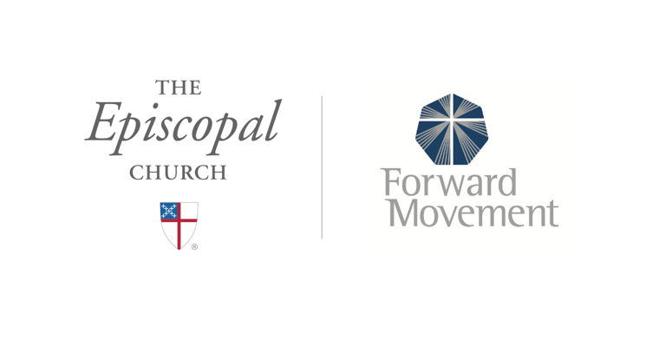
Sermons that Work and Bible Studies that Work are a joint offering of Forward Movement and The Office of Communication at The Episcopal Church.

https://www.episcopalchurch.org/bible-study/
https://www.episcopalchurch.org/sermons-that-work

