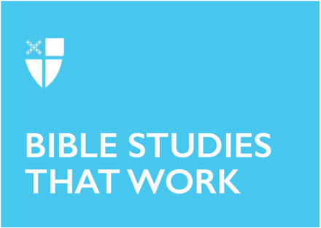
Pentecost (A)
May 10, 2026
[RCL]: Acts 2:1-21; Psalm 104:25-35 & 37; 1 Corinthians 12:3b-13; John 20:19-23 or John 7:37-39

Opening Prayer |
Almighty God, on this day you opened the way of eternal life to every race and nation by the promised gift of your Holy Spirit: Pour out this gift anew upon your Church, that by the preaching of the Gospel your saving grace may reach to the ends of the earth; through Jesus Christ our Lord, who lives and reigns with you, in the unity of the Holy Spirit, one God, for ever and ever. Amen.
Context |
Acts 2:1-21 marks a major turning point in the story of the Church. The book of Acts begins with the risen Jesus preparing the disciples for life after his ascension, promising that they will receive power when the Holy Spirit comes upon them (Acts 1:8). The soon-after day of Pentecost is the moment when that promise is fulfilled. Gathered together in Jerusalem for the Jewish festival of Pentecost, the disciples experience the Spirit as wind, fire, and speech.
This passage shows how the gospel begins to move outward into the world. Jerusalem was filled with pilgrims and residents from many regions, languages, and cultures. When the Spirit comes, the gathered crowd hears the disciples speaking about God’s deeds of power in many tongues. The miracle is not a collapse of difference into sameness. Rather, God’s message is heard across human difference.
The passage also introduces a key theme in Acts: The Spirit creates a community that is both rooted in Israel’s story and open to a widening circle of people. Peter interprets the moment by quoting the prophet Joel, showing that this surprising event belongs within the arc of God’s long-promised purposes. The Spirit is poured out widely, not narrowly: on young and old, on women and men, and even on those with little social standing. Acts 2 invites readers to see Pentecost not as an isolated wonder, but as the beginning of the Church’s Spirit-filled witness in the world.
Theological Reflection |
Acts 2:1-21 reveals that the life of the Church begins with (and relies on) gift rather than achievement. The disciples do not manufacture courage, insight, or mission for themselves. They wait together, and the Holy Spirit comes to them. Before the Church speaks, teaches, or serves, it receives. That pattern remains important. Christian witness is grounded first in God’s action.
The signs surrounding the Spirit’s arrival are vivid and physical. Wind fills the house. Tongues of fire appear. Speech bursts forth. These images suggest movement, energy, and transformation. The Spirit is the active presence of God, drawing a fearful and limited community into a new life.
One of the most striking features of this passage is language. People from many places hear the disciples speaking in their own native languages. This is a moment of deep recognition. The good news of God’s mighty works is not delivered in a way that requires everyone to become the same. Instead, the gospel is spoken so that each person may hear. Pentecost shows that the Spirit honors human diversity while creating communion within it.
That detail matters for the Church in every age. Communities of faith can easily drift into forms of speech, practice, or assumption that are clear to insiders but difficult for others to receive. Acts 2 presents another model. The Spirit leads the Church outward, toward intelligibility, hospitality, and encounter. The message of God is not locked away in a single culture or style. It is spoken for the life of the whole world.
The crowd’s reaction to the Pentecost event is mixed. Some are amazed and perplexed, asking what this means. Others mock the disciples and dismiss the event. This contrast shows that the work of God does not always appear obvious or respectable. The presence of the Spirit may unsettle expectations. It may disturb familiar categories. Yet Peter does not retreat from the moment. He stands and interprets it through Scripture, quoting Joel’s vision of God pouring out the Spirit on all flesh.
That phrase, “all flesh,” is central to this passage. The promise is expansive: sons and daughters shall prophesy; young men shall see visions; old men shall dream dreams. Even those of low social status are included. The Spirit is not reserved for a spiritual elite. Pentecost reveals a God who gives generously and calls broadly.
This passage also reminds readers that the Church is born in public. The Spirit does not come only for private reassurance. The disciples are empowered to bear witness in the midst of a crowded and divided world. Pentecost is not an escape from human difference, confusion, or tension. It is God’s answer within them. The Spirit forms a people who can speak of God’s deeds of power in ways others can hear.
Peter’s final word from Joel is a promise: “Then everyone who calls on the name of the Lord shall be saved.” That verse gathers the whole passage into hope. The signs are dramatic, the crowd is unsettled, and the future is opening in unexpected ways, but the direction of the story is clear. God is moving toward people in mercy. The Spirit comes to widen the reach of divine grace, to gather people into praise, and to send the Church into faithful witness.
Pentecost therefore invites our slow and careful attention. It asks readers to consider where the Spirit may still be creating understanding across difference, raising unexpected voices, and calling the Church beyond fear into joyful proclamation.
Reflection Questions |
- What stands out most to you in the imagery of wind, fire, and many languages in this passage? Why might that image resonate?
- What might it mean that each person hears the good news in their own native language?
- How does Peter’s quotation from Joel expand the reader’s understanding of who receives the Spirit?
- Where might the Church today need to become more open, understandable, or hospitable in its witness?
- What does this passage suggest about the connection between the Holy Spirit and the public life of faith?
Faith in Practice |
This week, set aside time to listen carefully to someone whose experience, background, or perspective differs from your own. Practice listening without rushing to respond. As an act of prayer, ask the Holy Spirit to deepen your understanding and enlarge your compassion. Pentecost reminds us the Church that God often builds community not by erasing difference, but by helping people hear one another more fully. How will you listen this week

Quincy Hall is Deacon-in-Charge at St. Mark’s Episcopal Church in Birmingham and St. Andrew’s Episcopal Church in Montevallo. He is passionate about preaching good news for a wounded world and helping the Church become a place of beauty, mercy, justice, and belonging. A Franciscan at heart, he shares life and ministry with Francis, his schnauzer and unofficial office manager who reminds him to take time for fresh air and a little fun.
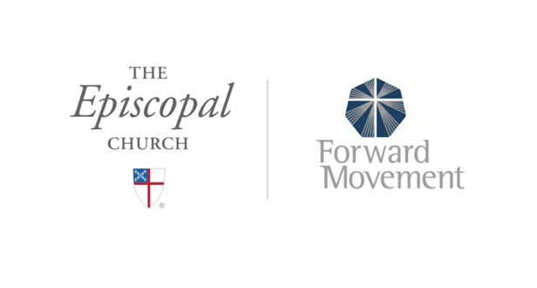
Sermons that Work and Bible Studies that Work are a joint offering of Forward Movement and The Office of Communication at The Episcopal Church.
https://www.episcopalchurch.org/bible-study/
https://www.episcopalchurch.org/sermons-that-work

