Pentecost (A)

[RCL] Acts 2:1-21; Psalm 104:25-35 & 37; 1 Corinthians 12:3b-13; John 20:19-23 or John 7:37-39

The Prophetic Imagination

On Valentine’s Day 2018, 17 people died tragically at Marjory Stoneman Douglas High School in Parkland, Florida. The event grabbed headlines around the world: another senseless act of violence carried out in one of the places where kids should feel most protected and secure.

But it was what came in the weeks and months after that Wednesday in February that made this tragedy different from all the others that had preceded it. A group of 28 students at Marjory Stoneman Douglas decided that they had had enough. They pooled their resources and used their voices to call on their peers to show up and to speak out against gun violence. Five weeks later, almost half a million people—students, teachers, parents, and concerned citizens— answered the call of those 28 students and gathered in Washington, D.C. for the first ever March for Our Lives. NPR reported that the D.C. march was one of 800 such events that took place that day in the United States.

This might seem like an unusual way to begin a sermon for Pentecost, but there is a lingering question worthy of our consideration: What if the work those 28 students started in 2018 was more than just a righteous reaction? What if it was the work of the Spirit, moving in a new way in the hearts and minds of young and old alike?

This is, after all, where Peter begins his Pentecost sermon: “In the last days, God declares, I will pour out my Spirit upon all flesh, and your and daughters will prophesy.” These words, spoken just 50 days after the tragedy of Good Friday and the bewilderment of Easter Sunday, changed the tone for the earliest followers of the Jesus Movement. For weeks, they had been waiting and praying, perhaps somewhat nervously, wondering what might come next. And it was into this uncertain and chaotic situation that the Spirit brought new hope, a new life for all followers of Jesus.

What happens next seems surprising, jarring almost, but it shouldn’t be. This has been the Spirit’s work since the very beginning. At the beginning of creation, over the waters of the deep—tehom (teh-home') in the Hebrew scriptures—Spirit was there, hovering, waiting, participating in new life against the backdrop of chaos and disorder.

During the times of the prophet Joel—the figure whom Peter used as inspiration for his Pentecost sermon—the people looked in anticipation for the Spirit’s arrival in their own moment of chaos and uncertainty. In the days of Joel, drought, wildfire, and swarms of locusts had led to severe famine across the land. People were losing hope. Despair and death were everywhere. And in the midst of that tragedy, the prophet received a promise: The suffering would not last forever. The rains would fall, the fields would again be green, the livestock would be healthy. But the restoration of Israel and Judah went well beyond streams and pastures; it included the heart too. Because in those days when everything was set right again, God’s Spirit would be poured out on everyone, young and old alike.

In our own chaotic and uncertain present, we are invited to consider how the words of the prophet Joel, echoed centuries later by the apostle Peter, are reflected in the daily lives of young people. Results from the 2025 edition of the annual Harvard Youth Poll show that young Americans have some serious concerns about the state of our country and our world. Their concerns include the rash of political violence we face, the lack of civility and productivity within the public sphere, the decline in accessibility of healthcare, the rapid increase in overall cost of a living—including their own grim prospects for future employment—and the impact of a world shaped by artificial intelligence. They are aware of what is happening in our country and around the world, and they are concerned. And if 28 students from Parkland, Florida, can teach us anything about this generation, it is this: Young people don’t linger with discontent. Instead, they dream about the world as it could be, and then they show up to try to make that world a reality.

Dissatisfaction with the present, coupled with the willingness to work for a different and better future, is the work of the Spirit—what the late Walter Brueggemann called “the prophetic imagination.” In his classic book The Prophetic Imagination, Brueggemann writes that the job of the prophet is to cultivate an alternative consciousness, one that “dismantles the dominant consciousness” of its own day while simultaneously engaging the “promise of another time and situation toward which the community of faith may move.” Can you, today, imagine a world in which gun violence no longer exists? What about a future where poverty is history? A future where everyone has enough to eat, access to clean water, and adequate healthcare? If you struggle to picture that kind of future, there is probably someone in your life right now who can imagine it. Go and ask someone in their teens or twenties—and prepare to be surprised.

This Pentecost, perhaps it is time for those of us with a little more experience to practice humility and listen attentively to both the concerns and the dreams of the young people among us. Criticism comes easily for most of us, but when we rest in our criticism alone, we miss the creative capacity of the Spirit that is evident with the younger generations: The audacity to move beyond criticism into a creative imagination of a hopeful future. This is the life of the Spirit moving among us, doing what the Spirit has done since the beginning: calling forth new life out of the chaos of the present. Amen.

The Rev. Dr. Perry M. Pauley is the fifth Rector of All Saints’ Episcopal Church and Day School in Phoenix, Arizona. Before becoming a priest, Perry spent more than a decade as a professor of Communication, working at Cal State Fullerton, San Diego State, and Arizona State. He’s been married to Michelle since 2003, and together they have two kids, Elias and Alayna. When he’s not working on a sermon, you will probably find him in the kitchen. He has also been known to play drums with the jazz ensemble at All Saints’ a few times a year.
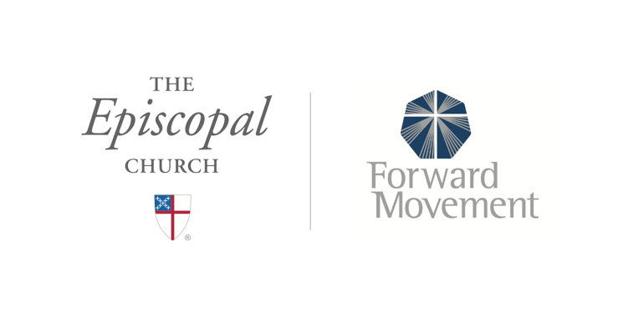
Sermons that Work and Bible Studies that Work are a joint offering of Forward Movement and The Office of Communication at The Episcopal Church.

https://www.episcopalchurch.org/bible-study/
https://www.episcopalchurch.org/sermons-that-work

