Easter 4 (A)

[RCL] Acts 2:42-47; Psalm 23; 1 Peter 2:19-25; John 10:1-10

Whose Voice?

Jesus often refers to his followers as sheep. Likely Jesus is picking up here on the familiar imagery of the twenty-third psalm, which describes God as a shepherd who guides us all the days of our lives.

Scriptural as the imagery may be, some people might prefer not to be referred to as sheep. Some are even offended by this image, and that’s probably because it has long been assumed that sheep are so … dumb.
Indeed a popular, derogatory term for a group of people acting stupidly is: “sheeple.”

So you might be surprised to learn that scientists from the University of Cambridge have proven that sheep are not dumb at all. In fact, they have a high degree of intelligence within the animal kingdom. The researchers performed several in-depth studies with sheep and demonstrated that the average sheep can recognize and easily distinguish between at least fifty other faces—of their fellow sheep, humans, and other species—and that this memory stays with them over a period of several years. This is a definite sign, the scientists said, of intelligence. Additionally, they found evidence that sheep are capable of a wide range of emotions—another signal of higher levels of intelligence.

So why does the idea that sheep are dumb persist? There’s actually a good reason for it, and that is because sheep act stupidly whenever they become frightened. As herd animals, they will do very dumb things when fearful. Of course, the lead scientist of the sheep study did offer the reminder that, “Any animal, including humans, once they are scared, don’t tend to show signs of intelligent behavior.”

While humans are recognized as the most intelligent species on the planet, maybe it is, in part, because of our tendency to react so often and blindly to fear that Jesus so often referred to us as sheep.

And yet there might be one important way that sheep have the upper hand on humans. Jesus teaches that sheep know the shepherd’s voice when they hear it. Do we know the Good Shepherd’s voice when we hear it?

Among the many, many competing voices in our world, one of the dominant and most controlling voices is the voice of fear. America has even been called a “culture of fear,” as peddlers of fear appeal to our deepest anxieties in order to gain power and advantage. Politicians, much of the media, advertisers, and advocacy groups, among others, peddle fear to gain advantage or profit. And there are likely many others in our lives who frequently speak fear into our hearts.

These individuals and groups may have different motives and methods for peddling fear, but none of them are terribly beneficial to us. Broadcasters, influencers, and the media seek sensational, often fear-inducing stories to ensure that people will tune in and stay hooked. Advertisers use fear to sell their products. This has been recognized since Edward Bernays applied psychology and the theories of his uncle, Sigmund Freud, to marketing. In his 1928 book Propaganda, Bernays asks, “If we understand the mechanism and motives of the group mind, is it not possible to control and regiment the masses according to our will without their knowing about it?” Marketers have said, “yes.” There’s even a branch of psychology called “neuromarketing,” which studies the human brain’s response to different kinds of advertising! And guess what they’ve found? Fear sells. Insurance companies are notorious for evoking fear, even “mayhem” (to borrow the lingo of one popular campaign). Medical and drug-related ads often start out with statements like, “Every 30 seconds someone dies of a heart attack” to get your attention and money. And we shouldn’t forget about the commercials that cause us to fear simply being inadequate, failing, or being publicly humiliated in some way—with only their product as the cure.

And what about politicians? Fear can be harnessed to get politicians elected: just convince enough of the public that you will keep them safe from various dangers—as you define them. Fear is also used by some politicians to get people to acquiesce to policies or practices they would otherwise oppose. This tactic is not new. Nazi leader Hermann Göring explained that if people can be made fearful, they may support a war they otherwise wouldn’t accept. He said: “The people don’t want war, but they can always be brought to the bidding of the leaders. This is easy. All you have to do is tell them they are being attacked, and denounce the pacifists for lack of patriotism and for exposing the country to danger. It works the same in every country.”

We are surrounded on all sides by invitations to fear. The fear peddlers in our culture sound a lot like the thieves Jesus describes in the tenth chapter of John’s gospel: those who fail to protect the flock because, “they care nothing for the sheep.” The result of their actions then, is to “scatter the sheep,” Jesus says.

Fear can keep us off balance, divided, and scattered as a people. Instead of coming together in a unified way, we can become so busy and distracted with protecting ourselves—or fighting with one another—that we don’t even realize what the thieves are up to.

We sheep desperately need a reminder to ignore—and even clearly oppose—the many voices of the thieves who surround us with fear. Instead, we need to listen to and follow the voice of the Good Shepherd, the one who calls us by name.

This shepherd leads us out of fear and division into peace and unity, where, as Jesus says, “we may be one flock under one shepherd.” The Good Shepherd, unlike the thieves, loves us. Instead of taking from us for personal gain, the Good Shepherd even gives his own life for us. In God, we really have nothing to fear because we are always in the hands of the one who loves us and will never let us go, in life and in death.

So whose voice are you listening to? Is it the voice of God, the Good Shepherd? Or the thieves? When we let go of fear, our panicked addiction to consumption, and our infighting long enough, we will hear the deeper truth: We are being called to follow the voice that beckons us to walk in the path of love.

God calls each of us by name. To hear that voice calling us above the clamor, the fear, and the thieves of this world, we have to stop, listen, and pray.

Do you know how to distinguish the Good Shepherd’s voice from the others? While many seek to control us and our choices, only the Good Shepherd loves us and leads us to still waters. You’ll know his voice because it will lead you into peace on the path of love. Even in the valley of the shadow of death, his voice will lead you to a place where goodness and mercy follow you all the days of your life. And his voice will lead to more abundant life.

The Good Shepherd loves you and calls you by name. Fear not.

The Rev’d D. Rebecca Hansen is the rector of St. Dunstan’s Episcopal Church in San Diego, and is the Diocesan Ecumenical and Interreligious Officer for the Episcopal Diocese of San Diego. She has served faith communities in Oregon, Missouri, Michigan, and Ohio. She discovered her call to ministry while serving as a missionary in Chiang Mai, Thailand, as a young adult. She shares her life with her husband, three children, and their multiple furbabies.

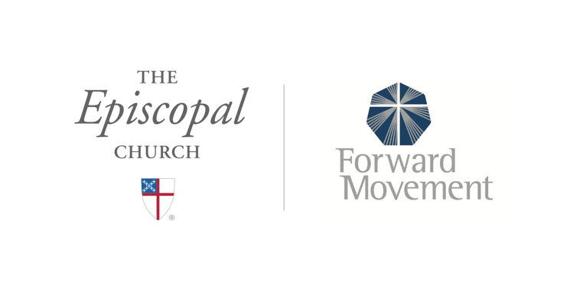
Sermons that Work and Bible Studies that Work are a joint offering of Forward Movement and The Office of Communication at The Episcopal Church.

https://www.episcopalchurch.org/bible-study/
https://www.episcopalchurch.org/sermons-that-work

