Pentecost 2 (A) – Proper 5

[RCL] Genesis 12:1-9; Psalm 33:1-12; Romans 4:13-25; Matthew 9:9-13, 18-26

Learning Tenderness

There it is again: the tenderness of God on display in the compassion and action of Jesus the Christ. It is the tenderness that welcomes desperate women who take their healing into their own hands, and irrational fathers who insist that daughters can be raised from the dead. It is the tenderness that calls disciples who have acted as traitors to their own occupied people, and hosts dinner parties that folks see, at best, as morally gray.

With the evidence of such attentive, transformative, and healing love in the gospel this morning, why do we find it so hard to engage with divine compassion? Why is it so hard to do the work of disciples, which is learning and living on an ever-deepening level—a seen-in-our-daily-lives, actionable level—that God is love, that we are loved, and that the only path to wholeness and fulfillment is the doing of that love? I say “doing love” because love is a verb, and it’s what we’re made for.

It’s just that simple… but not at all easy.

It sounds great: falling further into the endless depths of God’s tenderness and sharing that with others (all others). But how exactly are we supposed to do that? How are we supposed to do that when the people in the pulpits, wielding select Bible readings, or our own devastating life experiences, or watching 15 minutes of any news network, is so apt to plunge us into betrayal, heartbreak, and despair? We’ve been told “this is love” when experiencing actions that are vengeful and cruel, when hearing words meant to dehumanize, and when receiving punitive so-called consequences, rather than restorative justice.

How can we believe in “love” when we have been brought up in families, or have had friends or partners claiming the Christian faith whose ability to love is quite poor, despite trying their best How do we do “love” when others of us have suffered systemic injustice, presented to us as the best we deserve—as if any of us deserve racism, sexism, ageism, homophobia, transphobia, xenophobia.

If there is anybody listening today who is blessed enough to have had all your family and friends always love you well; who’s never have anyone reject you, treat you unfairly or cruelly; if no inexplicable tragedy has ever happened to you; then please feel free to use this time to catch up on your Facebook, Instagram, and email, because this sermon is not for you.
This sermon is for all of us who’ve had those with power over us use shame as motivation, physical degradation as a teaching tool, and exclusion as a way to maintain status quo.

The reality is that those of us who want to learn to give and receive divine tenderness are going to have to deal with the falsehoods, the wounds, the craziness of love that is not love.

Jesus is inviting us to unlearn ways of life that do not nourish us or strengthen the bonds of beloved community. We are invited to abandon unquestioning agreement with questionable beliefs. We can wrestle with the scriptures and explore the language and values of the cultures from which they came without abandoning faith.

Or we might need to reexamine the history of natural disasters being named “Acts of God,” which would indicate that divine love is deadly and arbitrary.

Or we might need to unravel the interwoven lessons of harm—done to some by those in God’s church—as being synonymous with how God loves and acts in the lives of God’s beloveds.

The author and Jesuit priest Gregory Boyle says it this way in his book, Cherished Belonging: The Healing Power of Love in Divided Times:

We unlearn what we need to unlearn. I suppose that because we have always insisted on a personified deity, it naturally gets us into trouble. This is where our endless projections pop up. This God is soaked through with all our stuff: judgmental, pissed off, suspicious, disappointed. Long is the list of the traits we project… In Jewish mysticism, God’s very nature is infinite compassion, and it is this merciful face of God that is imprinted on the human heart. God is compassionate and merciful, always and in everything.

And so Jesus calls us to practice this re-learning: arguing with biblical passages that have been used to serve human aims or justify human hatred.

We’re invited to the dinner party of the communion table, surrounded by the motley crew of other fallible human beings. Here we are invited to learn—with Holy Spirit’s help—to see human dignity and the face of God even in our enemies, simply because that’s also what God sees in us.

We’re receiving healing as we touch the garment of listening to and learning from the stories of Christ’s life, death, and resurrection, year after year after year. As we listen and learn, Jesus takes us by the hand, raising us from the living death of settling for anything less than bone-deep knowing that we’re absolutely adored by the One who made us, regardless of what others might call us.

We only get there by allowing the Spirit to lead us into discipleship work; into a contemplative prayer group; into incisive and discerning group Bible study; and then into living our learnings through relationship and outreach. We only get there by doing less doom scrolling and more hand holding. That’s how we receive more of who God really is: inexhaustible, relentless, transforming love.

But don’t get it twisted… This process of re-learning receiving, then doing divine love doesn’t fix everything. It doesn’t make suffering and evil suddenly cease to exist. Nor will we get satisfactory answers for why is life unfair, why bad things happen to beloved people, or why our particular and communal roads to forgiving and being forgiven might look different from our neighbors’ roads.

But what we will get is this: the voice of God on a loud, reverberating loop, saying, “I am Love. You are beloved. You are made to love and be loved. And no matter what, I’ll always be with you.”

And most of the time—probably not all of it—but most of the time, that, Beloveds, will be enough.

The Very Rev. Thelma M. (“Nikki”) Mathis is the Rector of St. Gregory the Great Episcopal Church in Athens, GA, Episcopal Diocese of Atlanta. She is also Dean of the Oconee Convocation in this diocese. For more than a decade, she has served on the faculty for the Episcopal Preaching Foundation and is currently faculty for the Learning to Lead program in her diocese. She is a contributor to Forward Day by Day, The Sewanee Theological Review, Graymoor, and the Episcopal Preaching Foundation publications Kerygma and Preaching the Beatitudes.
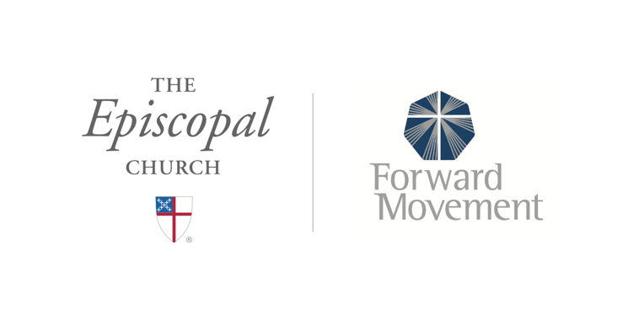
Sermons that Work and Bible Studies that Work are a joint offering of Forward Movement and The Office of Communication at The Episcopal Church.

https://www.episcopalchurch.org/bible-study/
https://www.episcopalchurch.org/sermons-that-work

