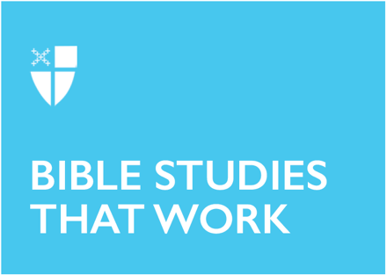

Pentecost 3 (Proper 6), Year A

June 14, 2026

[RCL] Genesis 18:1-15, (21:1-7); Psalm 116:1,10-17; Romans 5:1-8; Matthew 9:35-10:8,(9-23)

Opening Prayer |
O God, you made us in your own image and redeemed us through Jesus your Son: Look with compassion on the whole human family; take away the arrogance and hatred which infect our hearts; break down the walls that separate us; unite us in bonds of love; and work through our struggle and confusion to accomplish your purposes on earth; that, in your good time, all nations and races may serve you in
harmony around your heavenly throne; through Jesus Christ our Lord. Amen.
Context
Who is Jesus? Is Jesus a teacher, a healer, a miracle worker? Sometimes it is easy to become numb to the familiar details of scripture, including the figure of Jesus. This passage in Matthew is an opportunity to be reintroduced to Jesus.

To begin, it’s important to think about the structure of the gospels themselves. The gospels are made up of individual units of storytelling called pericopes. Biblical scholars have pointed to how different pericopes show Jesus as teacher, healer, exorcist, and miracle worker at foundational moments in his life and ministry.

The author of Matthew often focuses especially Jesus as a rabbi and teacher. Jesus’s teachings get a lot of attention in Matthew, like the three chapters devoted to the Sermon on the Mount, which helps establish Jesus’s teaching about the Kingdom of God. The Gospel of Matthew is also concerned with showing Jesus’s Jewish identity. Jesus teaches in synagogues and speaks with authority on the Torah, answering questions from—and engaging in dialogue with—religious leaders.

The passage ends with anticipation of the coming of the Son of Man, a messianic title from the apocalyptic book of Daniel. In chapter 9 of that book, Daniel has a dream of an angelic or divine being who is given authority and sits on God’s throne as regent and judge. The Book of Enoch, a popular apocalyptic text circulating in the Second Temple Period, identifies the Son of Man as the Messiah. For readers of those biblical texts, the title would have conjured images of a divine messianic figure, coming to reign over the Kingdom of God.

Theological Reflection
The first section of this passage (9:35-10:8) introduces Jesus as a disruptive force, moving from town to town and bringing change everywhere he goes. Where he encounters sickness, he brings healing. Where he encounters troubled or lost hearts, he offers compassion. Jesus announces the good news of the kingdom, but wherever he goes, the kingdom is already beginning to manifest all around him. This is how the kingdom spreads: wherever God’s presence is, the world cannot help but be changed.

In verse 37 Jesus invites the disciples into this work: “The harvest is plentiful, but the laborers are few.” His is a vision of abundance: There will be enough for everyone, if only people are willing to pitch in. The disciples (called in 10:1-2) will be drawn into Jesus’s ministry of holy disruption. In these verses, he gives them direct authority to do as he does: to cast out unclean spirits, to heal and cure diseases. In this way, the kingdom will spread from town to town, and city to city, as they bring God’s healing power to those they meet.

We see in these verses that Jesus sends the disciples out first to the people of Israel, but after his death and resurrection he will send them out to all nations (Matthew 28:18-20). And what does Jesus tell them to say? “The kingdom of heaven has come near” (10:7). This pronouncement is often understood in chronological terms as in something that will happen soon, but it can be understood in spatial terms too. The kingdom of heaven is very close. It’s as close as the next town over, where a man was healed. It’s a close as this town, where someone’s child was raised from the dead. It’s as close as the person coming to you in the name of Christ, offering compassion, like Jesus did.

In the second section of today’s lesson (10:8-15), Jesus begins teaching the disciples about the economy of God’s kingdom. In verse 8 Jesus says, “You received without having to pay.” In unhealthy economic systems, some only give and some only receive reward or payment, but the economy of God’s Kingdom is an ecosystem of interdependence. The disciples have had deep transformational encounters with Christ that led them to this point. They are not now serving to pay back what they have received—it is not transactional. Jesus is not counting up their part of some total. Rather, they are becoming part of a new community of believers, those give and receive as they have need.

In 10:9, Jesus instructs that their needs should be met, but not for profit. This vision of service is not about working until your mental, physical and emotional resources are demolished or ignoring your own needs. It is about relying on the network of hospitality and the care of others in the kingdom: strangers, friends, and fellow believers. However idealistic this sounds, Jesus doesn’t offer a naive view of reality. In verse 11 he acknowledges that not everyone will choose to participate in the economy of the kingdom. Yet it is not the disciples job to judge or punish them. Rather he tells calls them to shake the dust off their feet and leave it in God’s hands.

In the final section (10:16-23), Jesus further develops his portrait of the challenges the disciples will face in the world. Verse 16 explains that they will need to bring all their resources to bear on this calling: “Be wise as serpents and innocent as doves.” The challenges the world creates require skill and nuance to navigate, but even that won’t always be enough. Verses 19-20 suggest that when the disciples are put under pressure, they aren’t meant to have the perfect answers or know exactly what to do. They simply have to remember that God is with them and will not leave them. The passage closes with a reminder that the Son of Man, the Messiah, will soon follow. No matter the challenges they face, the kingdom of heaven is very near.

Discussion Questions |
- Where have you experienced the disruptive power of the kingdom of God in your life?
- How do you perceive and participate in the economy of the God’s kingdom?
- What message do you hear for your life today in Jesus’s teaching to his disciples about facing, faithfully, the challenges the world poses?
Faith in Practice |
Think about the community you live in and the ways your life is woven in with the lives of your neighbors. Who do you rely on and who relies on you? Reach out to your networks of community and offer support, fellowship, or care to someone this week. Schedule a time for giving or receiving hospitality. Take a friend to coffee or accept an invitation to dinner with a new acquaintance. Write a letter or invite a faraway friend to join you for a time of connection. Ask the Lord to send you out as a laborer into the harvest.

Kelsey Aebi is a Candidate for Holy Orders in the Diocese of East Tennessee, and an M.Div. student at the School of Theology in Sewanee, TN. As a seminarian, Kelsey especially enjoys the study of the Hebrew Bible, and serving as a Sacristan in the Chapel of the Apostles. In her free time, she enjoys reading fantasy and science fiction, praying the rosary, and traveling with her spouse.

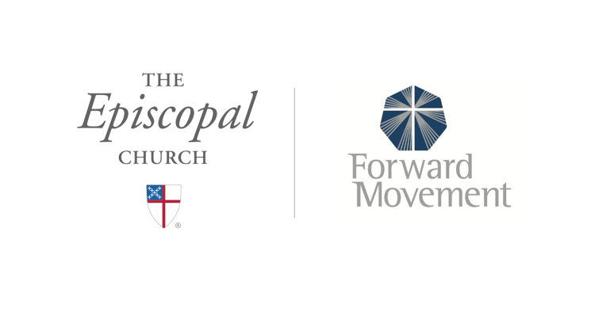
Sermons that Work and Bible Studies that Work are a joint offering of Forward Movement and The Office of Communication at The Episcopal Church.

https://www.episcopalchurch.org/bible-study/
https://www.episcopalchurch.org/sermons-that-work

