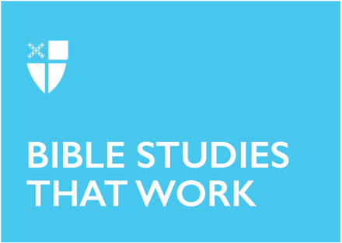

Pentecost 4 (Proper 7), Year A

June 22, 2026

RCL: Genesis 21:8-21, Psalm 86:1-10, 16-17, Romans 6:1b-11, Matthew 10:24-39

Opening Prayer |
O Lord, make us have perpetual love and reverence for your holy Name, for you never fail to
help and govern those whom you have set upon the sure foundation of your loving-kindness;
through Jesus Christ our Lord, who lives and reigns with you and the Holy Spirit, one God, for
ever and ever. Amen.

Context |
There is widespread consensus among Biblical scholars that Mark is the first gospel written, and that both Matthew and Luke use Mark as a source. All three synoptic gospels offer a linear narrative of Jesus’s life. Matthew and Luke also share material not found in Mark, and because of this, some scholars believe the authors of Mathew and Luke draw from another shared source, comprised of the sayings of Jesus.

Today’s passage from Matthew’s gospel is paralleled in Luke 12:51-53. Matthew is typically thought to be the second of the gospels written. Biblical scholars generally agree that Matthew was written toward the end of the 1st century C.E. It is often described as the most Jewish of the gospels, meaning that the author is invested in depicting Jesus and his followers as Torah observant and in connecting Jesus’s life and teachings with the texts of the Hebrew Bible.

One example of this practice can be found in the genealogy that opens the book, tying Jesus by blood and ancestry to the Old Testament. Another is the frequency of Old Testament citations found in Matthew. Today’s passage from chapter 10 of Matthew focuses on what is required of followers of Jesus and the inherent risk in discipleship. The chapter opens with Jesus empowering the disciples to cast out unclean spirits and heal diseases. It then moves on to describing the sending out of the disciples. As they are readied to do the work of Christ, Jesus instructs them about how they are to move through the world.

Theological Reflection |
Matthew 10:24-39 takes the reader on quite a rollercoaster and, on an initial read-through, can be jarring. It contains some very familiar verses, including the promise “even the hairs of your head are all counted. So do not be afraid” (Matt 10:30-31) and the challenging teaching, “I have not come to bring peace, but a sword. For I have come to set a man against his father, and a daughter against her mother, and a daughter-in-law against her mother-in-law” (Matt10:34-35). At the heart of this passage seems to be a lesson about priorities and perspective.

Jesus is trying to impart the foundation-rattling implications of the incarnation of God’s love—for human beings, particularly, and creation, more broadly. Jesus is also explaining the stakes of choosing to follow and prioritize Go—or not. “Everyone, therefore, who acknowledges me before others, I also will acknowledge before my Father in heaven, but whoever denies me before others, I also will deny before my Father in heaven” (Matt 10:32-33). This passage might feel exclusionary or harsh. But it can also be read as deeply gracious: an articulation of the radicality of Jesus’s advocacy for and love of human beings, as he draws humanity into relationship with God the Father.

This message ties directly into the thematic of priorities and perspectives. It might be helpful here to bring in the ancient Christian concept of rightly ordered desires, a concept often associated with the fourth-century bishop, St. Augustine of Hippo. Jesus’s statement, “Whoever loves father or mother more than me is not worthy of me; and whoever loves son or daughter more than me is not worthy of me; and whoever does not take up the cross and follow me is not worthy of me” (Matt 10:37-38) at first glance seems harsh and quite different from the familiar depiction of Jesus as a loving savior. However, approached with a sense of a hierarchy of desires, this teaching becomes easier to understand.

No earthly love or desire can be placed above love and desire for God without corrupting consequences. Loving one’s mother, father, sibling, or child more than God turns that family member into an idol. If instead God is placed as the ultimate love and desire, then that central relationship informs and supports all other rightly ordered relationships.

Jesus’s warning in Matthew 10:34, “Do not think that I have come to bring peace to the earth; I have not come to bring peace, but a sword,” has also proven troubling. Is this Jesus affirming the use of violence? Not necessarily. Rather, this passage should be read in the context of the paradigm shift and power inversion of the incarnation, illustrated throughout New Testament. If the norm of this world is violence, oppression, inequity, and cruelty than Jesus’s disruption of that norm constitutes an overthrowal of all systems and structures that prioritize and profit from the world as it is. Jesus points to a new system: the Kingdom of God. Jesus’s “sword” works as a divine weapon fighting against the cruelest tendencies of fallen humanity. It establishes something utterly different than any human violence, to which it stands in stark opposition.

Here again, the lens of right priority and perspective is helpful. Jesus is adamant that the things to which humans often ascribe ultimate importance are wrong. This world, as we see it, is not the ultimate reality. Its violence, its self-righteousness, its selfishness, and its hyper focus on the physical—none of these are ultimate or ultimately true. Jesus says, “For I have come to set a man against his father, and a daughter against her mother, and a daughter-in-law against her mother-in-law; and one’s foes will be members of one’s own household” (Matt 10:35-36). When read with attention to ultimate love and desire, this statement becomes legible: It’s an indictment of clinging tightly to the priorities of this world and of placing familial love before the love of God. This mis-prioritization results in a skewing of all other ordering and reinscribes our allegiance to the human status quo over the kingdom of God.

The good news in today’s gospel is that humans are brought into a transformed relationship with God the Father through the incarnational love of Christ. Ultimately, if one’s desires are rightly ordered, if God is the first priority, there is truly nothing in this world to fear; the things of this world do not have final say. Human beings are created for and invited into the eternal life of God through the transformative love of Christ. The cruelty of the world is defeated in the resurrection. And that ultimate reality sheds light on all other situations and relationships. Letting go of our misconceived perceptions about what matters is what enables us to take hold of what matters to God: “Those who find their life will lose it, and those who lose their life for my sake will find it” (Matt 10:39).

Reflection Questions |

- This is a challenging gospel lesson. What questions do you have?
- Have there been times in your life when God was your ultimate priority? If yes, what was that experience like? Did it impact your relationships with other people?
- How about now? How does your life with God show up in your daily, weekly, and monthly loved priorities?
- Anything that we love more than God becomes an idol. Are there relationships or things in your
life that might fall into the range of idolatry?
- How might we undermine the systems of violence and oppression that are normative in our world today?

Faith in Practice |

In the week ahead, practice prioritizing your relationship with God. Spend 5-10 minutes a day in silence listening for God. Consider what loving God requires of you. Be intentional about small acts that bring the kingdom to life: give time or donate to a local homeless shelter, support a local food bank, volunteer or offer support to a local animal shelter. Above all, remember that you are known and loved by God, and that this relationship is at the root of all others. How does that knowledge inform and infuse your week?

Adelle Dennis is a deacon in the Episcopal Church. She received her Master of Divinity from the School of Theology, Sewanee, TN in May 2026. She lives in Aiken, South Carolina with her husband and works in the Diocese of Upper South Carolina. She will be ordained to the priesthood in June 2026. Adelle is an Episcopal Service Corps alum and is passionate about youth and young adult formation in the Episcopal Church. She finds God in the Eucharist, intentional community, and long walks in the woods.

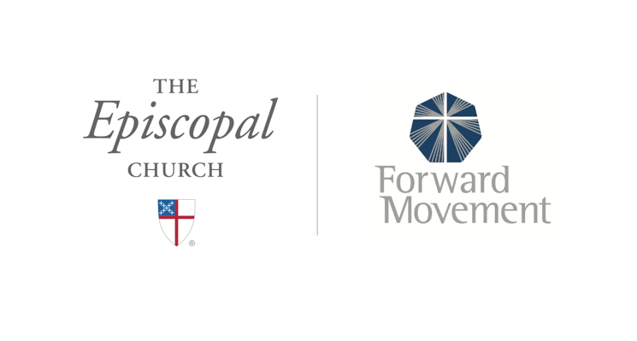
Sermons that Work and Bible Studies that Work are a joint offering of Forward Movement and The Office of Communication at The Episcopal Church.

https://www.episcopalchurch.org/bible-study/
https://www.episcopalchurch.org/sermons-that-work

