Pentecost 7 (A) – Proper 10
[RCL]: Genesis 25:19-34; Psalm 119:105-112; Romans 8:1-11; Matthew 13:1-9, 18-23

The Bound Will in the Backrooms

“There is no condemnation for those who are in Christ Jesus.”
In the name of God: Father, Son, and Holy Spirit. Amen.

Today’s reading from the letter to the Romans can be confusing. There are two ways that we can confuse ourselves about today’s reading from Paul’s letter to the Romans. The first is to treat his distinction between flesh and Spirit as a distinction between the body and the soul, in which the body is bad and the Spirit is good.
The second way to confuse ourselves is to read his words about “setting the mind on the Spirit, and the things of the Spirit,” as a matter of just making the right choices. If we aren’t careful, we might think that Paul is telling us that if we try hard enough, we can elevate ourselves out of the human experience entirely into a realm of self-transcendence. Of course, that’s not what he’s saying at all. If we’re going to get a better understanding of what Paul is getting at here, we’re going to need to take a look at some things we might not want to look at. We need to descend into some backrooms.
Backrooms, the psychological horror movie made by 20-year-old YouTuber Kane Preston, is turning out to be the unlikely hit of the summer. Without belaboring the point or giving too many spoilers, the premise is something like this: We see the story unfold through the perspective of Clark, a failed architect and failing furniture store owner. Clark is a divorced man with a drinking problem who has been living in his store because he has nowhere else to go. And yet he is resolutely unable to grasp, really grasp, that he is the one who got himself into this predicament. He blames everyone but himself. One thing leads to another, and Clark falls into an alternate dimension in the basement of his store, room after room of featureless yellow corridors lit by buzzing fluorescent lights. There are monsters in this suburban maze, but these monsters come from what you bring with you: your burdens, fears, and shame – and yes, your sins. In the end (spoiler alert), Clark chooses to stay in the Backrooms, where he can be just as monstrous as he wants to be. He tells his therapist, who by the end of the movie has been pulled into the Backrooms with him, “I don’t think I want to change. I like it in here.” His therapist replies, “I can’t save anyone. It’s just not up to me.”
Which brings us back to our passage from Paul’s letter to the Romans. In Romans, “the flesh” represents the power of fallen desire, the delusions of human self-sufficiency, the illusion that we have power in ourselves to help ourselves. If we are “in the flesh,” we refuse to let God heal in us what needs healing, to transform in us what needs transforming. In the Backrooms, everyone is given over to the flesh. In the Backrooms, everyone’s will is bound, as Luther put it, as our desires are completely turned in on themselves and we are unable to save ourselves from them. The metaphors at the heart of Backrooms have a deeper truth about the human experience. We are all in the Backrooms—or rather the Backrooms are in us—as the fissure between lost and found, flesh and spirit, runs through every human heart.
We can’t find our way out of this maze alone, that much we know. Tragically we also can have a hard time letting Jesus pull us out. We can have a hard time admitting that we need Jesus to do for us what we cannot do for ourselves. In Fear and Trembling, Søren Kierkegaard tells us that it is but a “little mystery” that “it is better to give than to receive,” and “a great mystery” that “it is far more difficult to receive than to give.” He writes, “what love for God it takes to be willing to let oneself be healed!” As anyone who has experienced it knows, healing can be hard, and the power of emotional and spiritual inertia cannot be underestimated. None of this is straightforward.
The Christian life isn’t a matter of linear progress—a constant springing forward, or a race run in a straight line. Instead, it’s a two-step dance that starts with our repentance, where we acknowledge both our need to be changed and our inability to do it for ourselves. In his commentary on Romans, Karl Barth writes, “Repentance is the ‘primary’ ethical action upon which all ‘secondary’ ethical conduct depends and by which it is illuminated. Repentance is – the renewing of your mind, that you may prove what is the will of God, even what is good and acceptable and perfect…repentance, as the ‘primary’ ethical action, is the act of rethinking.” The first step in “rethinking”: being transformed by the renewing of our minds to ask ourselves some very hard questions. Or rather, the first step is to let God—as God is revealed to us in Scripture—ask those questions of us. There, we find out that every day, in every way, we aren’t getting better and better. On the contrary, left to our own devices, we tend to only make things worse.
Barth continues:
This pressure towards enjoyment, possession, success, knowledge, power, rightness; this vigorous movement towards an attainable, comprehensible perfection; this pressure, in fact, towards works, forms the mysterious pivot round which the whole world of human genius revolves. But…our whole behavior, always and to the world’s end, bears stamped upon it the form of this world. We must not delude ourselves. There are no moral actions, such as love, or honesty, or purity, or courage, which have rid themselves of the form of this world. As there is no pure act of thought, so there is no pure act of will.
Or, as the contemporary artist Jenny Holzer put it much more succinctly in one of her installations, “Protect me from what I want.” It’s one of my prayers every day. “Lord, protect me from what I want.” Even when what I want is to follow Jesus, because my following is always going to be distorted by my own distorted desires.
Fortunately, none of us will be forced to put these principles to the test in a distorted and literal alternate dimension full of monsters, like we see in Backrooms. But they apply just as much in the ordinary, day-in day-out ways that we can stray, even when we try to follow Jesus. The answer to the problem of our flesh-bound will isn’t to “try harder,” because every day, in every moment, every time we falter, we discover that all our trying can’t save us. The good news is that Jesus can, and he already has. That’s the fertile ground where the work of the cross is planted in our hearts. That’s the garden of heavenly delight where we can hear again the gospel announcement that there is no condemnation for those who are in Christ Jesus. Every time we stray, no matter how lost we think we are, God is chasing after us and inviting us to come back—to come and follow. There, we can know again, as if for the first time, the immeasurable measure of Christ’s gift of grace.
We start over. We can always start over.

The Rev. Canon Dr. Kara Slade CGS currently serves as Associate Rector at Trinity Church in Princeton, New Jersey, and as Canon Theologian of the Diocese of New Jersey. In addition, she is Adjunct Professor of Theology and the Director of the Concentration in Episcopal and Anglican Studies at Princeton Theological Seminary. Kara is a professed member of the Community of the Good Shepherd within the Anglican Communion.

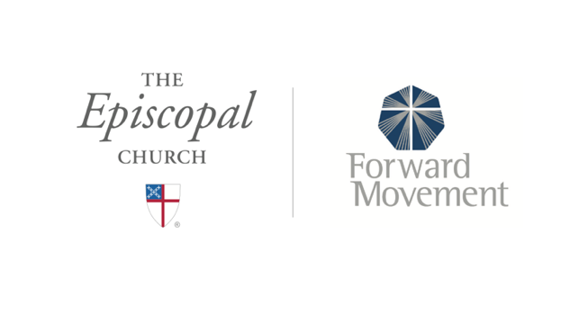
Sermons that Work and Bible Studies that Work are a joint offering of Forward Movement and The Office of Communication at The Episcopal Church.

https://www.episcopalchurch.org/bible-study/
https://www.episcopalchurch.org/sermons-that-work

Kane Parsons, dir., Backrooms (A24, 2006).
Søren Kierkegaard, Fear and Trembling/Repetition, ed. and trans. Howard V. Hong and Edna H. Hong (Princeton, NJ: Princeton University Press, 1983), 103-104.
Karl Barth, The Epistle to the Romans, trans. Edwyn C. Hoskyns (London: Oxford University Press, 1933), 469.
Barth, The Epistle to the Romans, 466-467.
Jenny Holzer, Survival Series: Protect Me From What I Want, Electronic LED Display, Times Square, New York, 1982.

