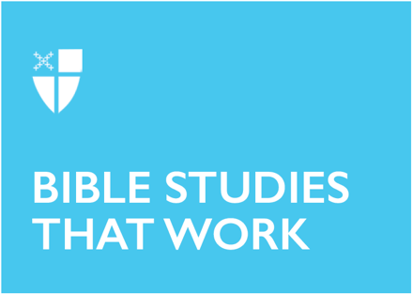

Pentecost 10A (Proper 13)
August 2, 2026
[RCL]: Genesis 32:22-31, Psalm 17:1-7, 16, Romans 9:1-5, Matthew 14:13-21

Collect |

Let your continual mercy, O Lord, cleanse and defend your Church; and, because it cannot continue in safety without your help, protect and govern it always by your goodness; through Jesus Christ our Lord, who lives and reigns with you and the Holy Spirit, one God, for ever and ever. Amen.
Context |
The Gospel of Matthew weaves a theological narrative across a geographical journey, as Jesus travels from Galilee to Jerusalem, teaching and healing along the way. In Matthew, the kingdom of heaven becomes a recurring theme, presented across a sequence of five major discourses Jesus gives—a structure the author may have used to mirror the five books of the Torah in the Old Testament. In this gospel, Jesus’s discourses are interspersed between narrative sections, similar to the way a movie might utilize the interplay of a third person narrator and personal dialogue to advance the plot.
Today’s gospel reading comes after the third discourse, sometimes called “Parables of the Kingdom,” as Jesus uses stories about a sower, weeds and wheat, a mustard seed, and treasure hidden in a field to convey the truth about the kingdom of heaven. At the conclusion of the parables, Jesus asks the disciples, “have you understood all this?” They quickly assure him they have—though as we will see in today’s reading that their confidence may be a bit misplaced.
At the start of Matthew 14, the perspective shifts back from discourse to narrative, and we encounter two contrasting banquets, presented back-to-back. We are told first of a gruesome dinner party, where Herod Antipas, unable to resist the pressure of his household and intoxicated guests, drunkenly requests the head of John the Baptist as a birthday gift. When Jesus receives the news of John’s death, he withdraws to a “deserted place by himself.” This sets the stage for the second event juxtaposed in our lectionary reading for today: a feeding miracle which offers a glimpse of what a banquet in the kingdom of heaven might look like.
Theological Reflection |
When Jesus hears the news of his friend John’s death, he distances himself both from the disciples and the crowd by sailing away alone in search of a quieter place. However, this very news seems to only pique the crowd’s interest in him and how he might respond to the murder. Curious and impatient, they follow his boat along the shoreline, collecting an ever-larger audience as they go. Instead of responding in anger and frustration, each of the synoptic gospels (Matthew, Mark, and Luke) name that Jesus responds with compassion and welcome. It is Jesus’s compassion that compels him to return to shore and rejoin the crowd, curing the sick among them until late in the day.
As evening falls, the disciples approach Jesus and remind him of the remoteness of their location and lateness of the hour. They encourage him to “send the crowds away so that they may go to the villages and buy food for themselves.” Jesus responds, “They need not go away; you give them something to eat.” The first half of his statement, “they need not go away,” is only recorded in Matthew’s Gospel and it underscores the same compassion Jesus embodies when he returns to shore to teach and heal.
Matthew offers with this scene a glimpse into a banquet in the kingdom of heaven: No one is turned away; all are welcomed with relentless compassion. This stands in direct opposition to Herod’s drunken birthday dinner, which leads only to death and violence. Jesus begins with the assumption of welcome, while in Herod’s court welcome is a condition to be determined by the whims of the rich and powerful empire.
In the second half of Jesus’s response to the disciples, Matthew offers us another clue into the kingdom of heaven. “You give them something to eat,” Jesus tells them. A banquet in the kingdom of heaven invites participants, not spectators. At Herod’s court, the culture of welcome looks on passively as life is exploited for sport. In contrast, Jesus invites the disciples to join him in active compassion by offering their own supper as the starting point for God’s work of abundance.
When Jesus blesses, breaks, and returns to the disciples the food they initially considered insufficient, the power of God transforms their perceived scarcity into astounding plenty. The text tells us that it is the disciples themselves who distribute the bread and fish to the crowd. They continue to participate in God’s work of abundance until twelve baskets overflow with leftovers, and everyone is full.
We are offered our own opportunity to play the role of the disciples at God’s banquet. What is blessed, broken, and given to us in the Eucharist becomes the starting point for God’s unfolding work of abundance. Like the disciples, we are invited to live with the compassion of Jesus, not compelled by scarcity or the whim of empire, but grounded in and living out the radical welcome extended to all who are fed in the kingdom of heaven.
Reflection Questions |
- Where do you see Jesus’s compassion at work in your life and our world today?
- Read the account of Herod’s dinner party in Matthew 14:1-12. What contrasts do you see between this banquet and the feeding of 5000? What conclusions can you draw about the differences between banquets like Herod’s and the banquet God offers in the kingdom of heaven?
- What would it look like to begin with the assumption of welcome in your faith community?
- How can your life or your community become the starting point for God’s work of abundance?
Faith in Practice |
Imagine you are one of the disciples holding one of the twelve baskets overflowing with leftovers when everyone is full. What do the contents of your basket look like? Spend some time reflecting on God’s abundance overflowing in your life. Consider writing some of your reflections down in a prayer of gratitude, sharing them with a loved one, or creating a list of God’s abundance together in the context of your faith community.
Katelyn Printz is a Postulant from the Diocese of East Tennessee, currently in her second year at Virginia Theological Seminary in Alexandria, VA. Prior to being in seminary, Katelyn worked as a Kindergarten teacher at a play-based Episcopal school in Kingsport, TN and at the local yoga studio. As a part of her studies, she is working at Saint Columba’s Episcopal Church in DC, and loves being involved with children’s ministry and weekly worship services there. In her free time, she loves hot yoga, reading novels, and hiking with her husband Ben and their dogs Max and Athena.

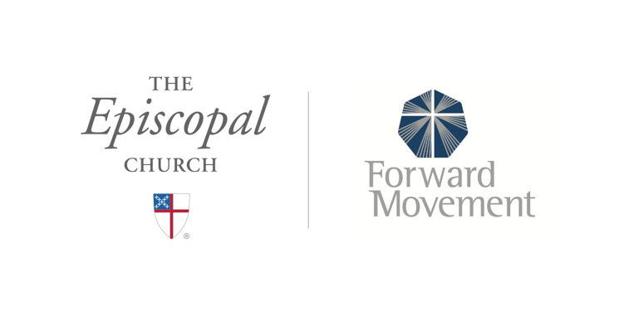
Sermons that Work and Bible Studies that Work are a joint offering of Forward Movement and The Office of Communication at The Episcopal Church.

https://www.episcopalchurch.org/bible-study/
https://www.episcopalchurch.org/sermons-that-work

