Pentecost 11 (A) – Proper 14
[RCL]: Genesis 37:1-4, 12-28; Psalm 105:1-6, 16-22, 45b, Romans 10:5-15; Matthew 14:22-33

To Have Dominion

Today’s Gospel features one of the most iconic of all Christian scenes: Christ coming to the disciples upon the waves. Jesus walking on water has become almost a cultural cliché; it graces everything from ancient icons to dollar store postcards. In this passage, however, the disciples do not find our Lord walking upon the sea a comforting image: instead, they are terrified! The winds have picked up, the water is choppy, and when the disciples see their teacher striding across the rollers, they interpret this as highly unnatural rabbinical behavior—as spooky supernatural activity—and in classic Scooby-Doo fashion, they shout, “G-g-g-g-ghost!!” The problem here is that Jesus commanding the waves to be firm so that he can walk to the boat is not at all otherworldly: seen from the Biblical perspective, that is the most natural thing in the world for a human to do. The disciples simply haven’t yet realized what a true human is.
In the Book of Genesis, humans are created for one purpose: to be the image and likeness of God, and as such, they are given dominion over Creation. Contrary to popular interpretation, dominion is not freedom to chop down all of the forests and strip-mine the land for maximum profit. Nor is dominion a byword for being good stewards of the environment.
Dominion is a state in which the whole of creation lives in harmony with the will of God. This dominion appears in iconography of the saints: when Saint Benedict is pictured with the raven who once saved his life, or when Saint Jerome is painted next to the lion said to have become his friend and protector. This idea of dominion is the source of C.S. Lewis’ vision of the innate veneration the animals of Narnia pay to the sons of Adam and daughters of Eve.

But to us—not to mention to the terrified disciples in the boat—it all sounds fantastical, like the stuff of a fable or a dream. This is not because we are infinitely wise beings, capable of evaluating the mystery of God, but because we have lost a part of our essential humanity.
In the narrative of the Fall, we see Adam and Eve turn away from God, away from their true nature, and towards nothingness. Our primary job description as humans—the essence of our humanity—is being the image and likeness of God. To be a human means to be a living vision of the peace of God, of the goodness of God, of the love of God. Those around you should look upon you and think, “how amazingly kind she is, how wildly accepting he is, what an oasis of peace they are.” To see a human being should be to glimpse a vision of God’s holiness. While this is sometimes the case, the vast majority of us spend our time preoccupied by our own little goals and projects; running from our fears, chasing our ambitions. To the extent that this core purpose of our human nature is diminished, we become less and less human.
In today's Gospel, Peter and the other disciples are focused on keeping their boat ship shape so that they can continue netting enough fish to feed their families, to pay the mortgage on the boat, and perhaps put a little away for retirement in an ancient world 401k – otherwise known as a mattress. Suddenly Peter sees the one true human walking on the waves and cries out, “Lord, if it is you, command me to come to you on the water!”
Why would Peter say such a thing? Is he trying to test Jesus’s reality? Is he begging to share the novel experience of stepping across the sea? What if this is neither a test nor the expression of curiosity, but is instead a plea for Jesus to return Peter to his own full humanity? What if Peter’s cry means, “Lord let me share this dominion, let me share your life as a vision of grace, a font of goodness, the image of the love of God.”
And what happens? Jesus tells Peter to join him in commanding the waves! While having dominion over water is impressive, this is something like a gateway miracle. What would it be like to have dominion not just only over something as basic as an unruly sea, but over something really uncontrollable—like your anger? What would life be like if no one ever had the power to ruin your day, to drive you crazy, because you were so full of love; even for those cutting you off in traffic and shouting at you from the TV screen.
It’s impressive to have dominion over leprosy, but what would it be like to have dominion over greed and covetousness? What would it be like to have the idol of wealth broken to such an extent that you could actually give to all those who ask of you; that when someone tried to take your cloak you would be quick to offer him your tunic as well? What if you had perfect dominion over your addiction to pride and power, to vanity and impressing others, dominion over addictions to shopping or pornography, to fear, to being judgmental? What if you could simply rebuke them and have them disappear?
What would happen if we, like Peter, were boldly to request such astonishing powers? Just the same thing: Jesus would command us to come to Him. When we ask for Jesus’s help, he actually gives us the grace to overcome, not just petty things like winds and seas, but these utterly overpowering forces as well.
There are times when we may experience this grace. We might be overwhelmed by compassion for another, forgiveness of our enemies or extravagant generosity… but then we get scared, we close off, we say, “I can’t just forgive that monster!” “I can’t just give away $10,000!” “I can’t walk on water!” And we begin to sink.
But here is the secret: You can jump back into the boat, you can say that you’ve gotten over your weird religious phase and are back to normal. Or in the midst of your doubts, in the midst of your fears, you can stay in the water.
There you can cry out with Peter, “Lord save me!” You can cry out to the one who is not only the perfect human, but God incarnate, “Lord make me a vessel of your peace! Lord forgive me my trespasses only to the extent that I forgive those who trespass against me. Lord Jesus Christ, Son of God have mercy on me!”
And what will Jesus do? Reach out and grab your arm. He will hold you above the waves when you can’t walk upon them.
Ask a Christian in Alcoholics Anonymous what it's like to allow Jesus to do the impossible through you.
Ask a former slave ship Captain like the Rev’d John Newton what it’s like to turn your back on your former life to become an anti-slavery crusader.
Either person will be quick to tell you of the amazing grace with which Jesus imbues your life when you ask for it.
But it takes faith to step out of the boat. It takes faith to be kind to those who are unkind to you. It takes faith to give away your money, your patience, your security. It takes faith to follow Jesus.
And this is why, like the disciples in the boat, we must bow down and worship Jesus. We must allow him to have dominion over us, we must come before his altar, hear his word, receive his body and blood, and allow him to send us into the world to do his will.

The Rev’d Bertie Pearson serves as rector of St. Alban’s Episcopal Church in Washington, D.C. He also produced the popular podcast The History of Christianity with Bertie Pearson. This podcast is an exploration of the ideas and themes which continue to shape the Christian faith, and is available on Spotify, iTunes, and wherever fine podcasts are distributed. Before his current parish, Bertie served both Spanish and English-language churches in Austin and San Francisco, played drums in the band Poolside, and toured as a DJ. He now lives a much more sedate life with his wife, Dr. Rahel Pearson, their two children, a small room full of dusty records, and a very goodhearted Australian Shepard named Ida.
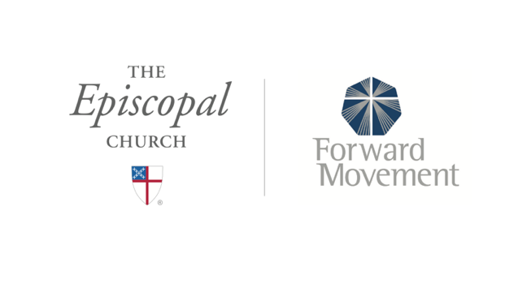
Sermons that Work and Bible Studies that Work are a joint offering of Forward Movement and The Office of Communication at The Episcopal Church.

https://www.episcopalchurch.org/bible-study/
https://www.episcopalchurch.org/sermons-that-work

