

Pentecost 12A (Proper 15)
August 16, 2026

RCL: Genesis 45:1-15; Psalm 133; Romans 11:1-2a, 29-32; Matthew 15: (10-20), 21-28

Opening Prayer |

Almighty God, you have given your only Son to be for us a sacrifice for sin, and also an example of godly life: Give us grace to receive thankfully the fruits of his redeeming work, and to follow daily in the blessed steps of his most holy life; through Jesus Christ your Son our Lord, who lives and reigns with you and the Holy Spirit, one God, now and for ever. Amen.

Context |

While the lectionary permits the omission of verses 10–20 from this week’s gospel, Jesus’s instructions in these verses—about the source of impurity—help to contextualize the interaction he has with the Canaanite woman in the verses that follow. These verses show Jesus to be an authority on Torah, protecting and upholding the integrity of the Law, even as he disagrees about its interpretation with other Jewish religious authorities. As we will see, the full meaning of the encounter with the Canaanite woman (vv. 21–28) becomes clearer when it is seen in light of Jesus’s preceding demonstration of his authority as a teacher and interpreter of Torah.

Verse 10 picks up with Jesus explaining his response to a question from the Pharisees and scribes about why his followers do not wash their hands before eating meals. It is likely that the Pharisees were encouraging practices of ritual handwashing that conflated the laws of keeping kosher and the laws managing purity/impurity. In the Torah, the rules about what foods are permissible and impermissible to eat, and how to prepare them (kashrut), are distinct from the rules about impurity (tumah) and how to restore oneself to a state of purity (taharah). The judgments of purity and impurity are not correlated to one’s internal character. They are states of being related to one’s contact with certain objects that are impure, like a deceased person or animal. The means for restoring purity—ritual washing—functions to bring an individual back into the state of ritual purity required for Temple worship. It does not act as a moral judgment.

Since there is a distinction between the rules regarding permissible foods and those regarding the states of purity/impurity, there are certain circumstances in which it is possible under Jewish Law, for someone to eat impure kosher food without entering a state of impurity themselves. It seems that, in this story, the Pharisees were teaching that it was possible for the consumption of impure kosher food to make one ritually impure. Jesus disagrees. He explains that impurity comes from within us (our hearts) not from things outside of us (what we eat or drink). He is defending the Law, not altering it. In exchanges like this, Matthew shows Jesus to be a Jewish teacher with great authority.

Theological Reflection |

Following this dialogue, Jesus leaves to visit Tyre and Sidon (places where Gentiles lived). There, an unnamed woman identified as Canaanite (she is Syrophoenician in Mark’s Gospel) comes to Jesus seeking healing for her daughter.

At first, he is unsympathetic to her because she is not Jewish. “I was sent only to the lost sheep of the house of Israel,” he says in response to her request. When she asks again for help, Jesus compares her to a dog who cannot receive the food meant for the children of the family. His words to this anonymous woman capture the animosity between Jews and the Gentile ethnic groups living near one another in the Ancient Near East. More than that, Matthew’s choice to describe the woman as Canaanite (and not Syrophoenician) illuminates the long-standing hostile relationship between ancient Israel and Gentiles, for this non-Jewish woman is descended from the enemies of Israel who lived in the land that God promised to Abraham and his descendants.

This woman insists on speaking with Jesus and she does not deny that he has been sent to save to the lost sheep of Israel (cf. Matthew 10:5-6). Although her name is unknown to us, her faith in Jesus’s power to heal her daughter rested not on the certainty of their shared ethnicity, but in her own certainty about who Jesus is. She addresses him as “Lord, Son of David.” And she remains sure that her proximity to him would and could heal her daughter. She understands that she is not one of the lost sheep Jesus says he was sent to find and affirms this when she responds to him. Yet she persists, and this persistence offers a startling affirmation of her hope that who she is in relationship to Jesus, as a Gentile, will not exclude her daughter from the possibility of being healed by him. In fact, her notably faithful response elicits the desired outcome because it demonstrates the depths of her trust in Jesus’s identity as Lord. Jesus heals the Gentile child.

Reflection Questions |

- Ethnic differences shape the ways that we treat other people: what lessons can we learn from Jesus’s and the Canaanite woman’s engagement across ethnic divides?

- Have you ever felt like God was not responding to you in the way you hoped when you sought healing for yourself on or behalf of a loved one? How did you respond? Do you feel any resonance with the Canaanite woman?

- We don’t know the name of the Canaanite woman, but she exemplifies faithfulness. What other unnamed models of faithfulness in the gospels come to mind?

Faith in Practice |

In your prayer this week, try to speak directly to God with the same kind of honesty that the Canaanite woman spoke to Jesus. Notice how you feel.

The Reverend Alden E.J. Fossett is the Curate at St. Paul's Episcopal Church in Brookline, MA. Alden was ordained deacon by the Rt. Rev. Julia E. Whitworth in May 2026 at the Cathedral in Boston and is preparing to be ordained priest, God willing, in December 2026. Born and raised in Los Angeles, CA, he was raised in the Christian faith at the oldest Black Baptist church in LA and later formed by seasons in UU and Quaker communities. After becoming an Anglican in college, Alden heard echoes of a childhood call to ordained ministry. He served as the Kellogg Fellow for the Episcopal Chaplaincy at Harvard and as a Harvard
Chaplain before attending seminary. Alden holds a Master of Divinity, a Diploma in Anglican Studies, and a certificate in Black Church Studies from Yale Divinity School/Berkeley Divinity School.

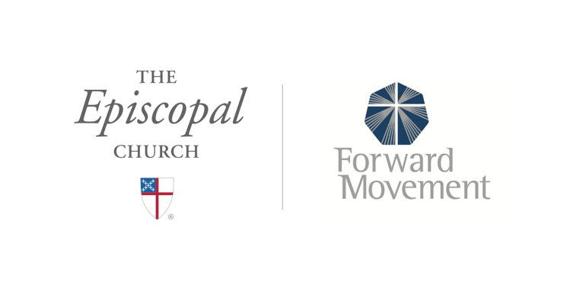
Sermons that Work and Bible Studies that Work are a joint offering of Forward Movement and The Office of Communication at The Episcopal Church.

https://www.episcopalchurch.org/bible-study/
https://www.episcopalchurch.org/sermons-that-work

