

Pentecost 16 (Proper 19 A)
September 20, 2026

RCL: Exodus 14:19-31; Psalm 114 or Exodus 15:1b-11,20-21; Romans 14:1-12; Matthew 18:21-35

Opening Prayer |

O God, because without you we are not able to please you, mercifully grant that your Holy Spirit may in all things direct and rule our hearts; through Jesus Christ our Lord, who lives and reigns with you and the Holy Spirit, one God, now and for ever. Amen.

Context |

Matthew 18:21–35 falls within Jesus’s teaching about relationships among his disciples and the wider community of Christians. This passage in particular takes up how they should respond when they have been wronged—whether the wrong is real or perceived. Peter asks Jesus the famous question, “How often should I forgive? As many as seven times?” Jesus offers an emphatic response: They should forgive “seventy-seven times.” Jesus then shares the parable of a forgiven servant who, in turn, is unforgiving, in order to illustrate how his followers are called to forgive.

In the parable, we learn about a servant with a debt of ten thousand talents—an overwhelming, essentially unpayable obligation that he has incurred. The king to whom he owes the debt performs an extraordinarily merciful act: After the servant pleads for compassion, the king cancels the entire debt. The servant leaves the king’s presence the beneficiary of more mercy than he could ever have earned or could ever repay. And yet despite receiving mercy and forgiveness from the king, he does not reciprocate the same grace when he encounters a fellow servant who owes him a comparatively small amount. In fact, he hands him over to be tortured until the debt is repaid in full.

The contrast between the two men’s actions in this parable illuminates the heart of Jesus’s teaching about forgiveness: Those who have received God’s forgiveness are called upon to extend that same forgiveness to others. The parable encourages us to reach out to God for mercy and, to in turn be transformed in how we respond to those who have wronged us. After all, God’s mercy toward us is immeasurable. We must similarly forgive without measure. Forgiveness becomes an expression of gratitude for the mercy we ourselves have received.

Theological Reflection |

Forgiveness is a central tenant of the Christian faith—one of the ways in which the love of Christ is made visible in daily life. In this gospel passage, Jesus presents forgiveness not simply as an admirable Christian virtue, but as a response to the extraordinary mercy that God has shown to us. The parable of the unforgiving servant highlights the relationship between receiving forgiveness and extending forgiveness to others.

The servant who stands before the king owes a huge debt, one that he admits cannot be repaid. The consequence for non-payment is imprisonment, together with the loss of his family, so the servant pleads for patience and mercy. In response, the king goes far beyond merely extending the servant’s time for repayment: He forgives the entire debt. The servant leaves the king’s presence free from an obligation that had once seemed impossible to overcome. In this parable, we see that forgiveness need not—indeed, cannot—be earned. Forgiveness is given by grace, a fact which only deepens our understanding of its value.

The extensive nature of this forgiveness is essential to understanding what follows. Immediately after receiving a full pardon, the servant is presented with an opportunity to extend a similar grace to his fellow servant. But he refuses to show the kind of compassion that was meted out by the king.

Jesus warns the disciples and his followers against this kind of behavior. When the servant makes a choice not to extend the same kind of mercy he has received, it is more than a failure to be kind. His refusal constitutes an inability to recognize the significance of the mercy that has been bestowed upon him. It is only when debtors acknowledge the overwhelming weight of their debt that they appreciate the true depth of the mercy they have received. Foundational to our Christian life is the recognition that the mercy we receive from God far surpasses anything we can earn or repay.

This is one reason why forgiveness is a key element of our Christian life: It is the hallmark of the love we have received from God in Jesus Christ. And through the boundless generosity God has shown to us, we are called also to extend our forgiveness to others. Just as the servant could not earn the forgiveness of his debt, so too no human can earn or deserve to be forgiven. Forgiveness does not originate with the merit of the one being forgiven, nor with the “forgiveabilty” of their offense. Remember, the servant’s debt was impossible to repay. Forgiveness does not depend upon the offender’s merit or capacity for repayment. Rather, forgiveness originates in mercy. Forgiveness originates in the mercy we have been shown. We forgive not out of our love for the one who has wronged us, but out of God’s love for us.

Hurt, disappointed, betrayed, or treated unjustly, we can find it difficult to forgive those who have wronged us. Yet forgiveness does not require us to ignore the harm that occurred or pretend that we have not been negatively impacted by it. It does not erase the need for setting boundaries and holding others accountable for injustice and other forms of transgression. At the heart of forgiveness lies the recognition that every person stands in the need of God’s mercy. Thus Jesus calls us to forgive others with the same forgiveness we ourselves have received—that is to say: with a forgiveness that is unmerited, unearned, and without limit.

In our Christian lives, there may be instances where forgiveness is relatively simple; there will also be circumstances in which forgiveness is more difficult. You may have relationships in your own history—or stories in your community—in which reconciliation was not possible or even the most appropriate thing to pursue. But forgiveness and reconciliation are not the same thing. Even without reconciliation and the restoration of relationship, forgiveness is possible. Forgiveness is not a transactional act in which a person wipes the slate of an offending person clean; rather it is an expression of love that recognizes and draws upon the immeasurable mercy of God. Recognizing that we ourselves are recipients of mercy, we are called to extend the same mercy and compassion in our relationship with others.

Forgiveness is much more than what we Christians receive from God; it becomes something that we practice in daily living. Forgiving one another, we mete out the mercy God has shown us, from the vast treasury of our own receipt. Not even seven times, but seven times seventy times.

Reflection Questions |

- Remember a time when you were forgiven. How did it feel to be the recipient of someone else’s mercy?
- Sometimes it can be difficult to offer forgiveness. Recall a time when you have struggled to forgive someone. What got in the way?
- Where in your life is God inviting you to embody greater mercy, compassion, and patience with others right now?

Faith in Practice |

In today’s world, it can be easy to become consumed by injustice or other forms of wrongdoing that we experience, or which we witness others experiencing. This week, call to mind a wrong that weighs on your heart—one instance where you find it almost impossible to forgive or offer compassion. Open your heart to God in prayer about this situation. Seek God’s help to find your way to forgiveness. Pray for the perpetrator.

Jerrick Rutherford was born and raised in Guyana, South America, and is currently a Postulant for the Priesthood in the Diocese of Newark. He earned an Associate’s degree in Education from the Cyril Potter College of Education and a Bachelor’s degree in Education from the University of Guyana. He also holds a Master of Science in General and Special Education as well as a master’s degree in School Leadership from Columbia University and is presently completing a Master of Divinity at Bexley Seabury Theological Seminary.

A lifelong educator, Jerrick has taught in Guyana, Botswana, and New York City. He currently serves as Vice Principal of Bronx Bridges High School, a public high school dedicated to serving English Language Learners. His professional work reflects a strong commitment to equity, leadership, and the transformative power of education.

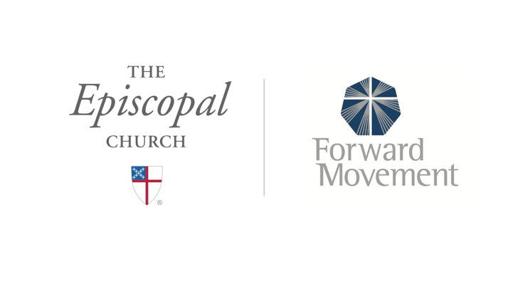
Sermons that Work and Bible Studies that Work are a joint offering of Forward Movement and The Office of Communication at The Episcopal Church.

https://www.episcopalchurch.org/bible-study/
https://www.episcopalchurch.org/sermons-that-work

