All Saints’ Day (A)

[RCL] Revelation 7:9-17; Psalm 34:1-10, 22; 1 John 3:1-3; Matthew 5:1-12

Called to Be Holy

This morning, on All Saints’ Day, we remember that we are part of a family—a very big family we call the Communion of Saints. It is a family that includes you and me, those who are here with us today, and the saints we have loved who have died. It is a family that transcends time and place, even death itself. In the mystery of God, the Communion of Saints embraces the past, the present, and even the future.
Today, as we remember those who have gone before us, we are reminded that in God, in Christ, through the waters of baptism, our lives are bound together forever.

But there is something else we remember today. We remember our own calling to be saints.

Each of us is called to be holy. It is a calling we receive in baptism, when we become members of the Communion of Saints. Although we probably do not go around calling ourselves “saints” very often, being a saint is actually at the heart of what it means to be a Christian. Because to be a saint—to be holy—is at the heart of what it means to follow Jesus.

This idea shows up at the heart of the novel by Catholic priest, Graham Greene, The Power and the Glory. The novel’s main character is a priest who is very far from perfect. He drinks too much, has fathered a child, and carries the weight of many past sins. Yet Greene writes of him: “He knew now that at the end there was only one thing that counted—to be a saint.”

On All Saints’ Sunday, we are invited to remember that the same is true for us. Few of us will come close to perfection in our lifetime. We all have a past. We all carry our own failures and wounds. And yet we are called to be saints.

But what does that actually mean: to be a saint? What does it mean to be holy?

The word “saint” may make you picture the figures in religious paintings, with gold halos behind their heads. We may think of people who were martyrs, who lived extraordinarily virtuous lives, or who spent their days in prayer. We can easily imagine saints as people who were somehow different from ordinary human beings.

And if that is what holiness means, it can seem like a pretty tall order. But All Saints’ invites us to see holiness differently.

Recall what Rowan Williams once said in a talk to young people on All Saints’ Day. He observed that, in parts of the Old Testament, holiness can seem to mean being set apart from everything else. Think of Moses and the burning bush: God tells him not to come any closer because the ground is holy. Or think of the Holy of Holies in the Temple in Jerusalem, a place set apart from ordinary human life. In the Old Testament, holy places seem to be set apart.

But in the Gospels, we see something different.

For Jesus, holiness is not about being separate from the world. Instead, it is about entering more deeply into it. Jesus does not spend his life keeping his distance from human suffering, human failure, or the people others consider unclean or unworthy.

Instead, he moves toward them.

As Rowan Williams puts it, “Holiness … is Jesus going right into the middle of the mess and the suffering of human nature. Being holy is being absolutely involved, not being absolutely separated.”

This is what it means to be a saint. Being holy is not about being perfect or pure. It is not about becoming “otherworldly.” It is not about keeping our hands clean or staying safely removed from the complicated realities of human life. The call to be a saint is very much a call to be present in this world—to be absolutely involved in it. But being a saint means being in the world, while not being of the world. This means showing forth the values of Jesus, instead of the values of empire. As disciples, we are called to live the way of the kingdom instead of the way of the world. This is how we are called to be “absolutely involved.”

This is part of what Jesus is teaching in today’s Gospel, the Beatitudes. There, Jesus names those who are blessed in the kingdom of heaven. In Jesus’s time, to be blessed was closely connected with holiness. A blessed person was a holy person.

Yet notice who Jesus calls blessed:
“Blessed are the poor in spirit.”
“Blessed are those who mourn.”
“Blessed are those who hunger and thirst for righteousness.”
“Blessed are the merciful.”
“Blessed are the peacemakers.”
“Blessed are those who are persecuted for righteousness’ sake.”

Jesus does not say, “Blessed are the perfect.” He does not say, “Blessed are those who never fail.”

Instead, he points toward people who are deeply engaged with the realities of human life: people who know what it means to grieve; people who long for justice; people who practice mercy; people who make peace; people who are willing to suffer for what is right. This is a way of living that is in the world, but not of the world.

This is the holiness Jesus calls us to.

Holiness gets involved. Holiness has something to do with mercy and justice and peacemaking. Holiness is willing to enter into the places where human life is most difficult.

In other words, the saints are not people who have escaped the messiness of human life. They are the people who have learned how to meet that messiness with the love of God.

And that is good news, because it means that becoming a saint does not require us to become perfect. God does not need perfect saints.

What God needs are saints who are willing to make their lives a place where God’s kingdom can take root and grow; saints in whose hearts the Beatitudes take on flesh and blood. God needs saints who strive for holiness, even when they know they will fall short. Those who seek after the better way, even when they know they will never fully achieve it.

I can’t lie: Being a saint won’t be easy. Sometimes it will feel like pure joy, but sometimes it will mean struggle and sacrifice. We live in a world where not everyone is ready to embrace the values of the kingdom of God or the vision of the Beatitudes. And sometimes, as saints, we will have to struggle for them—for what is good and right.

And that’s where more good news comes in: We are not alone on this journey. In fact, we will never be alone. Gathered into the Communion of Saints, we join a big family of other saints. A family that includes everyone gathered here, people who are far away, and even people who have died—the people we remember today. They aren’t physically here with us, but we can trust that they are present in the mystery of God, rooting for us in our own journey toward becoming saints. Amen.

The Rev. Edmund Harris serves as associate rector at St. Thomas Church in Medina, Wash. Prior to St. Thomas, Edmund served for eight years as rector of St. Peter’s Episcopal Parish in Seattle. Before moving to the West Coast, he helped to found Church Beyond the Walls, a street-based worshiping community in Providence, R.I., and served as assistant rector at Church of the Epiphany in East Providence, R.I. Edmund is a graduate of the University of Virginia, the University of Chicago Divinity School, and Berkeley Divinity School at Yale. He lives with his spouse, Michael, their son, Ben, and their cats, Leo and Ambrose.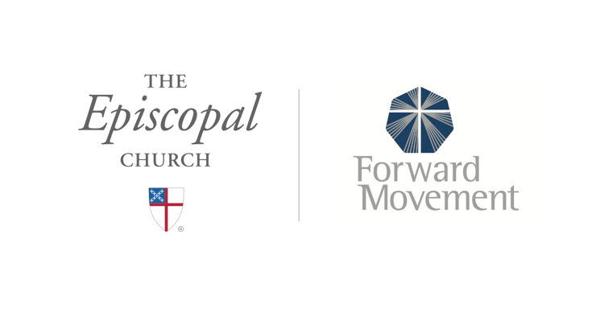
Sermons that Work and Bible Studies that Work are a joint offering of Forward Movement and The Office of Communication at The Episcopal Church.

https://www.episcopalchurch.org/bible-study/
https://www.episcopalchurch.org/sermons-that-work

