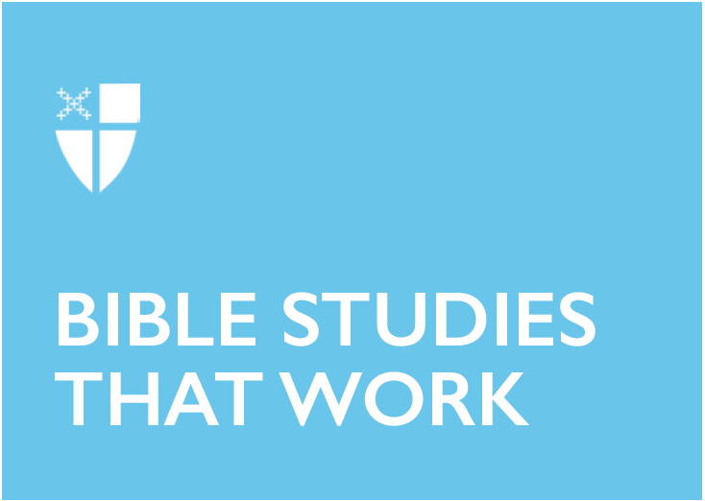

Advent 1 (A)
December 1, 2019

RCL: Isaiah 2:1-5; Psalm 122; Romans 13:11-14; Matthew 24:36-44

Isaiah 2:1-5
Power has always been portrayed as dwelling in high places. Thus, it is fitting for the prophet to envision Zion as the “mountain of the Lord,” the seat of divine sovereignty and judgment over nations. But can power reside in lowly places?

Power attracts like a magnet, drawing in all kinds of people. In the text, the “mountain of the Lord’s house” is described to be the “highest of the mountains,” where hope inhabits and eventually triumphs. A theme that resonates in ancient motifs depicts hope as a state of being or condition which can only be wielded by those in high places. Can hope be a reality for the weak?

In the backdrop of exile and struggle, the prophet looks up to Zion. He waits for instruction and lasting peace. In his mind, hope ascends and does not descend. Hope and power are knit together so only the highest among the high can make it possible. Therefore, peace and justice between nations are determined by the mighty. Yet for those who have never held swords but only ploughshares, how long shall they wait?

- What is power?
- How does Jesus Christ confound this idea of power?

Psalm 122
Everybody wants to go to Jerusalem.

Bone tired and weary, migrants follow the way to Zion. Treading the paths generations have walked before them, men, women, and children leave everything they have known and loved for a better life. Anywhere in the world is better than their homeland, torn by war, turmoil, and instability. In Jerusalem, they cry, “Peace be within your walls, and quietness within your towers.”

On the other side of the world, families gather at Ninoy Aquino International Airport in the Philippines. There are often two opposite – yet familiar – scenes. Boys and girls cling fiercely as their mothers leave to mother the children of the rich. A distraught husband meets his dead wife; after years of service in a foreign land, she returns lifeless. He weeps with those who sacrifice to make ends meet: “For my brethren and companions’ sake, I pray for your prosperity.”

The tribes go up, the tribes of the Lord go up to Jerusalem.

- In our current context of migration, what does Jerusalem symbolize?
- How does the reality of migration inform our faith?

Romans 13:11-14
Paul’s understanding of the immediacy of salvation is connected with the imminent return of Jesus Christ. Thus, he encourages his readers to wake from sleep and works of darkness. In our liturgical context, this attitude of watchful waiting is a persistent expectation that Christmas is coming; in the interlude, the season of Advent forms and creates a people of hope. Advent brings with it the dawn of a renewed and resilient faith that grapples with the crippling realities of evil and suffering while working towards tangible hope. To be an eschatological people, then, is to live a life of faith seeking to be authentic and relevant in the present as instruments of God’s relentless love. It is a season that places hope in the immediacy of the times and the manifestation of salvation in the here and now.

- Is the season of Advent confined to the future?
- How can we live out our claims of hope and salvation in the present?

Matthew 24:36-44
The unexpectedness and ambiguity of the nature of the coming of Christ have deeply perplexed believers for years. The uncertainty which comes with the text has shaped interpretations of doom and gloom, aiming to soothe the anxiety of the fearful. By comparing “the coming of the Son of Man” to the days of Noah, Jesus describes the Parousia as an event that nobody could predict or know except God. However, I believe the vagueness of the description of the coming of Christ should not necessarily result in uneasiness – but rather, hopeful wonder. This hopeful wonder underscores our status as creatures before the Creator and invites us to rest in God.

- In what ways can observing the season of Advent strengthen our faith?
- How do we live in hopeful wonder in the face of God’s coming in Christ?

