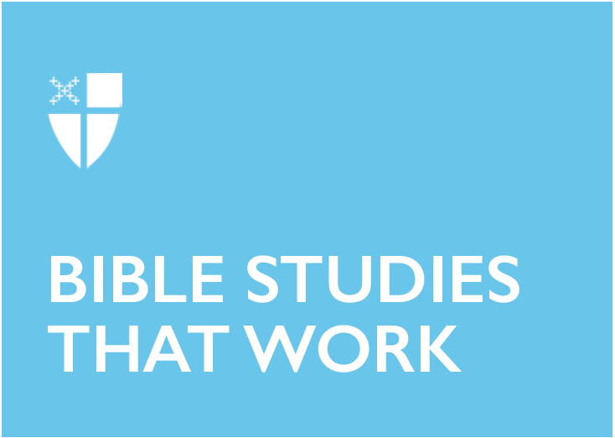

Advent 2 (A)
December 8, 2019

RCL: Isaiah 11:1-10; Psalm 72:1-7, 18-19; Romans 15:4-13; Matthew 3:1-12

Isaiah 11:1-10
It is interesting that the text offers a telltale expansive view of justice that includes all creation. The prophecy describes the peaceful cohabitation of the wolf and the lamb, the leopard and the kid, the calf and the lion, humans and snakes. Life against life is pacified. The language is rich with the promise of the extent of God’s justice in creation. If one could read the prophet Isaiah’s tree imagery beyond the usual lens of monarchic lineage from David, the new branch that grows from the root of Jesse takes a whole new meaning; the branch of Jesse can symbolize the extent of God’s harmony with creation, its leaves spread over the earth, enlivening all. God’s knowledge encompasses like “the waters cover the sea,” allowing us to recognize the integrity of creation and draw as toward worship and stewardship.

- Is justice anthropocentric?
- In an age of gross neglect of creation and the suffering of ecosystems, how does our faith encourage us to be effective stewards of creation?

Psalm 72:1-7, 18-19
The symbols that David chose to paint the reign of the king are replete with themes of constancy, resilience, and flourishing. It is a royal psalm, describing life under the king’s reign as bringing lasting peace and prosperity. It is also important to note that the use of the sun, moon, and rain as imagery describing the king are especially important to those who labor. A bountiful harvest depends upon the rising and setting of the sun, the rain on the fields, and the moon that shines by night. Behind the royal setting, the psalm offers a poignant view of the dependence of nations on the stability of the people. If the farmers are poor, a nation cannot be rich, no matter how tall the commercial buildings grow. If fisher folks are weak, the nation cannot be strong, no matter how abundant the steel supply in the city is. And if laborers are oppressed, a nation cannot ever be free, no matter how long the marches on Independence Day are. God’s justice must flourish beyond the throne.

- How can a royal psalm make sense to those who live on the fringes of society?
- How does the season of Advent correspond to God’s justice?

Romans 15:4-13
The universality of Jesus Christ draws all people to him. Therefore, the text emphasizes the inclusive nature of our hope in Christ. Paul urges his readers to “welcome one another” and join with one voice to glorify God. In the context of diversity, he stresses the need for mutual humility, just as Christ has become a servant for the sake of all people. He proclaims the prophet Isaiah’s words that, in Christ, “the Gentiles shall hope.” This is a compelling undoing of exclusive salvation, formerly reserved for a particular race or group of people, now open to humankind. It is a marvelous declaration of Christ’s fulfillment of Old Testament prophecies. As peoples gather toward him, the Scriptures testify on Christ’s behalf.

- How did Jesus Christ fulfill Old Testament prophecy?
- In an age when boundaries and borders are drawn, how does the inclusive nature of our faith transform our idea of mission?

Matthew 3:1-12
Baptism in the wilderness is a curious thing. In the wilderness, where the vagabonds and outcasts dwell, a furious John the Baptist rejects a group of priests coming for baptism and admonishes them to “bear fruit worthy of repentance”—an obvious refusal to be convinced by the Pharisees’ and Sadducees’ display of righteousness, even though they are considered to be the holiest groups in society during that period. He knew their intention to find fault in his actions. By describing the perfection of God’s judgment as an ax poised at the roots of an unfruitful tree, and as a winnowing fork separating wheat from the chaff, John does not give them the opportunity to see baptism as an empty ritual. More than the outward displays of piety, baptism calls for a repentant heart. More than an obligatory adherence to temple law and order, baptism is an act of offering and surrender unto God. Thus, the rejection of the Pharisees and Sadducees can be understood in light of the baptism of Jesus. By his willful act to be baptized by John later in the text, a new and holy priesthood is realized.

The text also teaches us that the ministry of John the Baptist as the forerunner of Jesus Christ can be ours, too. In the Philippines, a festive Filipino fiesta requires clear roads. Since the procession goes through neighborhoods, people “prepare the way” by cleaning their front yards, usually a part of the main road. Each family and the whole barangay then wait in eager expectation for the procession to pass by their houses. Delicacies are served, loved ones gather, and the sound of pomp and laughter fill the air. I wonder if the season of Advent can be a fiesta for the coming of Christ, wherein the community of faith gathers in eager anticipation of him.

- How do we “bear fruit worthy of repentance”?
- John the Baptist is considered to be the forerunner of Jesus Christ. How does the season of Advent challenge us to “prepare the way” for him?
Sunshine Dulnuan is currently in her first year as a Master of Theological Studies student at Church Divinity School of the Pacific. Since she is under the Faculty Development Program of Saint Andrew's Theological Seminary in the Philippines, she will return to teach Systematic Theology after finishing her studies. She loves ramen and one of her goals in life is to taste every kind of noodle soup in the world.

