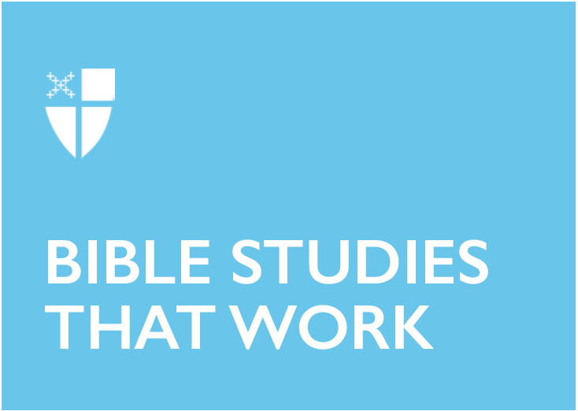

All Saints’ Day (C)
November 3, 2019

RCL: Daniel 7:1-3, 15-18; Psalm 149; Ephesians 1:11-23; Luke 6:20-31

Daniel 7:1-3, 15-18
Visions and dreams in the Bible are fascinating, perhaps because they are often considered sacred. At the time that Daniel was living, these visions were interpreted to be about politics, foretelling a possible future. Daniel decided to write down his dream and also to seek out someone else to help him make sense of what he had seen.

- Do you interpret your dreams?
- What might God be telling you in your dreams?
- Who do you trust to help you interpret things in your life?

Psalm 149
The beginning of this psalm is all about joy and rejoicing. Praise God with song, and dance, and noise. So often we get used to the quiet in our liturgy, and we forget that it is okay to bring our shouts to God as well. God asks for us to love with all that we have, and that includes dancing with our bodies and shouting with our lungs. We are told that “the Lord takes pleasure in His people,” and we should take pleasure in God too!

- How can the praises of God be in our throat?
- What are you afraid to bring to God, and how might you think of it as worship?

Ephesians 1:11-23
This letter to the Ephesians suggests that we “might live for the praise of Christ’s glory.” I am always struck in reading through this set of letters how important it is to encourage one another in faith. Christianity is not undertaken alone, but rather is the work of community – it takes all of us speaking words of encouragement to one another so that we might not forget Christ and what He has done for us.

- Who is someone you can pray for, to encourage them in the faith?
- What do you think is ‘the hope to which we are called?’

Luke 6:20-31
On this All Saints’ celebration, the words of the beatitudes are particularly striking, specifically in the places where Jesus mentions “for that is what their ancestors did to the prophets.” We are connected to those who came before us, and it can be powerful to remember our place. I am reminded that each of us walks on the shoulders of our ancestors and brings to life a legacy much larger than us. We walk in the footsteps of giants – not just in the ones who came before us in our family, but also in the ones who came before us in our story of faith. A beautiful song by Sweet Honey in the Rock is called We Are.

“We are our Grandmother’s prayers. We are our grandfather’s dreamings. We are the breath of the ancestors. We are the spirit of God.”

We are in a moment of time now to think not only of the ones whose footsteps we walk in, or whose shoulders we are carried on – but also to think about the legacy that we are leaving for the next generation.

- What are we doing to the prophets of this age?
- How will we carry our future generations on our shoulders?

This Bible study, written by the Rev. Jazzy Bostock, originally ran for All Saints’ Day in 2016.

