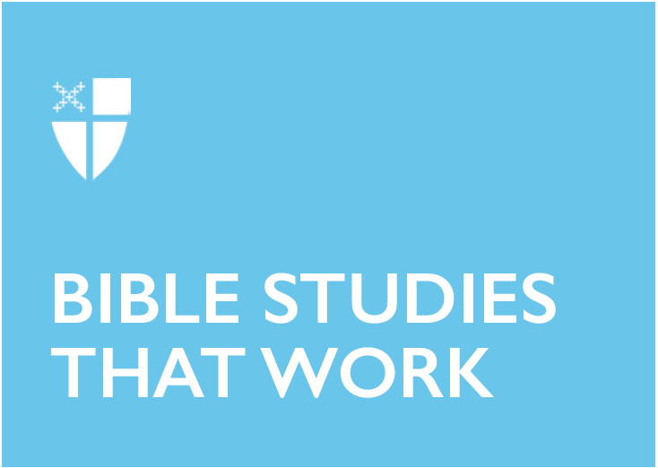

Christ the King Sunday (C)
November 24, 2019

RCL: Jeremiah 23:1-6; Psalm 46; Colossians 1:11-20; Luke 23:33-43

Jeremiah 23:1-6
In Ancient Near Eastern societies, “shepherds” was also a term used to refer to kings or leaders. Today, our readings look specifically at the kings of Judah who are subject to the judgments given in Jeremiah 23:1.

The shepherd metaphor is used for God (Psalm 23), humans (Ezekiel 34), and, in Christian tradition, Jesus (Mark 6:34). We see this metaphor inside our standard designation of clergy as pastors who tend to their congregational flocks.

Here, we see God announcing a regime change in Judah. One might say the region is “Under New Management”. For the prophet Jeremiah, this was an incredibly turbulent time. The seats of power in the Ancient Near East had shifted, Assyrian dominance of the past millennia was fading, and the Babylonian empire was an ever-present threat.

A shepherd brings sheep – or, in this case, people – together and protects them, tends to them. The shepherds we see in Judah however, made a policy decision that placed the people in peril, and ultimately exile. However, God promises to “bring them back to their fold”.

The chaos of injustice under the shepherds who only cared for their own interests will be removed; God will be their shepherd and promises to raise up shepherds who will care for the people.

What we see so potently here is that the judgment of leadership is tied to the work of shepherding. How have you provided for protection, peace, and gathering of your people? There is no special DNA that is needed to be a good shepherd; it is ordinary men and women who make bold choices to be good shepherds. It is also up to ordinary men and women to flock to those shepherds whose hearts are turned toward justice, protection, and mercy – those who imitate God’s shepherding.

- Who are the shepherds in your life? Whom do you shepherd? How are you mirroring God’s shepherding in these relationships?
- What does this text tell us about providing or having healthy leadership?

Psalm 46
Lions, tigers, and bears, oh my! Well, not quite. Instead, we have cosmic disorder, political calamity, and militaristic strife. Psalm 46 reminds us that we are both in the desert and the promised land. We are reminded to trust in God in even the most troublesome situations. The recurring refrain “The Lord of hosts is with us” serves as reinforcement to God’s presence and God’s protection, even in the midst of chaos. This refrain highlights God’s protecting presence but also emphasizes God’s identity.

Amid utter disarray, in churning waters that threaten to overwhelm the order of creation, we are reminded: “God is with us.” God commands us to “be still, then, and know”. This verse is often plastered on coffee mugs and Christian t-shirts as a command that only we receive. A more faithful reading would understand that the audience for God’s command was both the faithful and the forces of chaos that threaten them. We are reminded of Jesus’ ability to calm the raging sea in Mark 4:39.

We are people that prefer to trust in the things we can see, a strong military, a booming economy, a solid resume, or a full savings account make us feel secure. The truth is: these sure defenses are not so sure.

God is the only sure defense. On Christ the King Sunday, the final Sunday of the liturgical year, the Church once again reminds itself of God’s ultimate power over all. We are not saved by a strategic military defense, the NASDAQ, or our accumulation of wealth and achievements. We are saved through the suffering, death, and resurrection of Jesus Christ.

The Lord of hosts is with us; the God of Jacob is our refuge. Selah.

- How can we recognize in our own lives that God is God and that the powers around us are not?
- What is your “refrain” verse? What is the truth about God that you keep coming back to when you feel anxious or out of control in the chaos of the world?

Colossians 1:11-20
The reading from Colossians gives us a twofold message. The first part lays out a multitude of ways in which we are can grow and be transformed in Christ: strength, power, glory, endurance, patience, joy, and thanksgiving. The second part of the reading gives us a Christological vision of ways to describe and understand Christ: He is the visible image of the invisible god, the creator, redeemer, and sustainer, a direct channel to the timeless eternal things of God.

When we put both sections in dialogue, we find that in Christ we can find strength, endurance, patience, joy and thanksgiving in letting go our old ways of living and embracing growth in a new life. All of these things flow from the way that Christ connects us and all of his creation to the power, hope, faith, and love that make up life’s greatest possibilities and are the deepest realities of God and God’s creation.

- How does our ability to let God transform us interrelate with the facets of who Christ is?
- What does this text tell us about the connection between our daily lives and God’s enduring purpose for all creation?

Luke 23:33-43
Jesus is hanging from a cross. This is where we find him in today’s reading from Luke. Not exactly the place you would look for a king, but then again, nothing is ever quite as you expect with Jesus. Luke brings us to the place called “The Skull” and we find Jesus between two criminals.

One joins the soldiers and religious authorities and mocks him, the other intervenes and protests Jesus’ innocence. He asks Jesus to remember him when he comes into his kingdom. Out of all things that could have been asked, he asked to simply be remembered and not forgotten, not to be saved or rescued, not to be relieved of pain, but simply to be remembered.

Jesus responds – some of the only spoken words of Jesus in the entire lectionary for this Sunday – by declaring that today, even now, he would enter with Jesus into Paradise. What kind of king is this? Welcoming criminals into his realm and promising relief and release amid terrible agony?

He is a king that is never quite as you expect him. He is a king who refuses to conform to the expectations of this world. A king who will not be governed by the world’s limited vision or its truncated sense of justice. This king meets us in our weakness. This king is willing to embrace all, forgive all, redeem all, because that is his true nature. He is a king that delights in ushering us into his kingdom while at the same time exhorting us to recognize and work to restore the kingdom already surrounding us. What king is this? He is our king.

- As we ask, “What kind of king is this?” consider: How does the answer to that question inform what kind of church we are?
- What does it mean to be marginalized in the light of this text? What does this text have to tell us about how we faithfully respond to those living in the margins?

Amanda Payne is from the Diocese of Dallas and has served in youth ministry for over 12 years. She studied Russian and South African History at Texas A&M and is currently studying at Nashotah House Theological Seminary for her Master of Divinity. Amanda has specialized experience and training with high-risk teens, suicide intervention, domestic minor sex trafficking, and rape survivors. She attended EMM’s pilot Love God, Love Neighbor training and has expanded her ministry to include teaching and advocacy for refugees and refugee resettlement.

