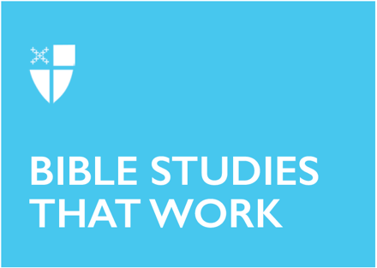

Easter 6 (A)
May 17, 2020

RCL: Acts 17:22-31; Psalm 66:7-18; 1 Peter 3:13-22; John 14:15-21

Acts 17:22-31
Whereas realtors talk about the three most important things as being “location, location, location,” preachers focus on “context, context, context.” There is the context of the passage being preached, of course, but at least as important is the context into which we preach.

In this selection from Acts, we see Paul skillfully using the context in which he finds himself to preach the good news. Rather than criticizing Athenian religious culture, he draws attention to it and praises it in order to tell the Athenians about the “unknown god” to whom they have built a temple. He acknowledges the goodness he finds in their religious practice and then suggests to them how to find the true goal of that practice. Paul uses Greek poetry and philosophy to introduce the Athenians to the Living God of Jesus.

While we, of course, need to understand the scriptural context of each Sunday’s texts, we must have a sense of the cultural context of the people to whom we are speaking. Breaking open the Word in a time of security and predictability is a very different process than speaking the same Word into a time full of fear and anxiety and social distancing.

- What is the current context of the community with whom you are reflecting?
- How can you adapt the message of the Good News to that circumstance?

Psalm 66:7-18

“Bless our God, you peoples!” The psalmist speaks to all the peoples of the earth of the faithfulness of Israel’s God. Verses 7-11 both celebrate God’s love for Israel and tell of the salvation God has accomplished in times of travail and trouble.

In verse 12, there is a new voice, in the singular. “I will tell you what God has done for me.” Here God’s saving actions are directed to the individual, whose gratitude wells up in a thanksgiving sacrifice. The psalmist cannot contain his gratitude but must proclaim it to the peoples.

Whether as a collective or individual voice, the psalmist proclaims the faithfulness of God and invites the peoples to join in thanksgiving. The psalmist witnesses that this God is the God of salvation. “Blessed be God.”

- Where do you find the action and presence of God in life?
- Where does your individual story connect to the story of God’s people?

1 Peter 3:13-22
This letter was written to a group of believers who either anticipated or were experiencing persecution. Suffering is expected as a result of following the way of Jesus, even suffering for doing what is right. The people are encouraged to take Jesus as their model and identify with him in his suffering. This standard that is put before us can seem impossible if we don’t realize that it is all possible because God loves us so much.

The reality is that if we live like Jesus in the world, we will experience rejection and ridicule at times. Respond to abuse with gentleness and reverence? The world says that it is foolishness. Only the “strong” can win in the world’s game. However, we are not called to live by the rules of the world. The passage makes clear that even in suffering and persecution we are not to “fear what they fear” or be intimidated, but to trust in and proclaim the hope that is in us. The resurrection of Jesus, who suffered for sins, “the righteous for the unrighteous,” brings us to God.

- Have you experienced suffering for following Jesus?
- How do you make an account for the hope that is in you?

John 14:15-21
“I will not leave you orphaned; I am coming to you.” This promise is the center of this section of the Farewell Discourse. In last week’s passage from John, Jesus told the disciples that he was going to the Father. This week, he reassures them that they will not be left alone. The Father will send “another Advocate” who will always be with them. Jesus is the first Advocate, the one who is the Truth, and the Advocate whom the Father will send will be the Spirit of Truth, the spirit of Jesus himself.

Twice in this passage, Jesus tells us that those who love him, who follow him, will keep his commandments, which involve love for others and will result in being one with him and the Father. This union with Jesus and the Father is the Spirit who is with us always. The world, that is, the powers that do not receive Jesus, cannot know either him or the Father and do not know the Spirit. Those who love will be loved and receive the revelation of Jesus’ Spirit.

- What are the signs you see of the Advocate, the Spirit, moving in the life of the world today?
- What does it mean to you to keep Jesus’ commandments?

Sr. Kate Maxwell is an Episcopal Benedictine monastic, a member of the Companions of St Luke - OSB, and serves her community as Dean of Formation and Safe Church administrator. She is currently in her second year in the Episcopal Church in Minnesota’s School for Formation as a postulant for holy orders. She lives in St. Paul, where her feline companion allows her to share an apartment.

