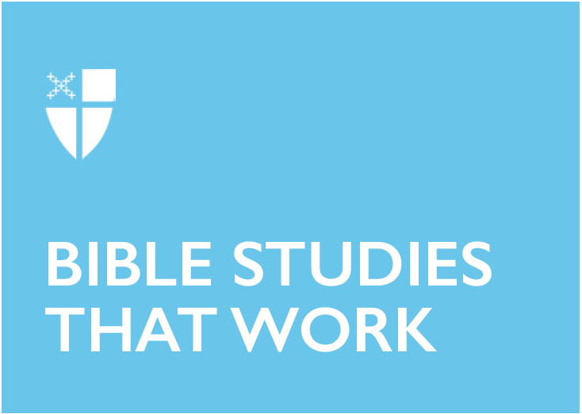

Easter 7 (C)
June 2, 2019

[RCL] Acts 16:16–34; Psalm 97; Revelation 22:12–14,16–17, 20–21; John 17:20–26

Acts 16:16–34
It is only after the apostles are thrown in jail that God rescues them with a dramatic earthquake. Why does God wait to free them until after they are beaten and persecuted? Why not save them before the trouble? Sometimes God doesn’t intervene on our timeline or in the way that we think would be best for us. But instead of being frustrated or afraid, Paul and Silas continue to trust in God’s faithfulness.

This passage is hugely dramatic. The apostles are flogged and then put in the innermost cell with their feet bound. Their prospects look bleak. Yet despite their wounds, even at midnight they are still praying and singing to God. Their faith is evident to all those around them. Because they’re together, they’re able to support each other until God makes a way.

The jailer and his entire family converting in the face of God’s power is an example of all things working together for good for those who love God (Romans 8:28). God transforms even this enormous hardship into something beautiful.
- When has God’s timeline been different than what you might have chosen for yourself, and what was the result?
- Who can you rely on to support you when things look bleak?
- Why is it important that not only the jailer but his entire household becomes believers?

Psalm 97
All the world recognizes God’s greatness: the clouds and the darkness, the lightning and the fire, the mountains and the heavens. What response could we have to such immense scale other than wonder? The psalmist draws on our senses to convey something incomprehensible to our limited understanding: God’s greatness. To us, mountains seem immense and permanent, but even they melt in God’s presence. The throne represents the awe of God’s power, but it could also make us believe there is distance between creation and its all-powerful creator. This authority can seem overwhelming, so the psalm reminds us of God’s love for the righteous.
- How can we appreciate God’s greatness while also seeking closeness with God?

Revelation 22:12–14, 16–17, 20–21
These are the final words of Revelation – and the Bible. John reminds us that God is the Alpha and the Omega. This teaches us something about the story of the created world, but it also teaches us about ourselves personally. We, too, begin and end our earthly lives in God. We have individual identities, of course, but our deepest identity is that we are children of God. When we get lost on the way, remembering our end can reorient us. Even if God doesn’t always give us a roadmap, we know in which direction to point.

The book concludes with a promise: Jesus, the descendant of David and the root of the tree, will return to open the city gates for us. Those who are ready “will have the right to the tree of life” (22:14). Just as the tree of life was the site of our downfall in Genesis, here it is a feature of our new life with God.
- What kind of experiences can make us forget that our identities are based in God?
- Why does the “tree of life” reappear here at the end of the Bible?

John 17:20–26
Frequently in the Gospels, we see Jesus teaching, traveling, and performing miracles. When he prays, he goes off by himself and we tend not to actually hear his prayers in the narrative. Here, we see Jesus petitioning God: please let your love be known to my disciples. By offering this prayer as a pattern we can imitate, Jesus shows us that we can and should ask God for help. He uses the phrase, “I desire,” to ask for what he wants.

What Jesus wants is for us to experience the closeness with God that he knows so deeply. He knows that human beings need more than anything to understand our dependence on God. When we lose sight of that, we forget ourselves. How do we connect to God and open our hearts? We need to realize that we are one with Jesus, with other people, and with God. With his prayer, Jesus gives us an insight that erases the perceived distance in today’s psalm. That is, while God is so expansive that we need figurative language to try to understand, at the same time, God is someone that Jesus knows intimately. Through the way he lives his life, he shows us that we, too, can abide in God.
- How do you ask God for what you desire?
- What does it look like to abide in God in today’s world?

Helena L. Martin is a Master of Divinity candidate at Berkeley Divinity School at Yale. She is passionate about the ways that prayer, community, and music call us into deeper relationship with God, ourselves, and one another. For fourteen years, she has been a Songwriting Master Teacher at YPI Creative Arts Camp, where she helps students discover their own voices through songwriting and performance. Helena is discerning her call to ordained ministry with the Episcopal Church in Connecticut and hopes to become a parish priest. Additionally, after completing her MDiv, Helena plans to pursue further education and contribute to the growing field of Biblical studies' intersection with disability studies. Her main interests in this area are the healing miracles in the Gospels and the body metaphors in the Pauline epistles. How have language and narratives in the New Testament affected the way Christians think about our bodies? How have these Scriptural elements reflected the way we think about people with physical differences and disabilities? Helena has been active in the disability community, most recently as a committee member for the Sibling Leadership Network. Outside school, she loves teaching and practicing contemplative prayer, spending time with family, and making music.

