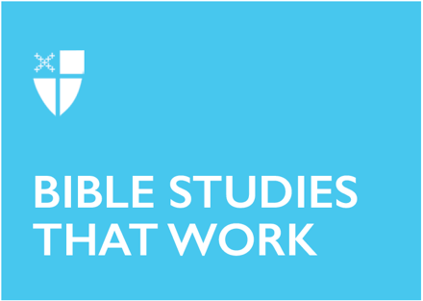

Epiphany 5 (A)
February 9, 2020

RCL: Isaiah 58:1-9a, [9b-12]; Psalm 112:1-9, (10); 1 Corinthians 2:1-12, [13-16]; Matthew 5:13-20

Isaiah 58:1-9a, [9b-12]
God has told the prophet Isaiah to “Shout out, do not hold back!”, and Isaiah speaks accordingly, drawing out the hypocrisy of God’s people in their devotional practices. This continues the call for a renewal of heart and behavior that we heard in Micah last week. Isaiah says that the people of God ask, “Why do we fast, but you do not see?” He follows it up immediately with the answer: “Look, you serve your own interest on your fast day, / and oppress all your workers.” Fasting (for Isaiah’s community and for ours) is an expression of repentance, but here it is only a cover for more selfish behavior. Isaiah says that in order to be attended to by God, the people must repent in their hearts and behavior: “Is not this the fast that I choose: / to loose the bonds of injustice . . . to let the oppressed go free.” Only then will God answer the people’s cry and say “Here I am.”

- What can you think of in our common life in America that is a “yoke” to be lifted, or “the bonds of injustice” that must be loosed?
- In your town or city, what is “the pointing of the finger, the speaking of evil” that should stop?
- Where else in the Bible do we find this emphasis on God’s requirement of honest and unhypocritical devotion?

Psalm 112: 1-9 [10]
Psalm 112 continues Isaiah’s theme and elaborates on what the life of the truly righteous person will be like. They are “merciful and full of compassion,” and are “generous in lending,” “manag[ing] their affairs with justice.” The result of living in true righteousness is a life that is happy, fearless, honorable, and trusting: “their heart is right.” The Psalmist’s words are a description, an exhortation—but also a gesture of hope, a trusting prayer that right behavior will have practical results in the speaker’s heart and mind, and in the world.

- Which of these descriptions of a righteous person rang most true for you? Did it remind you of anyone?
- What quality in this description was most immediately appealing to you for your own life?
- In what ways does this Psalm specifically encourage us to grow in righteousness?
- Did any of these images or phrases remind you of other parts of Scripture?

1 Corinthians 2:1-12, [13-16]
Paul was writing to a congregation he had built himself a few years before, located in the diverse port city of Corinth. Today’s passage comes in the midst of a longer cry for unity in a divided congregation. Picking up on the idea of divine foolishness we heard last week, Paul admits—boasts!—that he didn’t come to the Corinthians with “plausible words of wisdom.” Instead, the power of his testimony, and of the whole community’s, is in “a demonstration of the Spirit and of power.” The power and wisdom of God—secret, inexplicable to human rulers—is where our faith should rest. Paul describes this power and wisdom coming to us “through the Spirit,” who helps us understand and speak what God has given us.

- In your Christian communities, what signs of the Spirit have you seen that are not about “plausible” arguments? (Like extreme generosity, unexpected kindness, etc.)
- Have you known someone in your lifetime who has made Christ known to you, like Paul, not in “lofty words” but “in weakness and in fear”?
- How might this metric (humanity’s “plausible words” vs. God’s foolishness) change the way we normally think about justice? or peace?

Matthew 5:13-20
In the Gospel according to Matthew, Jesus gives us another angle on the righteous life. The people of God must be bright—a bright flavor, a bright open light—shining before others “so that they may see your good works and give glory to your Father in heaven.” Matthew’s Jesus also makes explicit here something that runs through the whole Gospel—that he has come as fulfillment of the law, not as its destroyer. The call to righteousness seems to have changed in his new witness, but it has not at all removed it. Those who are “great in the kingdom of heaven” will be following and teaching the words of the law and the prophets.

- Where else in the Bible do we find images like the flavorful salt or a bright lamp?
- How might these particular words of Jesus shape the way we think of his relationship to the law?
- How might our actions in a largely secular society be like a lamp lit in the darkness?

This Bible study, written by Emily Garcia, originally ran for Epiphany 5 on February 5, 2017.

