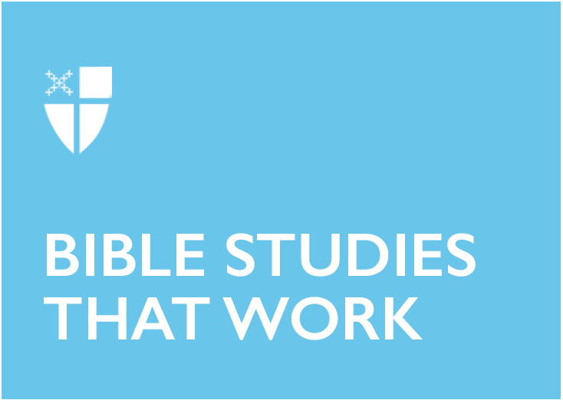

Day of Pentecost (C)
June 9, 2019

[RCL] Genesis 11:1-9; Psalm 104:25-35, 37; Romans 8:14-17 or Acts 2:1-21; John 14:8-17, (25-27)

Genesis 11:1–9
This passage in Genesis describes a time when all of humanity resided in one place and spoke one language, a vision of unity that sounds awfully appealing today. Imagine how our perception of the world’s economic and environmental challenges would change if we saw ourselves as part of one global community, with loyalties that reached beyond our particular region, state, or nation. And think of how delightful it would be to freely communicate our hopes and dreams, our joys and sorrows, to anyone in the world in words they could fully understand! Sadly, in the story of the Tower of Babel, the fruit of unity is not recognition of our interdependence, but an overweening ambition tinged with fear. Rather than tend to one another’s deeper needs, humanity seeks to build a monument to itself, one that will reach the highest heavens and, presumably, place all people on an equal footing with God. Indeed, God observes that nothing they propose to do going forward will be impossible for them.

We might think that in a world where nothing is impossible for us, everything would be better. If so, then God’s decision to confuse our language is, well, confusing! But if the truth be told, the rush to satisfy our own desires might once again result in displays of foolish pride rather than mutual progress. After all, we still seek to glorify ourselves through the pursuit of wealth and material possessions, the twin towers of our own making. On the other hand, acknowledging our reliance on God tempers our pride and fosters a sense of humility. Humility is a great gift, for in recognizing our own shortcomings, we sow the seeds of compassion for others. Solidarity rooted in compassion, rather than vanity, is the form of unity that God wishes for us.

- How has your own pride affected your relationship with God? With others?
- What would be a humbler and more productive and way of engaging in dialogue with those who don’t “speak our language,” whether we encounter them in church or elsewhere?

Psalm 104:25–35, 37
We read today’s psalm in robust praise of the God who has created “all that is, seen and unseen,” as the words of the Nicene Creed attest. However, the psalm also reminds us that all of creation, including us, still depends on God. God sends forth his Spirit, the psalmist tells us, and the world is not only formed but continuously renewed. We should rejoice not only in the fact of creation but in the gift of the Spirit that works to renew God’s world with each and every day.

- Can you recall a time when you were especially dependent upon God’s grace? What events brought you to that realization?
- Looking back, how did the Holy Spirit sustain and renew you?

Romans 8:14–17
Paul testifies that when we allow ourselves to be led by the Spirit of God, we show ourselves to be children of God. Having been adopted by God, we nevertheless still share with Christ as heirs to God’s promise of new life. Paul suggests that when we suffer, we should recall that Christ suffered, yet ultimately was glorified. May we one day share in Christ’s glory.

- What would it mean for us to allow ourselves to be led by the Spirit of God?
- Is suffering inevitable, even for the children of God? Is it necessary for us to experience suffering to more deeply appreciate the redemption offered through Christ?

Acts 2:1–21
The events of Pentecost are often referred to as “the birthday of the church.” But the miracle of Pentecost is really about the arrival of the Holy Spirit, who descends with the sound of rushing wind and the appearance of tongues of fire. In the drama of this moment, we must not overlook what immediately follows: the disciples themselves are filled with the Holy Spirit.

All that happens afterward depends on this fact.

Through the power of the Spirit, the disciples gain the ability to communicate with all those gathered around them, who have come “from every nation under heaven.” This is no ordinary assembly, but a polyglot collection of men and women from throughout the known world. Astoundingly, they each hear about God’s deeds of power in their native tongues, in words that deepen their knowledge of the gospel. This marks the beginning of Christian evangelism, as the followers of Christ start to follow his command to make disciples of all nations (Matthew 28:19).

Today’s Old Testament reading reminds us that the building of the Tower of Babel ended in confusion. The Day of Pentecost, by contrast, brings mutual understanding. The former story proceeds from the desire of humans for glory; the latter flows from the desire of the Holy Spirit for harmony. There is a lesson here; by paying less attention to our own impulses and more attention to the movement of the Spirit, we might better discern God’s will for the Church today.

Trusting that the Holy Spirit is still at work, our congregations should be unafraid to embrace people from a variety of races, languages, and cultures, because we know the Spirit can turn the cacophony of Babel into the sonorous unity of Pentecost. And individually, we ought to be willing to testify to God’s deeds of power, letting others know that the God we have come to know through Christ is a loving and liberating presence in our own lives. The Gospel is good news, and it deserves to be shared as widely as possible!

- How is the Holy Spirit at work in your life? In the life of your church?
- Think about ways in which you might share your knowledge of Christ with others, especially with persons whose life experiences are different from your own.

John 14:8–17, 25–27
“I am in the Father and the Father is in me,” Jesus says to Philip, adding that he speaks not on his own. Rather, “the Father who dwells in me does his works.” This is a remarkable testimony; with these words, Jesus reveals the truth of the Incarnation: that even in his humanity, he is intimately connected to the divine. The works the disciples have witnessed enable those who cannot believe Jesus’ words to recognize him through his deeds.

Yet there is more to come. Jesus wants his disciples to continue to experience the divine presence, even after he has left them. Accordingly, he promises to send an advocate, a comforter, and a healer who will abide with them forever. All of these terms describe the Holy Spirit, who arrives on Pentecost and remains among us as a constant teacher and guide, for the church as a whole and for everyone who strives to follow Christ.

- We celebrate the gift of the Holy Spirit each year at Pentecost. How have you felt the presence of the Holy Spirit today?

This Bible study was written by Ed Stewart of the Church Divinity School of the Pacific.

