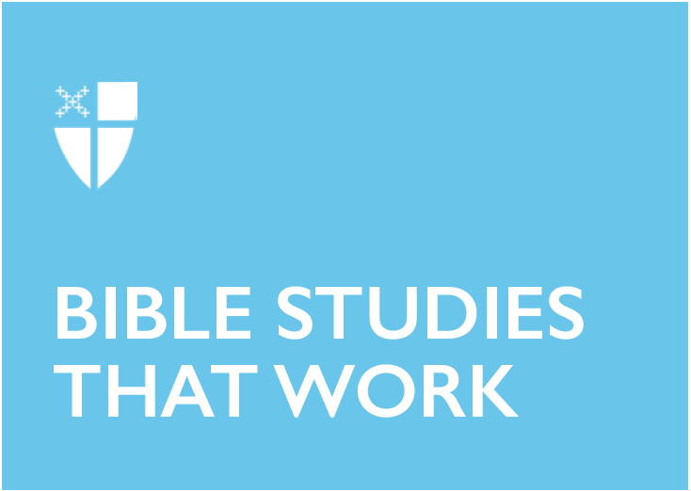

Pentecost 8 - Proper 13 (C)
August 4, 2019

RCL: Hosea 11:1-11; Psalm 107:1-9, 43; Colossians 3:1-11; Luke 12:13-21

Hosea 11:1-11
Meditating on this passage of prophetic imagining surfaces the tension that characterizes the relationship between God and Israel. Both parties bend their backs, but God’s bending nourishes while the peoples’ bending isolates them from infinite sustenance. The poet paints a picture of YHWH—the God of their ancestors—who calls out to them time and again only to be cast aside. The more God called out, the further the people ran outside of earshot. In the poet’s hands, God reminisces about teaching the people how to walk, embracing them with open arms, and healing them when healing was needed. God says, “I led them with cords of human kindness, with bands of love” (v. 4), but perhaps the people mistook the cords and bands as tools of bondage rather than connectors of infinite mercy. In verses five through seven, it seems that the Assyrian conquest vindicates God’s anger, tempting God to turn a blind eye when the people finally wave their arms in distress and return God’s call.

But this is a God who desires closeness. And perhaps the poet even endeavors to imagine YHWH, the great I AM, into a space of introspection. The poet’s words seem to push the creator of all things to say, “For I am God and no mortal, the Holy One in your midst” (v. 9) – a reminder to the Holy One of his abundant capacity not only for anger and wrath but also for intimate knowing and loving. In verse eight, the poet writes that God’s heart recoils within God, as if it had been previously wretched out by Israel’s rejection. Instead of burning with wrath outside of the chest, God’s heart recoils and grows warm and tender with compassion close to Godself. The writer suggests that YHWH can no more exist without the love and affection of humans than a fish can live outside of water.
- What causes us to bend away from God?
- How might we straighten our backs to meet God?

Psalm 107:1-9, 43
A great companion to the Hosea passage, this psalm reiterates the steadfastness of God’s love. For the psalmist, God’s love moves beyond words and feelings that make one feel tingly on the inside. God’s grounding and dynamic love shows up to do something. It is the kind of love that moves bodies from one place to another and joins person to person—from the wild desert to an inhabited town. God’s steadfast love is the kind of love that materializes in the form of food and water when souls are weary. The psalmist reminds us that for those who have wandered beyond the bounds of civilization, finding themselves stranded from all that they know, God’s love follows them with unceasing tenacity.
- Can you name your last desert dwelling? What led you there and how did you get out? If you are still in your desert moment, what effect does this psalm have on you?
- What are the “food” and “water” in your life that God has provided for you?

Colossians 3:1-11
Should we harbor evil desire and greed within us, or wage anger, malice, and slander toward our neighbor with no regard? Probably not. But by putting to death all of the things earthly and earthy, all of the things that indeed make us human, what do we sacrifice? If we dismiss some earthly passions, do we dismiss all of them – like the need to eat, sleep, create, love, or seek the comfort of others and provide it in return? Focusing on the supposed dualistic hierarchy of spirit over body and heaven over earth creates an either/or situation. Either one can be spiritual and Christ-like, or one can be sinful and earthly, but never both. One is good, the other bad.

And yet the joy of Scripture unfolding with revelations from each succeeding generation building upon tradition bids us to explore a variety of interpretations. The writer of Colossians invites listeners to “Set your minds on things that are above, not on things that are on earth, for you have died” (v. 2). The writer calls the Colossian community to contemplate their life before joining the church, and questions how it might be different now that they have been raised in Christ. What changes will they make in their lives?

Membership does not mean paying monetary dues and maintaining the status quo. Once one says yes to following Jesus and living a Christlike existence, the dues one pays are non-material. Sacrifice comes in body and in spirit and welcomes a newly integrated existence dependent upon both. In verses nine and ten, the writer uses the metaphor of being stripped of old garments and “[clothing] yourselves with the new self, which is being renewed in knowledge according to the image of its creator” (v. 10), acknowledging the countercultural nature of living according to the image of the creator. The inner transformation manifests outwardly and compels the newly-made person into right relationships with neighbors tempered by understanding, patience, and uplift.
- Colossians makes much ado about remaking the self into the image of Christ. What or who is the image of Christ for you?
- Does it feel burdensome or freeing trying to live this lifestyle?
- In what ways are you being called to live counterculturally?

Luke 12:13-21
In his opening remarks, Jesus proclaims that he will not participate in pronouncing any kind of judgment. Still, he rather sneakily uses the parable, in fact, to pronounce judgment. Jesus seems to say to the young man desperately wishing to draw him into his family quarrel, “You’re paying attention to the wrong things!” In the New Revised Standard Version translation, Jesus sets the scene for his story and tells the crowd to “Take care” (v. 15). The original Greek word for this phrase means see, view, or perceive. He does not tell them to listen up or pay close attention. Instead, Jesus tells them to “perceive,” and then follows with, “Be on your guard against all kinds of greed; for one’s life does not consist in the abundance of possessions” (v. 15). By saying this, Jesus indicates that this goes beyond objective reality or rationalizations of the mind. He wants the young man and the crowd to feel the meaning within their bodies, and to know in a different kind of way.

This does not necessarily seem to be a lesson centered on sharing, but the rich man in the parable uses the word “my” five times in the span of just two verses: “my crops,” “my barns,” “my grain,” “my goods,” “my soul” (v. 17-19). Then, he knocks down his old barn and builds a bigger one to hold his stash. Luke stresses the importance of an equitable society, so the truth to be perceived comes directly from Jesus’ use of the word abundance. With great irony, the rich man capitalizing on his abundance makes him blind to the truth of God’s abundance. The rich man’s greed is built upon his fear of scarcity for his future. Luke drives this point home when God says, “You fool!” (v. 20), echoing Jesus’ opening sentiments to the young man. God seems to say, “Your eyes are so narrowed on your material accumulations, you cannot see the destruction your greed rains upon you or the others around you.”
- How might your perceptions be out of focus with God’s?
- Within your communities, where do you see the fear of scarcity doing harm to others?
- Are there spaces where you can expose the myth of scarcity and introduce the abundance of God?

Lindsey Ardrey is a postulant for holy orders in the Diocese of Louisiana attending Seminary of the Southwest in Austin, Texas. Before entering seminary, Lindsey worked as Children’s and Youth Minister at St. George’s Episcopal Church in New Orleans and served as co-chair for the diocesan Commission for Racial Reconciliation. She is a self-professed bibliophile, lover of speculative fiction, and writing enthusiast.

