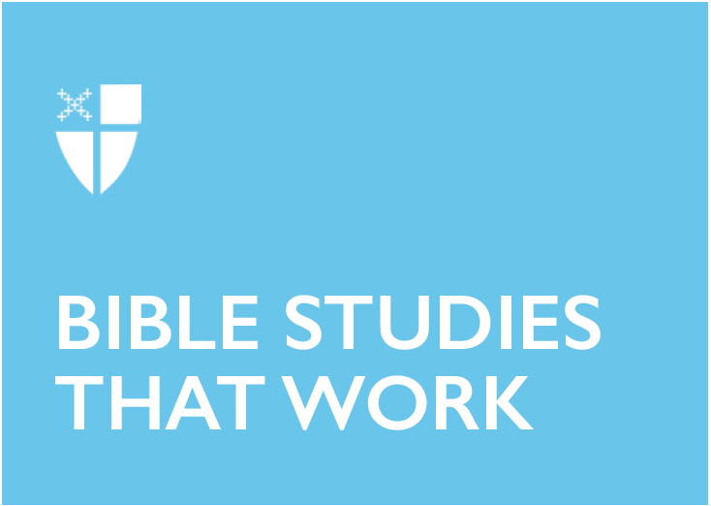

Pentecost 10 - Proper 15 (C)
August 18, 2019

RCL: Isaiah 5:1-7; Psalm 80:1-2, 8-18; Hebrews 11:29-12:2; Luke 12:49-56

Isaiah 5:1-7
The prophet begins this iconic passage by speaking on behalf of his “beloved” (i.e. the Lord). The love song unfolds, describing a vineyard situated on land that was perfectly suited for a vineyard – lush, fertile ground on a hill with no stones and only “choice vines.” What was expected of the vineyard did not come to fruition. Only bad or wild grapes came forth from the vines. The prophet turns to the audience as an arbitrator; the prophet asks Israel to judge themselves in light of the vineyard parable. What else could have been done for the vineyard? The answer is implied: nothing. So, the vineyard will be trampled down, destruction is inevitable.

This parabolic text is not dissimilar to Nathan offering a parable for David to judge, only to find out that the person David condemns in the parable is himself. Those who are hearing this text can only agree with the prophet and with the Lord: we are at fault, we are the ones who have abandoned the gifts of the land, we are the ones who have been unfaithful. This point is underlined, bolded, and highlighted in the last verse: “He expected justice, but saw bloodshed; righteousness, but heard a cry.” Israel had abandoned their commitment to covenant loyalty by neglecting justice and equity and disregarding righteousness. So have we. When we hear this parable, this prophet’s anthem, the only response is for us to repent, to ask for forgiveness, to learn to practice and embody justice yet again.

- What lush land have you been given and neglected (both literally and figuratively)? What wild grapes have been yielded by your community lately?
- Besides the General Confession in the Book of Common Prayer, what are other ways that our communities can practice repentance and confession for our “bloodshed” and “cries”?

Psalm 80:1-2, 8-18
The psalmist gives us a different, possible response to the destruction of the vineyard, to the ravaging of its vine. Underlying this psalm is a different theology, a different way of seeing Israel’s own destruction. Isaiah the prophet condemns Israel’s disregard for justice and righteousness – because of their actions, destruction has come upon them. But the psalmist asks God: why have you broken down the vineyard’s wall? Are you to blame for our destruction? Instead of only seeing Israel’s own complicity, they ask God why he was involved in the people’s destruction. And even more, it’s a call to God to tend the vine again and to save God’s people from further ruin.

The different perspective that the psalmist offers is so human: when tragedies happen, we wonder why God’s hand has been against us. We ask for God’s hand to return to us and give us life. We simultaneously protest the destruction of our world as we know it and we ask God to be near and sustain us. The psalmist records our own human protest and pleading in light of a world that is not fully set right. At the end of the psalm, we plead for restoration, for light, for salvation. God does not intend for the walls of our vineyards to be broken down, but God will help us rebuild them.

- When the world as you know it ends, how do you respond to God? How has your community responded? What can you learn from the psalmist?
- What vineyard walls have been shattered? What would rebuilding them look like?

Hebrews 11:29-12:2
By faith, by faith, by faith… the long line of forefathers and foremothers unfolds in this passage, declaring God’s powerful deeds done by means of their faith. But time would fail to tell of the others, the author of Hebrew offers.

Time would fail to tell of the others, wouldn’t it? Those who carried the faith to us: mothers and fathers, sisters and brothers, friends who extended an invitation and walked with you through a dark time. Aunties who disclosed God’s marvelous works in their lives and cousins who held your hand in hushed prayers under the night’s sky. Time would fail to tell of the journal pages full of prayers on behalf of you and me. Time would fail to tell of the ways that God has used all sorts of people in all sorts of places to spread God’s kingdom. Time would fail to tell of the ways that God continues to liberate and redeem and make whole all that has been wrong. Time would fail…

This great cloud of witnesses, the ones we personally know and the ones whom we’ve only read about, are cheering us on. They gave up much for us to be here, proclaiming the coming of the kingdom, and they’re asking much from us: do the same for those in your midst. Write prayer entries in your journal for others, be the cousin who holds out a hand in prayer, be that father or mother or sister or brother who tells others of the glory of God. Be another one – one that time would fail to tell of – in our midst.

- Who is in your great cloud of witnesses?
- What are the feats of faith that you’ve seen in your own life?

Luke 12:49-56
The fire which Jesus brings is startling to the contemporary hearer. This passage pivots and turns on ancient rhetoric, utilizing hyperbole and passion, as described by the Rev. W. Bentley Manning. But isn’t the fire a regular experience of our faith journey? Are we not purged and cleansed by Jesus’ presence and life? Our loyalties are realigned, and Jesus invites us into the transformational fire.

This fire is not the same as self-soothing techniques or self-actualization. You might lose yourself under its flames. These sparks ignite and spread in the landscape of the soul – coming through the deserts of our hearts, cleansing us from our sin and worldly allegiances. The fire comes into our minds and renews our imaginations. The fire comes, yes, even into our family and political lives and changes them. The division that Jesus speaks about is temporary, an initial death. We lose ourselves and the things we thought were our true lives, only to find a spring of salvation, a baptism of healing, a Savior who gifts us everlasting life.

- What are the ways that the fire is purging you in this season?
- What imaginative renewal do you hope for in your community?

Kellan is a senior seminarian at The School of Theology in Sewanee and is from Grand Rapids, Michigan. Before moving to Tennessee, she studied Religion and Gender Studies at Calvin College and worked for the Diocese of Western Michigan as their Young Adult Missioner. If she can’t be reading, she’d like to be rock climbing or cooking with her husband, Kai, or walking through the woods with their dog, Tillie.

